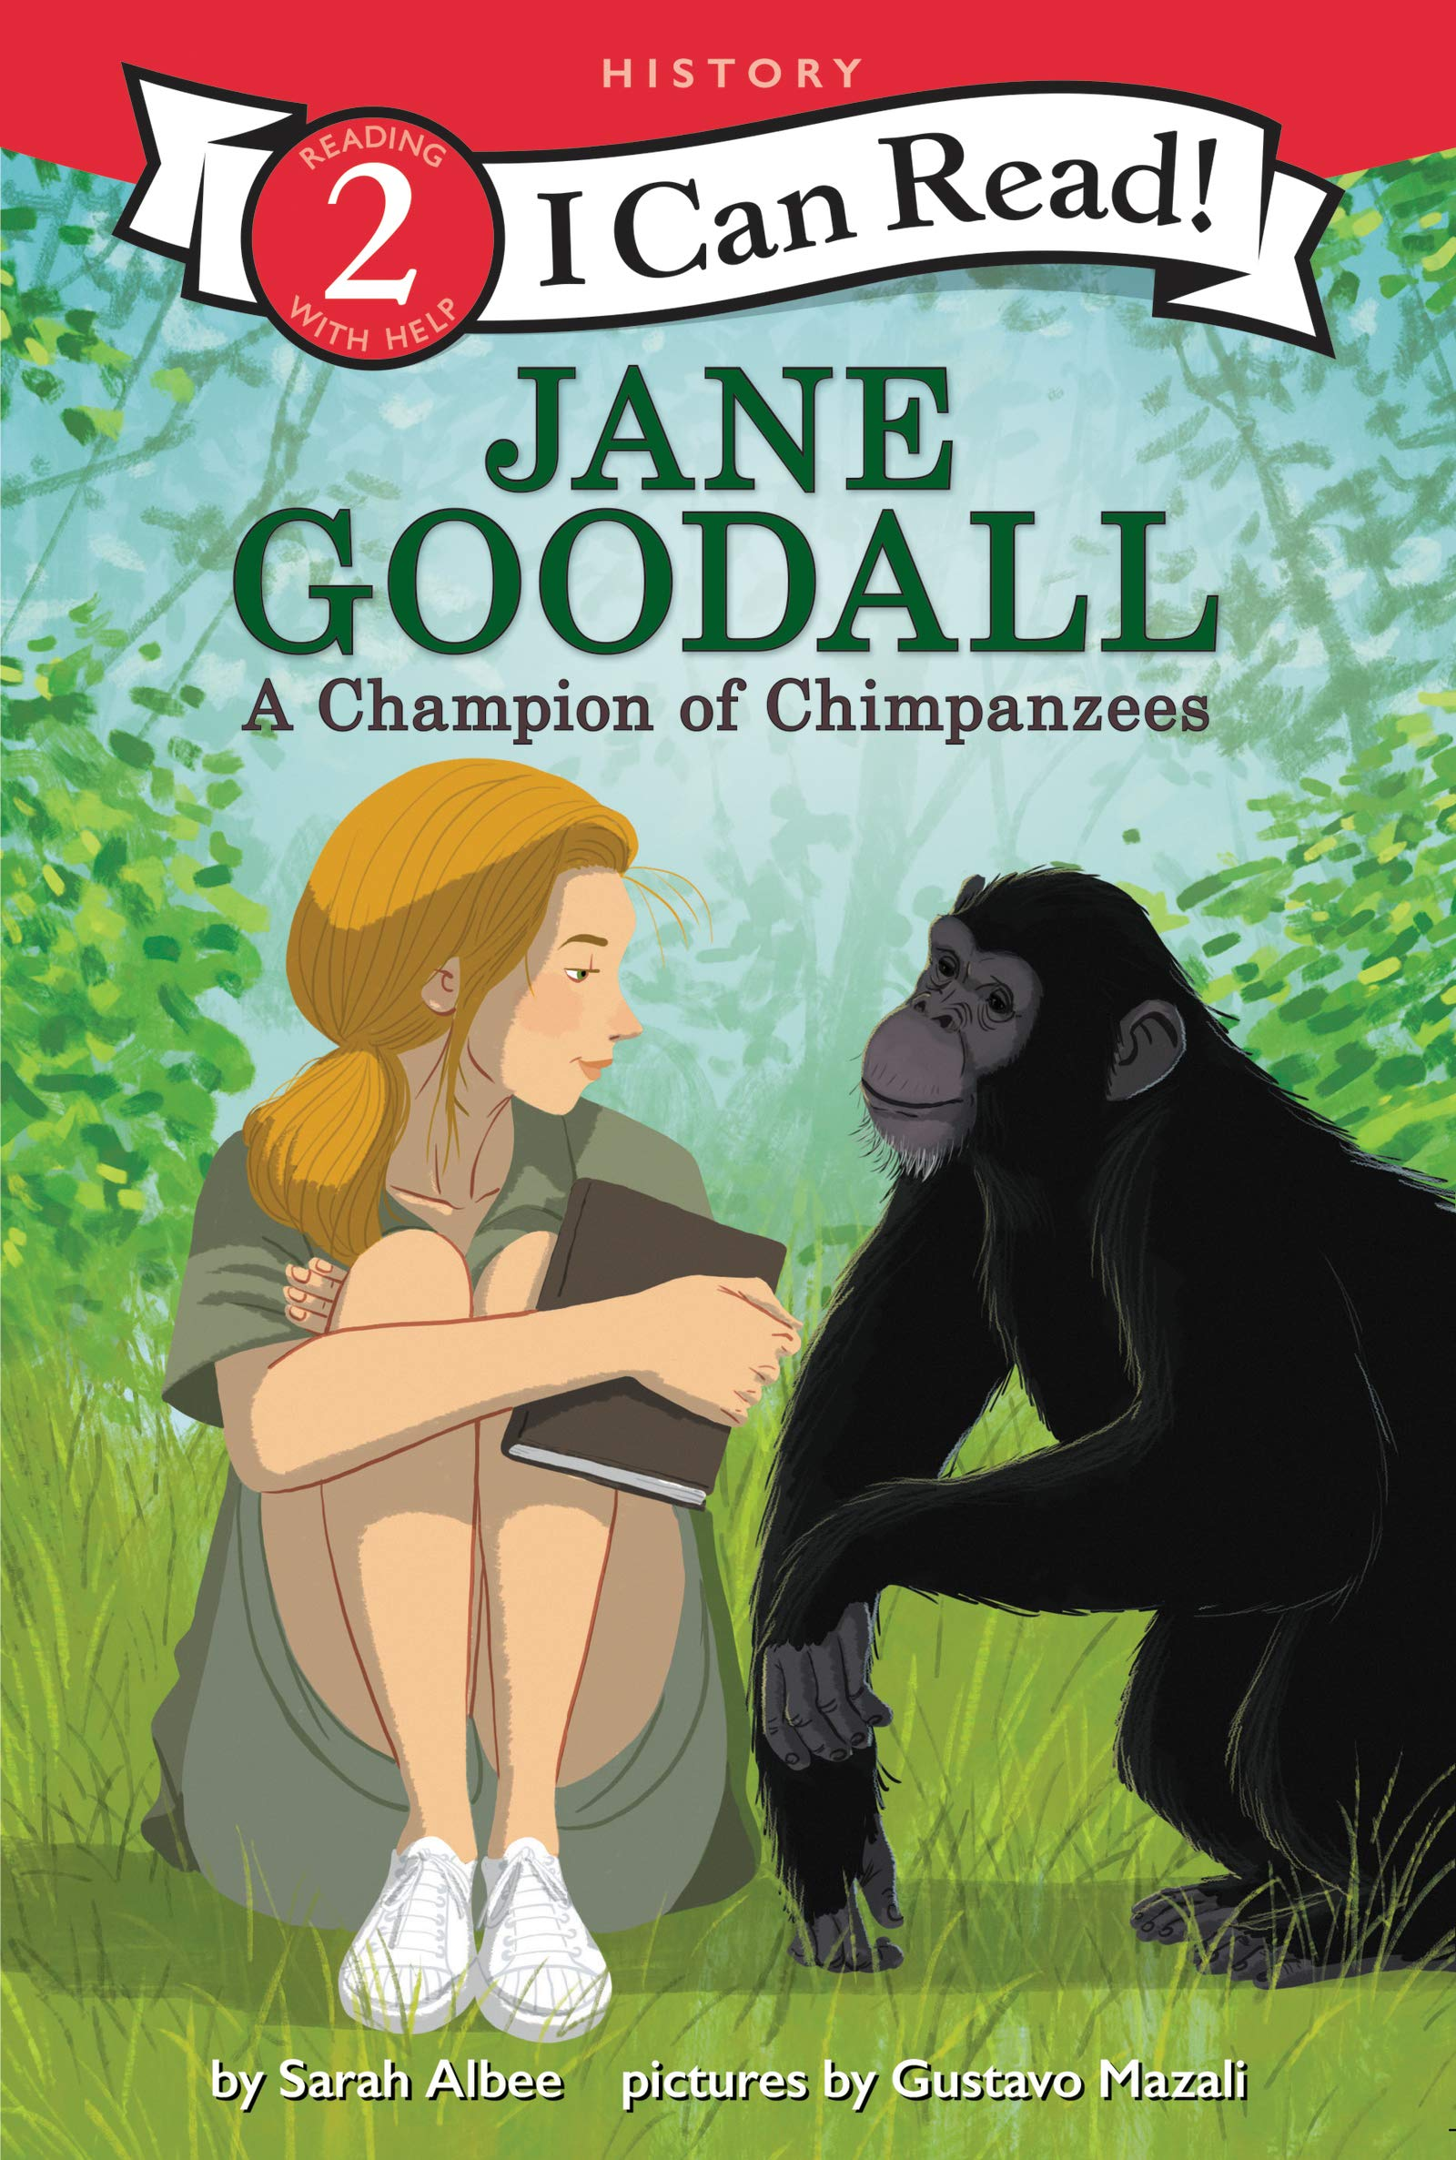Jane Goodall: A Champion of Chimpanzees
by Sarah Albee
Jane Goodall was the first person to study wild chimpanzees up close in a rain forest. She befriended the chimps and discovered amazing facts about their behaviors. What she learned forever changed how people look at these animals. This biography includes a timeline and photos all about the life of this inspiring scientist.
Verdict: Any fans Jane Goodall, animals, or chimpanzees in particular, will enjoy this Easy Reader biography. After learning about Dr. Goodall, there are facts about chimpanzees in the back, as well as additional question and answer text for further investigation.
Find it: E B GOO

Let’s Play, Crabby!
by Jonathan Fenske
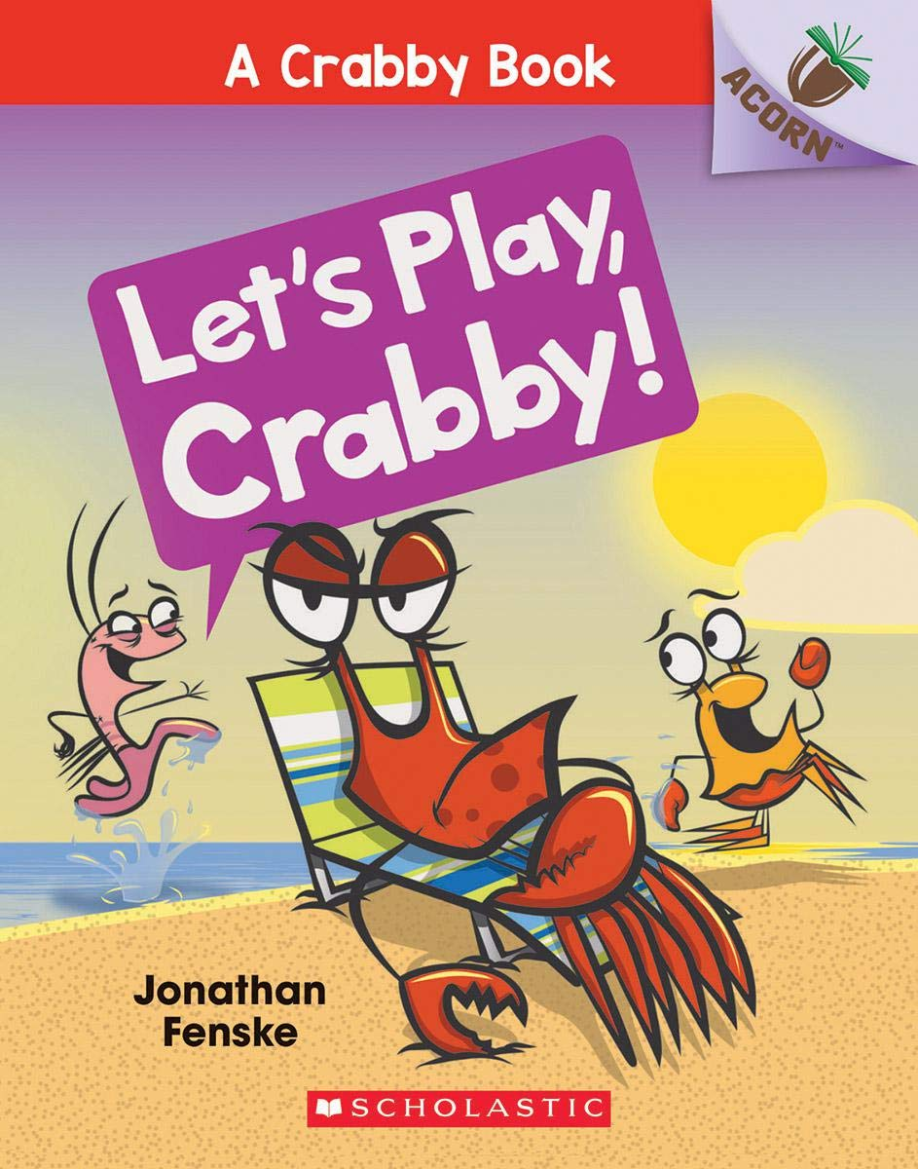Plankton wants Crabby to play a game. Plankton tries to get Crabby to play Simon Says, Tag, and Hide-and-Seek. But Crabby does NOT want to play with Plankton. Will Plankton give up? Or will Crabby finally play along? With comic speech bubbles and full-color artwork throughout, the series is sure to be a hit with new readers!
Verdict: I love the Scholastic line of books with different ‘tiers’ for different readers. Acorn is their Easy Reader line and is great as a transition before chapter books. At 44 pages, this book is longer than a lot of other easy readers, but is still simple enough for those just learning to read on their own. Most pages have more than just one line of text, but most are short sentences. Bonus: at the end, you get to learn how to draw Plankton!
Find it: E FEN

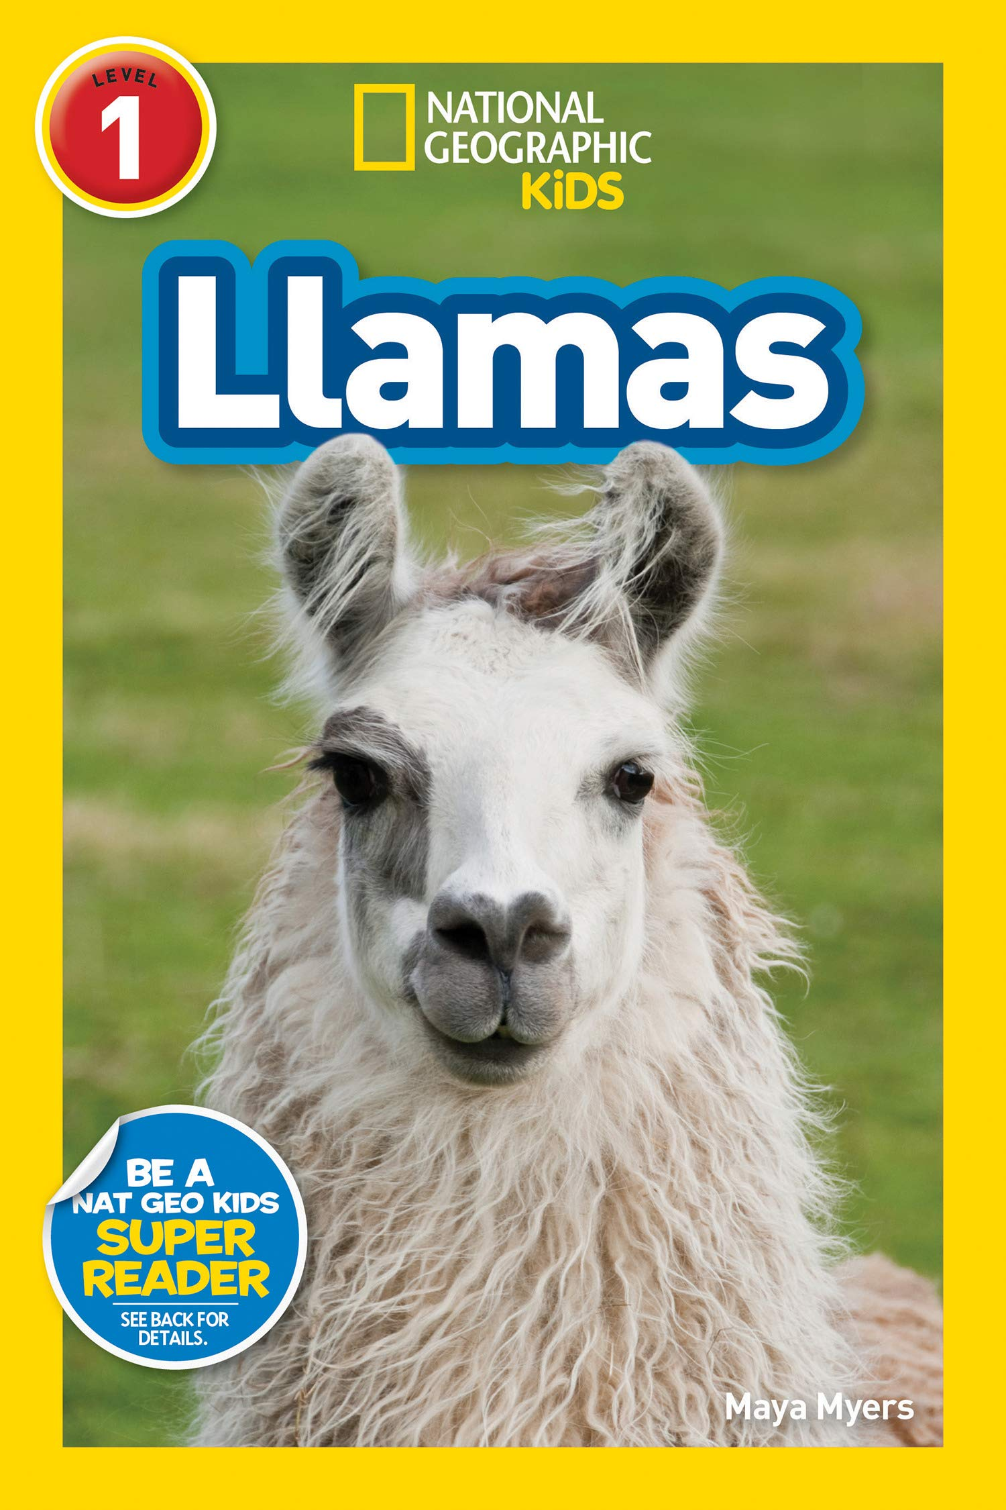Llamas
by Maya Myers
Learn all about the fascinating lives of llamas–including what they eat, where they live, how they help people, and their behavior in this new National Geographic Kids Reader. The level 1 text provides accessible, yet wide-ranging, information for beginning readers.
Verdict: Llamas are quickly becoming a new favorite animal for many, and this book will only reinforce that! This book is full of fun facts, vocabulary words, jokes, great photos, and a fun trivia game at the end. Did you know llamas can weigh up to 440 pounds? That’s just one of the many things you’ll learn if you check out Llamas!
Find it: E 599.63 MYE

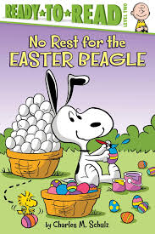No Rest for the Easter Beagle
by Charles M. Schulz
It’s almost Easter and Snoopy is exhausted! He still has lots of eggs to color and hide. When Lucy recommends that the Easter Beagle take a break, it’s up to the Peanuts Gang to color and hide all the eggs. Everyone wants to help, but are they up to the task?
Verdict: Peanuts fans will have fun with this book. Each character’s personality really comes to light as they all try to ‘help’ with the Easter eggs. Some, of course, aren’t much help at all! A cute story for Easter but could be read any time of year as a way to promote working together and how everyone is important!
Find it: E SCH

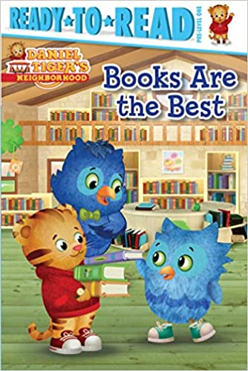Books are the Best
by Maggie Testa
It’s storytime at the library! Right away, Daniel and O find a really cool pop up-book and can’t wait for O’s Uncle X to read it to them. But as soon as Uncle X begins, O looks around and gets distracted by all of the other great books! Can O’s uncle teach him to focus on what’s special about the book they are reading at that moment before moving on to the next?
Verdict: Children familiar with the TV show will love the Daniel Tiger easy readers! I particularly like this one because the text tells a full story. Many easy readers have page after page of the same text but with a slight change in a word or a letter – this is, instead, a simply written narrative of the episode. It also comes with a moral, like most Daniel Tiger stories, of “Enjoy the wow that is happening now,” which is a great lesson for any age!
Find it: E TES

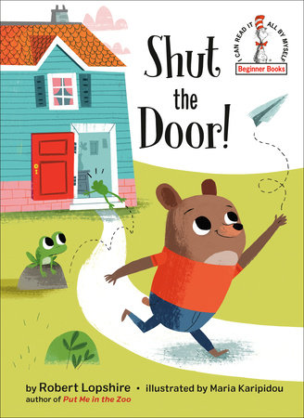Shut the Door!
by Robert Lopshire
When a little bear forgets to close the door to his house, he encounters a series of unwelcome (and untidy) visitors--including a swarm of flies, an egg-loving skunk, and a moose in search of a bath! This rhymed easy-reader by Robert Lopshire--author of Put Me in the Zoo and I Want to Be Somebody New!--is perfect for beginning readers, and its surprise ending will leave kids giggling with glee while reinforcing the message that we ALL need to be responsible for our actions.
Verdict: At first I wasn't sure about this book, but it turned out to be a fun read with a great twist at the end. As a parent, we've probably all said, "Shut the door!" or "Turn off the lights!" or something similar, and this book is an exaggerated version of what can happen when we don't! The story is longer than some easy readers so beginning readers may need helping getting through it but it's long enough to be interesting to those that are starting to transition to chapter books. Check it out for yourself today!
Find it: E LOP

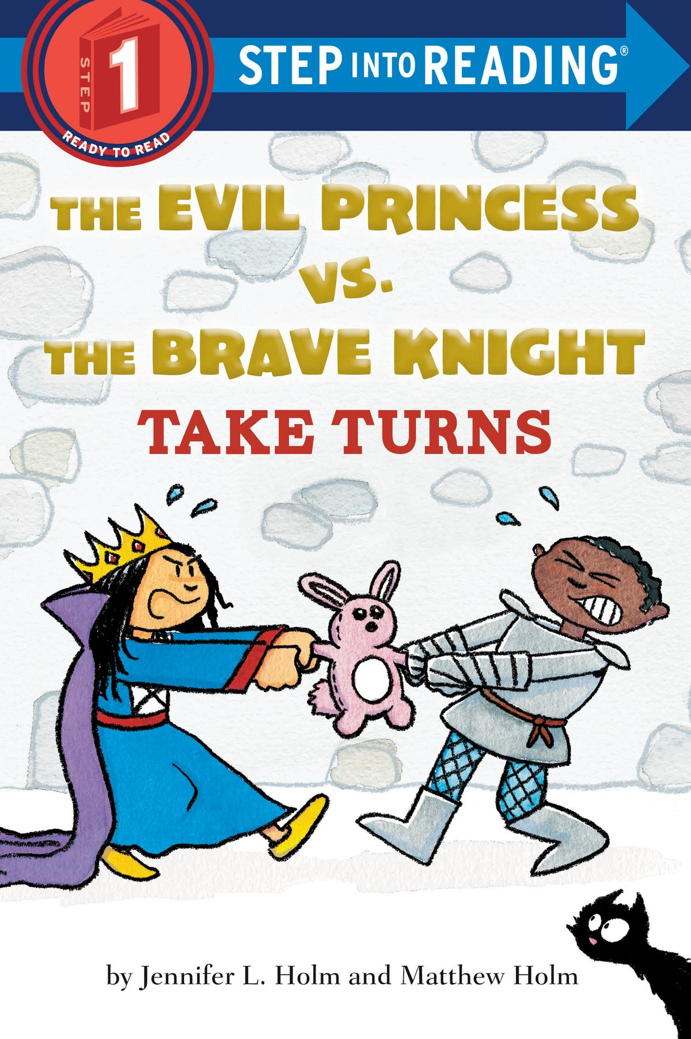The Evil Princess vs. the Brave Knight Take Turns
by Jennifer & Matthew Holm
The Evil Princess casts terrible spells, while the Brave Knight fights dragons. Could these siblings be any more different? Watch them try to learn to TAKE TURNS!
Verdict: For any parent that is tired of saying, "Can't you two just get along?" - this book is for you! It doesn't necessarily teach children how to take turns, but it does introduce the concept in a semi-humorous way. Those children that like castles, princesses, knights, and cats will enjoy this book even more!
Find it: E HOL

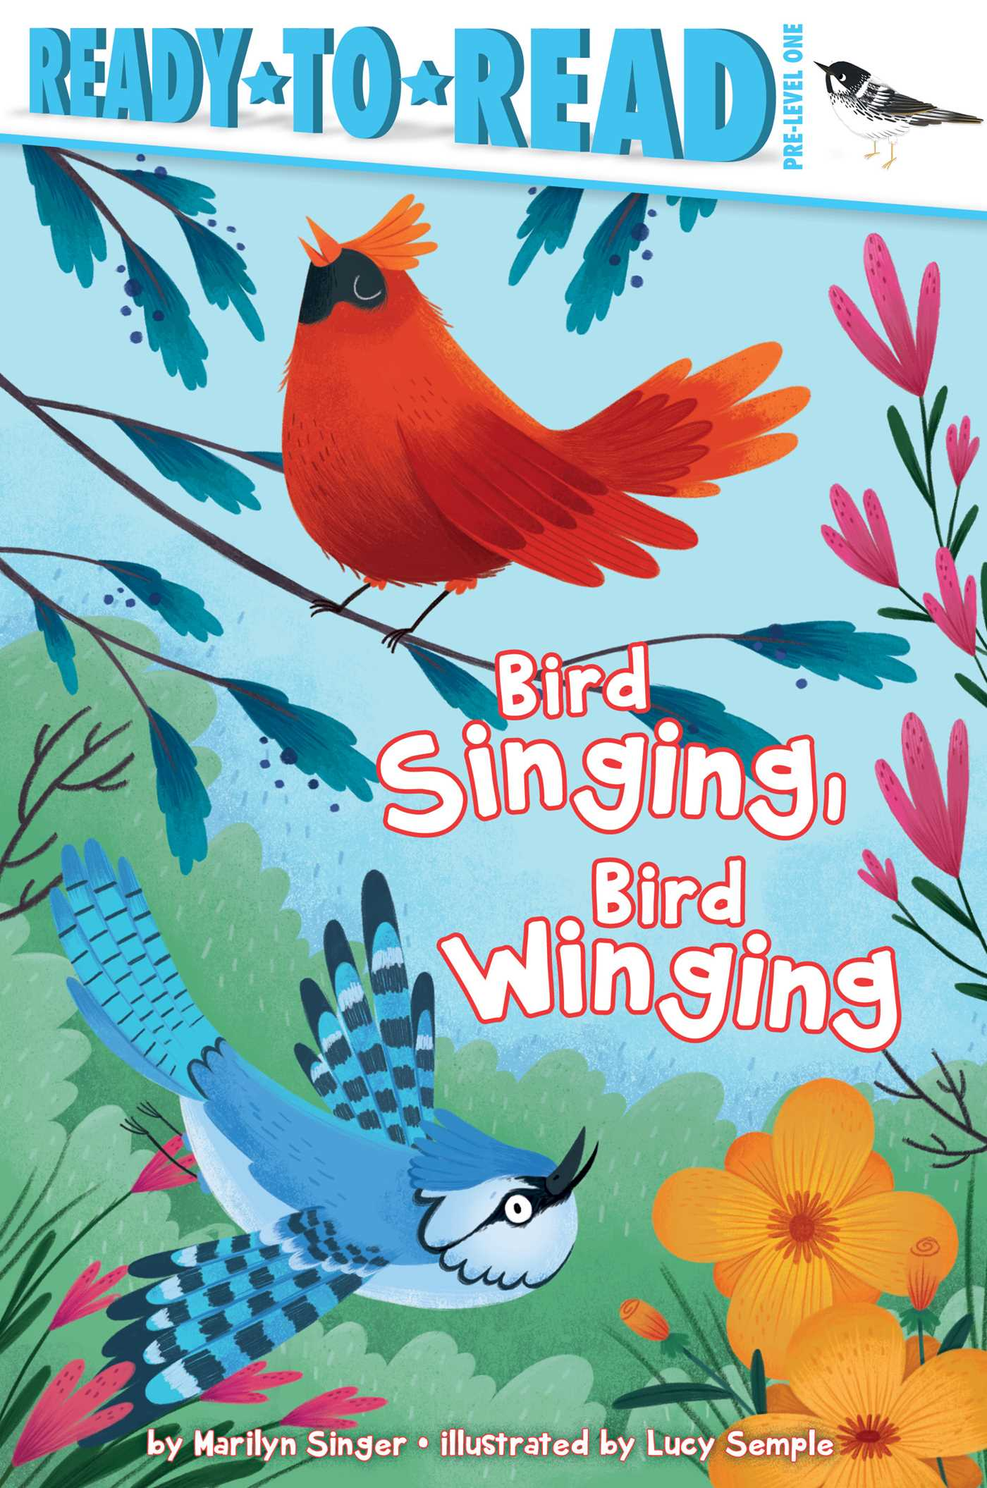Bird Singing, Bird Winging
by Marilyn Singer
See birds of all different kinds in this easy non-fiction reader. See them singing, winging, walking, talking, and so much more in this charming book that includes a special section at the back with facts on each type of bird.
Verdict: This book is a very, very elementary introduction to the life of birds. Young readers will be introduced to new vocabulary terms, like preening and lapping. For those wanting more substance, the end of the book is filled with lots of fun facts about the birds pictured in the pages of the story. Overall, a good starter book for learning about birds as children also learn to read.
Find it: E 598 SIN

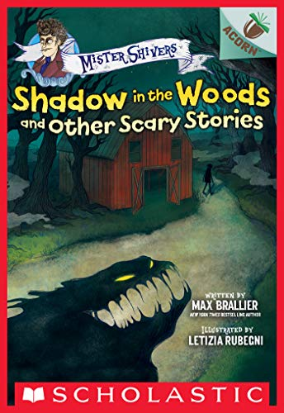Shadow in the Woods
and Other Scary Stories
by Max Brallier
What is making that strange sound in the woods? Who wrote that dark message on the wall? These five spine-chilling stories will have beginning readers everywhere begging to stay up late to read (with the light on!). With authentically scary, easy-to-read text and creepy, full-color artwork throughout, this book is perfect for young children who crave lite scares. This scary story collection from New York Times bestselling author Max Brallier is THE book to share at sleepovers or around a campfire. It will send SHIVERS down your spine!
Verdict: For children just learning to read that like scary stories, this is the series! This book is the second Mister Shivers book and is a perfect transition between traditional easy readers and chapter books. At the end of the book, you even get a drawing lesson and a writing/talking prompt!
Find it: E BRA

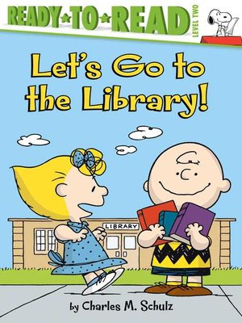
Let's Go to the Library!
by Charles M. Schultz
Sally is so excited; she is going to the library to get her very first library card. And of course her brother Charlie Brown and Sweet Babboo Linus are there with her to celebrate this big day!
Verdict: What librarian wouldn't love a book about getting your first library card? Peanuts fans are sure to enjoy following Sally on her trip and any reader will probably agree that "Happiness is having your own library card."

