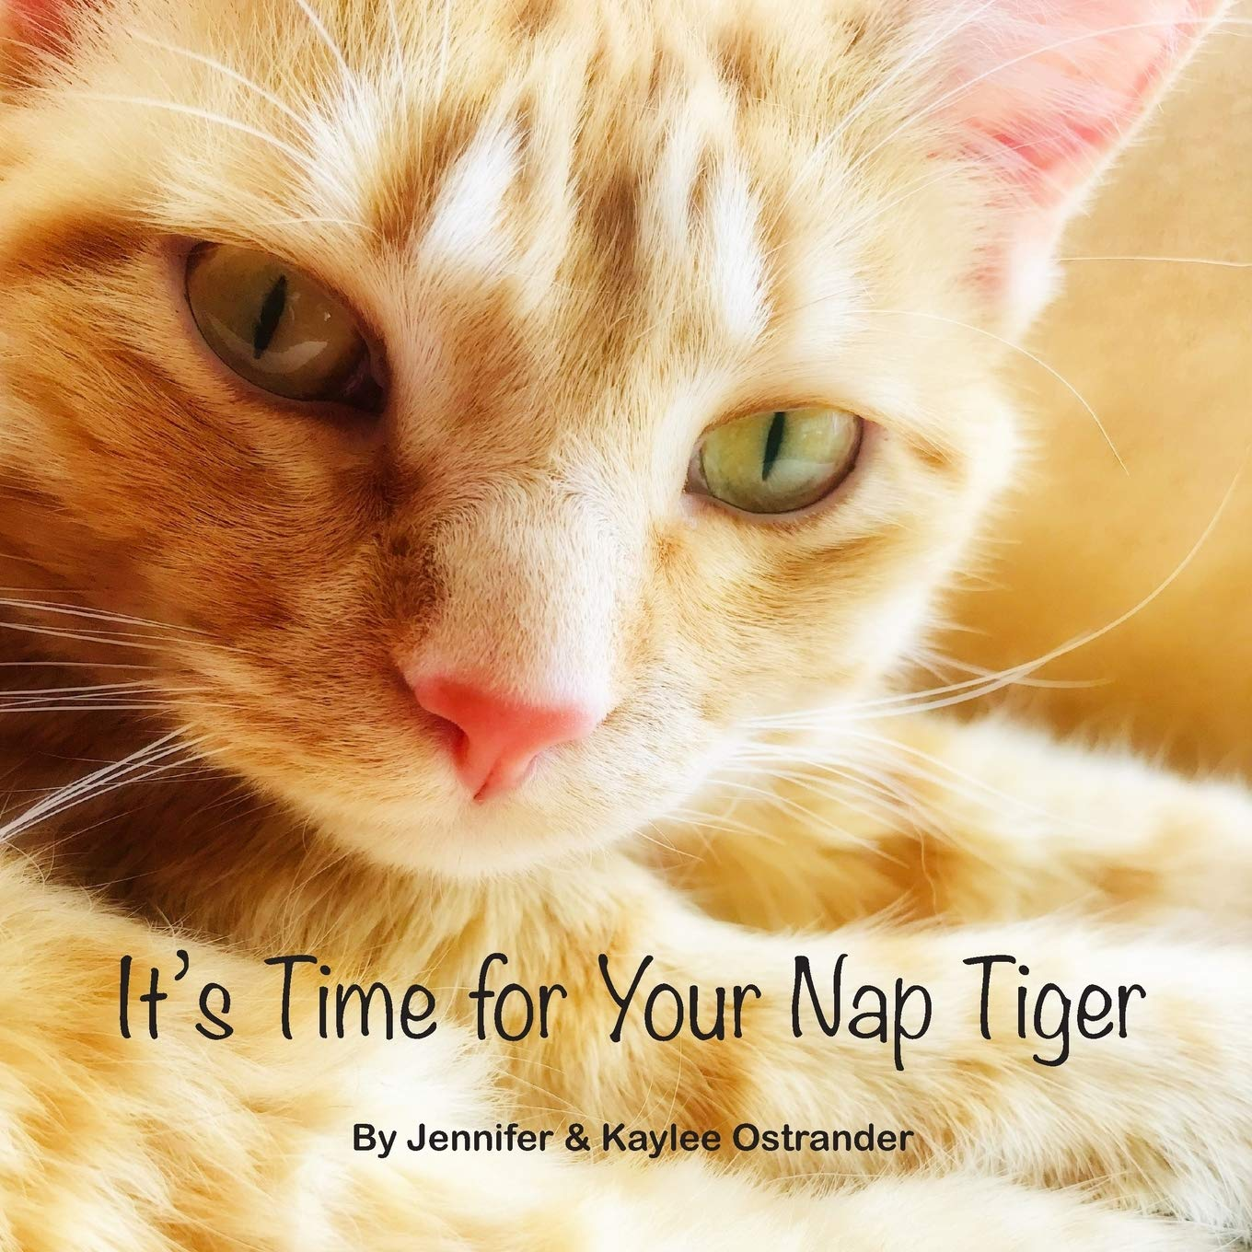It’s Time for Your Nap Tiger
by Jennifer & Kaylee Ostrander
The darling orange tabby cat named Tiger who stars in this book will do anything to avoid taking his nap. Read along in this extra cute book full of high quality photos of a real orange tabby cat to find out what finally changes his mind about his nap. It’s time for your nap Tiger!
Verdict: Cat lovers rejoice – Tiger is here! An all-too-true tale of avoiding a nap that is sure to appeal to children and adults. The dialogue between Tiger and the narrator mirrors a relationship between a young child and their caregiver. Check out this local authors’ book today!
Find it: NEW PIC OST

There Was an Old Woman Who Lived in a Book
By Jomike Tejido
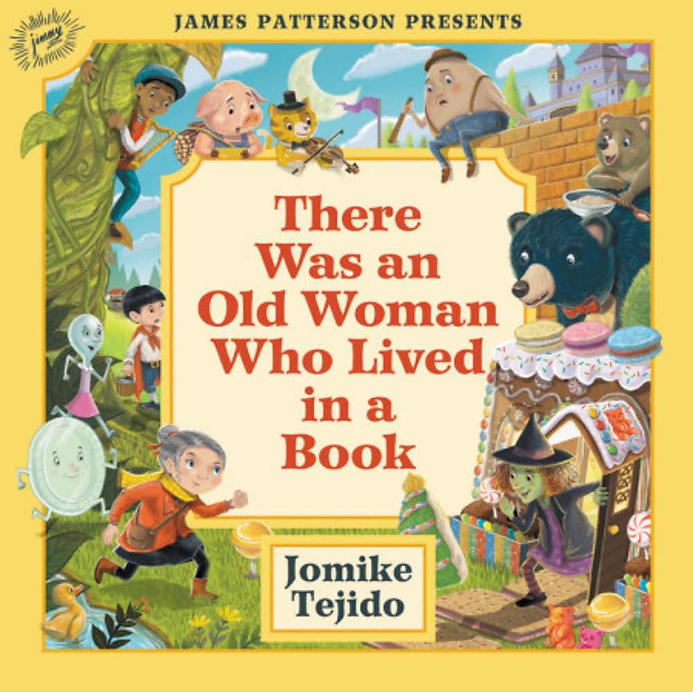The old woman has lost her children! On her journey to find them, she realizes that there is something missing from all of our favorite fairy tales and nursery rhymes! Can they find all the missing items, and the children, before it’s too late?
Verdict: A cute book if you know all of your fairy tales and nursery rhymes. Younger children who haven’t been introduced to many of these yet may have a hard time following the story. It could be a great opportunity to check out other books with these tales in them and learn all about Goldilocks and the Three Bears, Baa Baa Black Sheep, Jack and the Beanstalk, Hansel and Gretel, and many others. Older children may be able to follow the story line better having heard the various tales it references.
Find it: NEW PIC TEJ

When the Babies Came to Stay
By Christine McDonnell
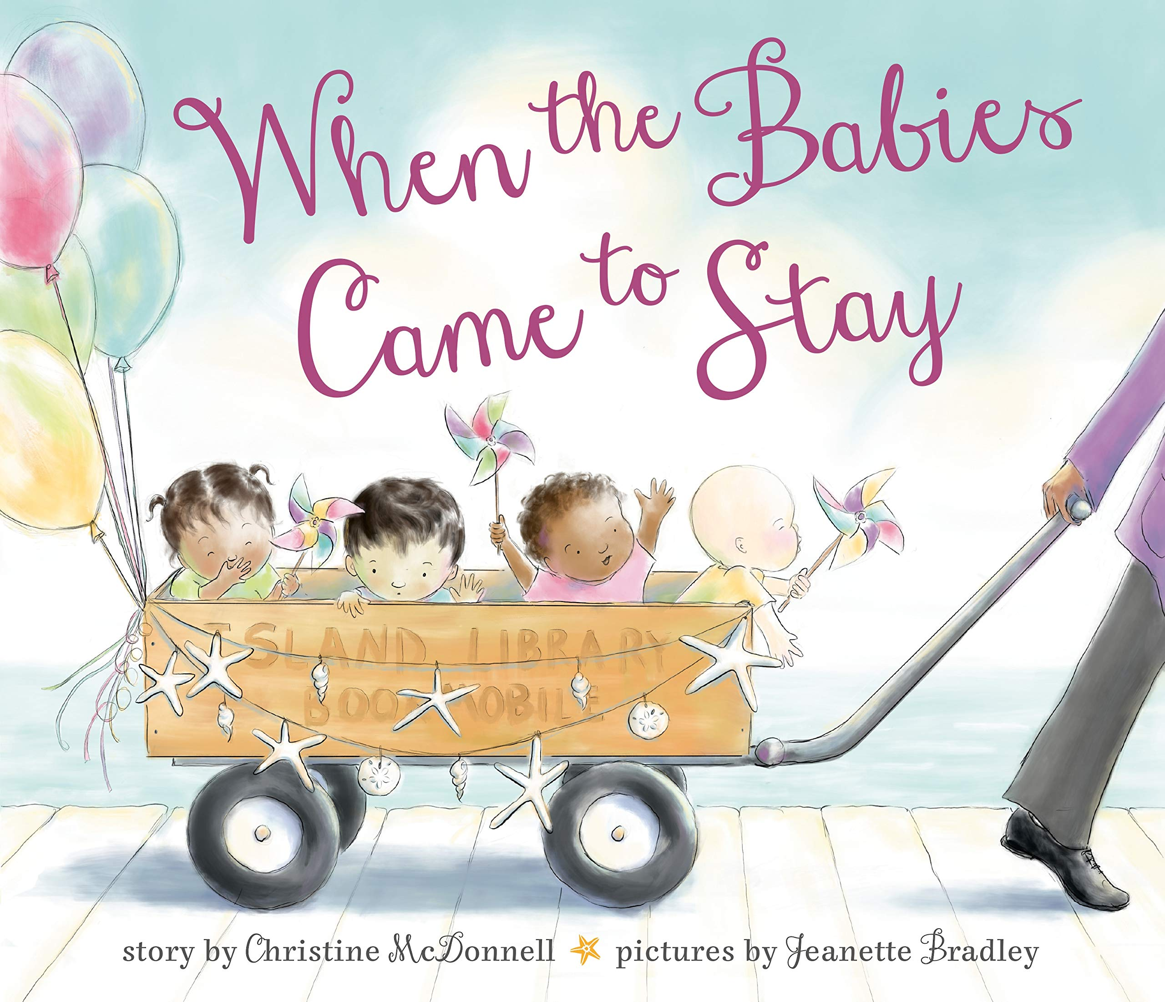“Families don’t always look alike, you know, and where we’re going is more important than where we came from.” Four little babies arrived on an island with notes pinned to their blankets. This lighthearted story tells the tale of adoption and how an island community came together to keep the four babies safe.
Verdict: A beautiful story introducing the concept of adoption, albeit in an unusual way. Other children ask why they don’t all look the same or where the came from, and the children take the questions back to their adoptive mother. Being a librarian, she normally had answers to questions, and she couldn’t have answered her children any better than she did. A great read for anyone, but especially those looking for heartwarming stories about adoption and mixed families.
Find it: NEW PIC MCD

Wild About Dads
by Diana Murray
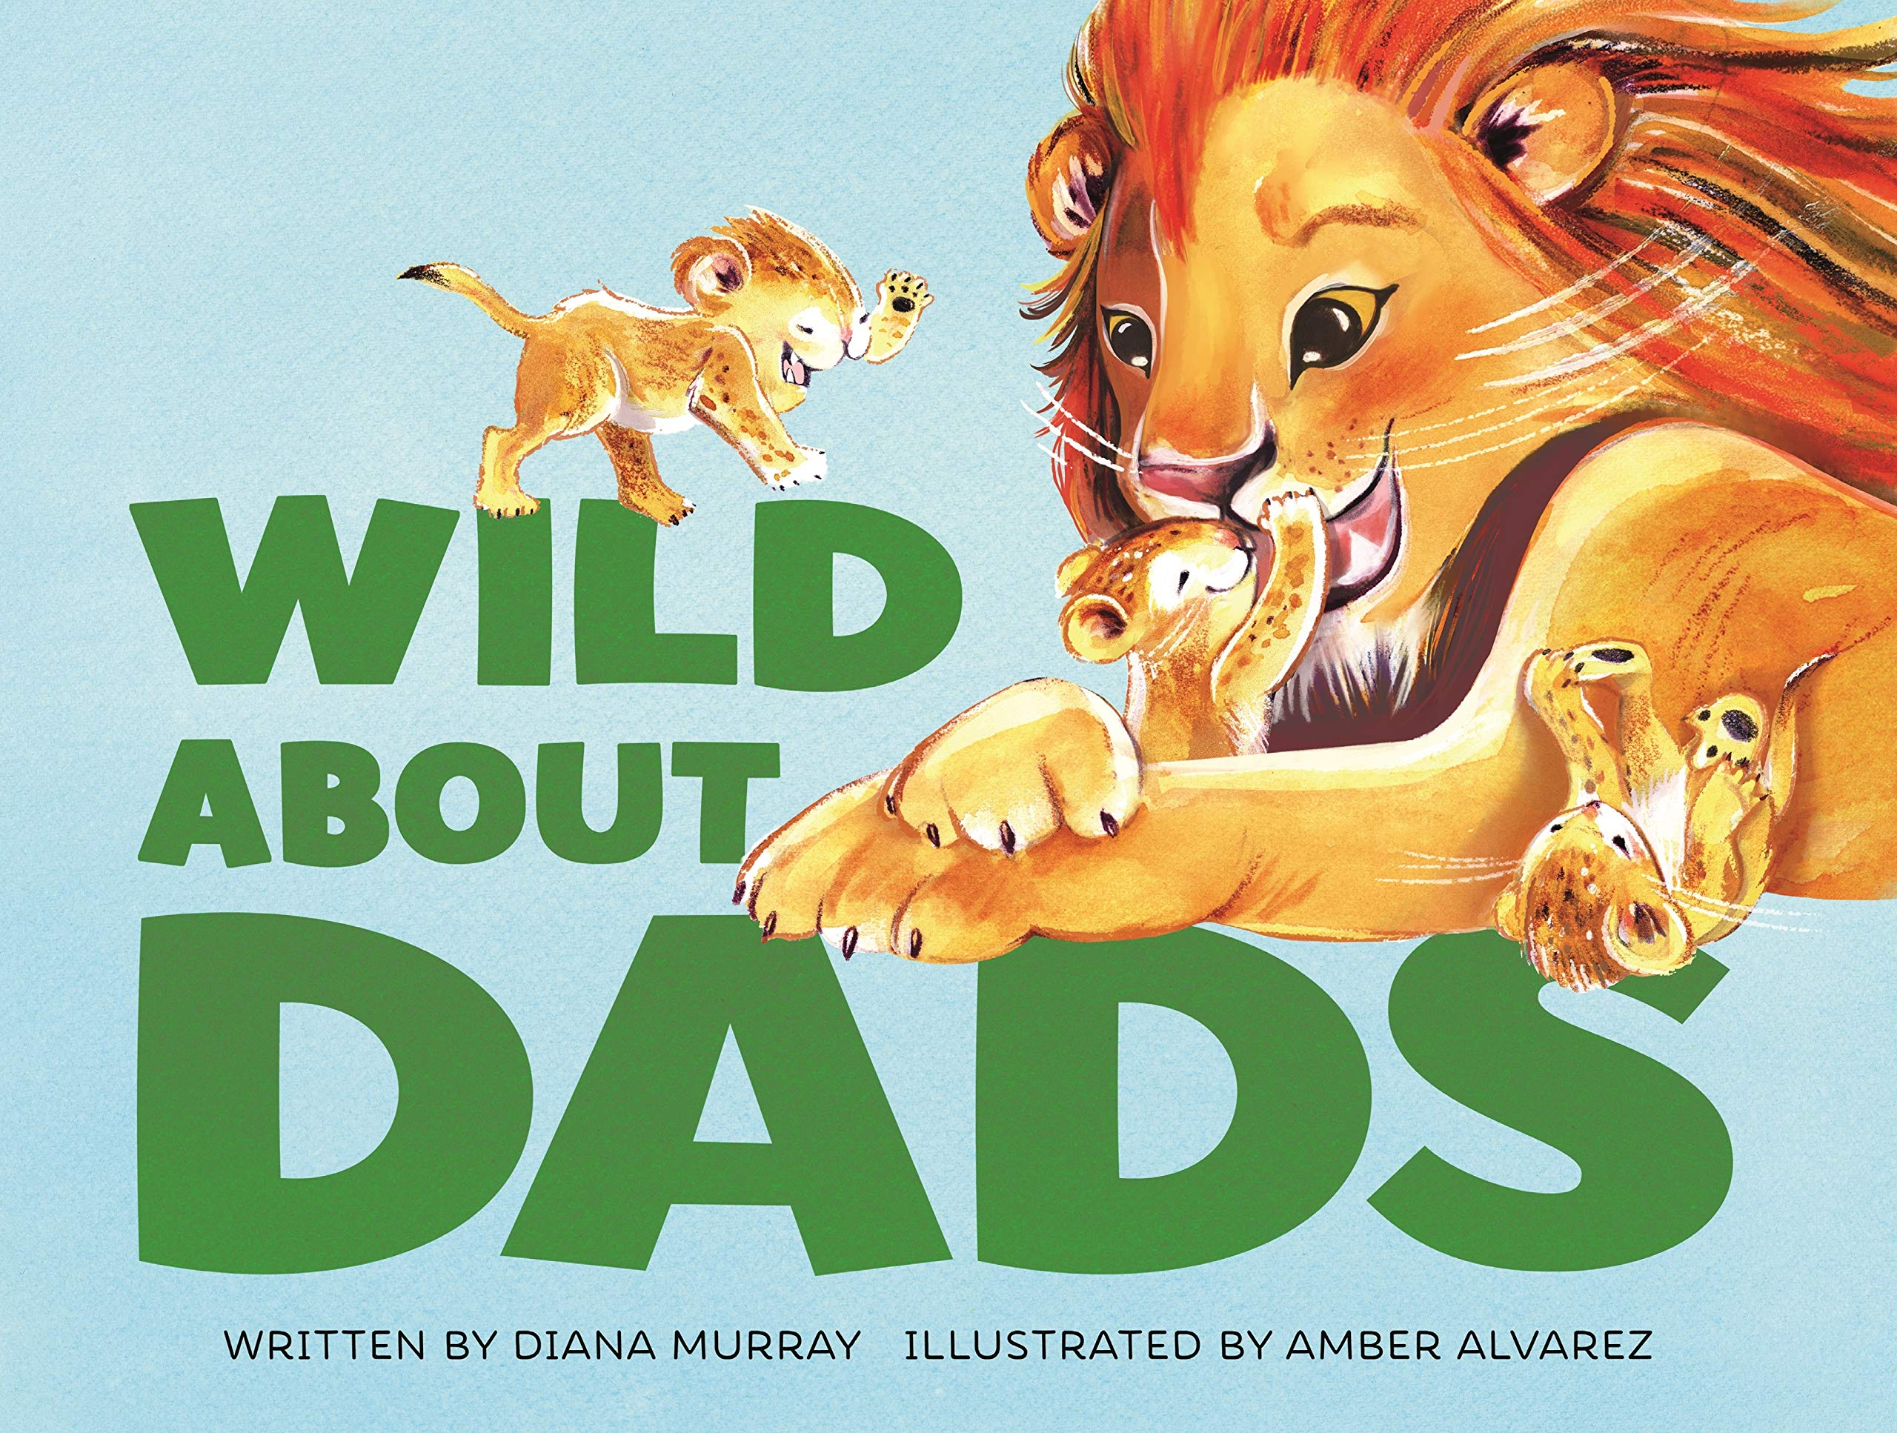Dads can help you reach up high,
and help to keep you warm and dry.
Dads are strong, dads are brave,
but sometimes dads could use a shave.
Everyone loves dads―humans, lions, frogs, prairie dogs, and even pelicans! See all these animals snuggle their little ones in this sweet, rhyming picture book that celebrates fatherhood in its many forms.
Verdict: A great book for dads of all kinds – Perfect for sharing for Father’s Day! The storyline is simple, so maybe better suited for younger readers and their caregivers, but it’s filled with lots of animals and kids will surely enjoy pointing out all the ‘babies’ and ‘daddies’ on the pages.
Find it: NEW PIC MUR

Plenty of Hugs
by Fran Manushkin
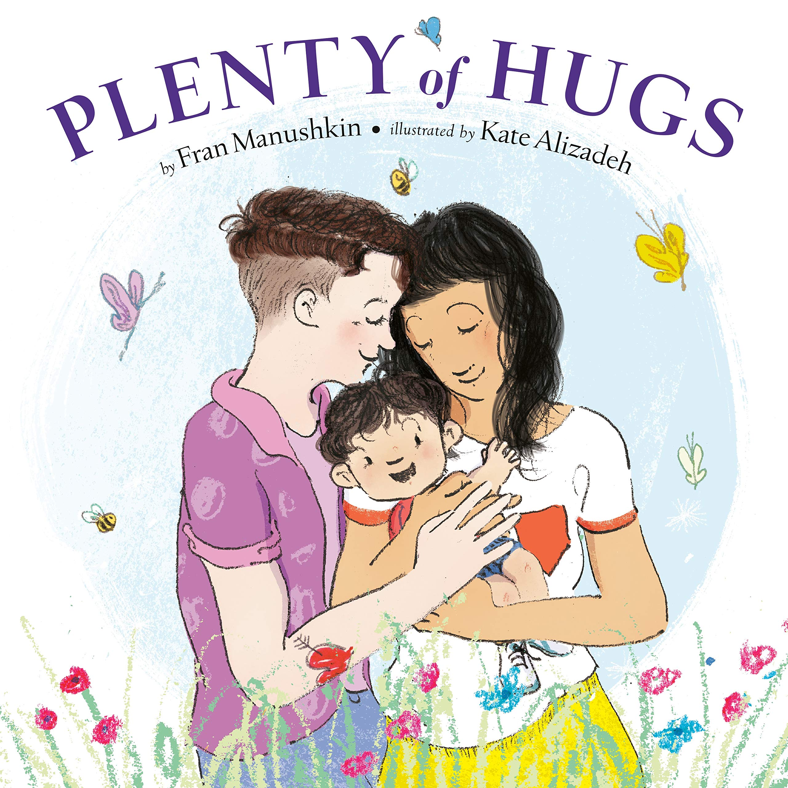This cheerful book follows a family from morning to night in lively rhyme that rolls off the tongue. There’s a buzz for each bug, and a breeze for each tree, and plenty of hugs for you and me. The toddler and mommies take a morning bike ride to a farm stand, they visit a zoo in the afternoon, and in the evening there’s the bath and storybook routine before the child is tucked cozily into bed. There are seas for ships and kisses for lips, so we can whisper I love you!
Verdict: A cute rhyming story that will be loved by any family! The story line is really a love letter from parents to their child and shows them exploring their world throughout the day. I especially appreciate the language used to describe the mommies – any my strong arms to carry you!
Find it: NEW PIC MAN

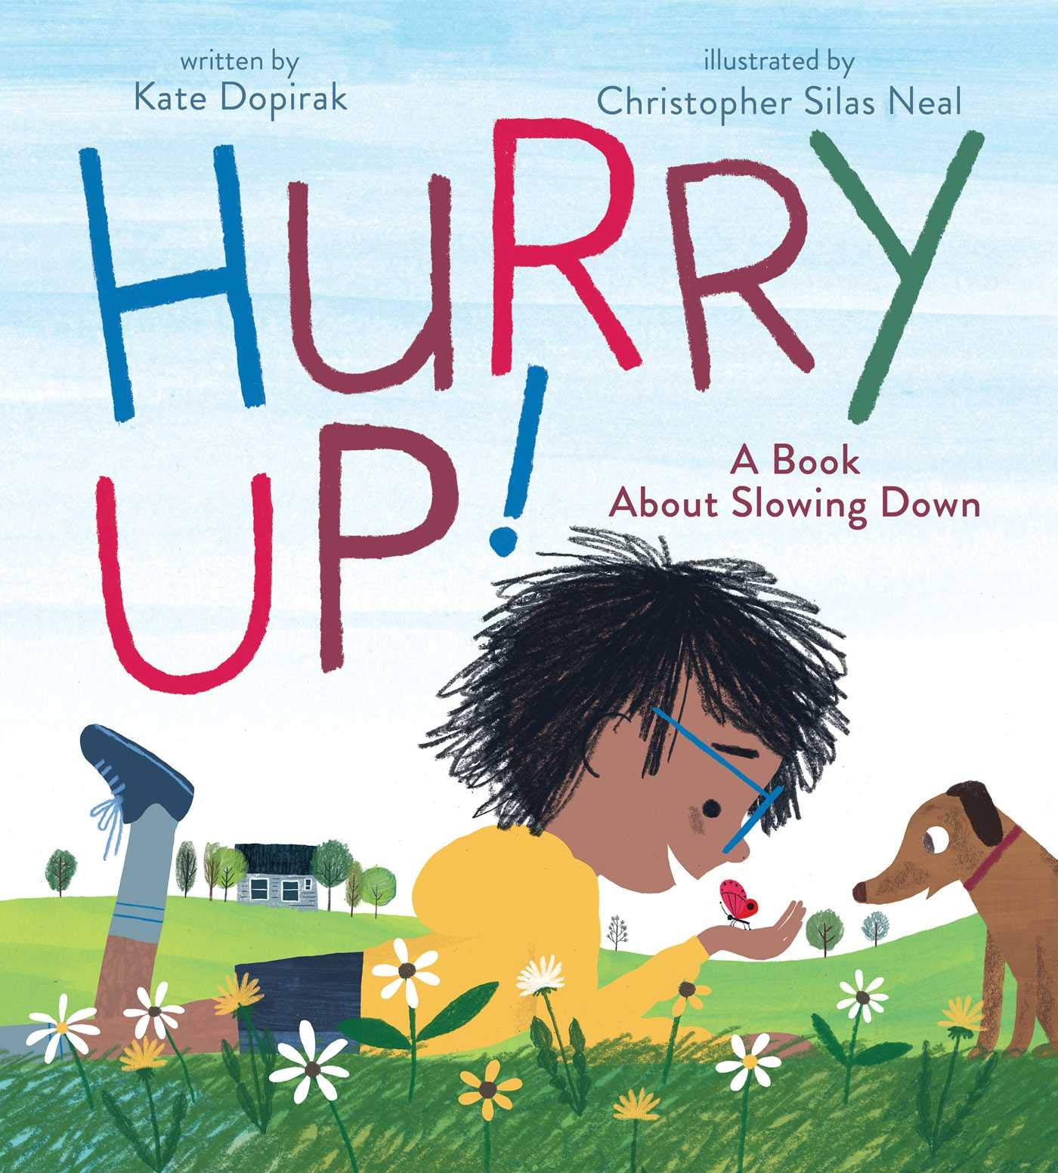Hurry Up!
By Kate Dopirak
For one busy boy, life is all hurry up, hurry down, hurry round and round and round! That is until he takes a big breath...and a big break...and slows down to see all the wonderful things in the world around him.
Verdict: A great reminder to take a step back and enjoy what's around you today. Anymore, everyone is so rushed to get to the next thing on their list that they don't stop to enjoy new flowers, playing fetch with their dog, or counting the stars. Whether your family likes to stay busy or take things moment by moment, you'll enjoy this book and the beautiful illustrations.
Find it: NEW PIC DOP

All the Way to the Top
By Annette Bay Pimentel
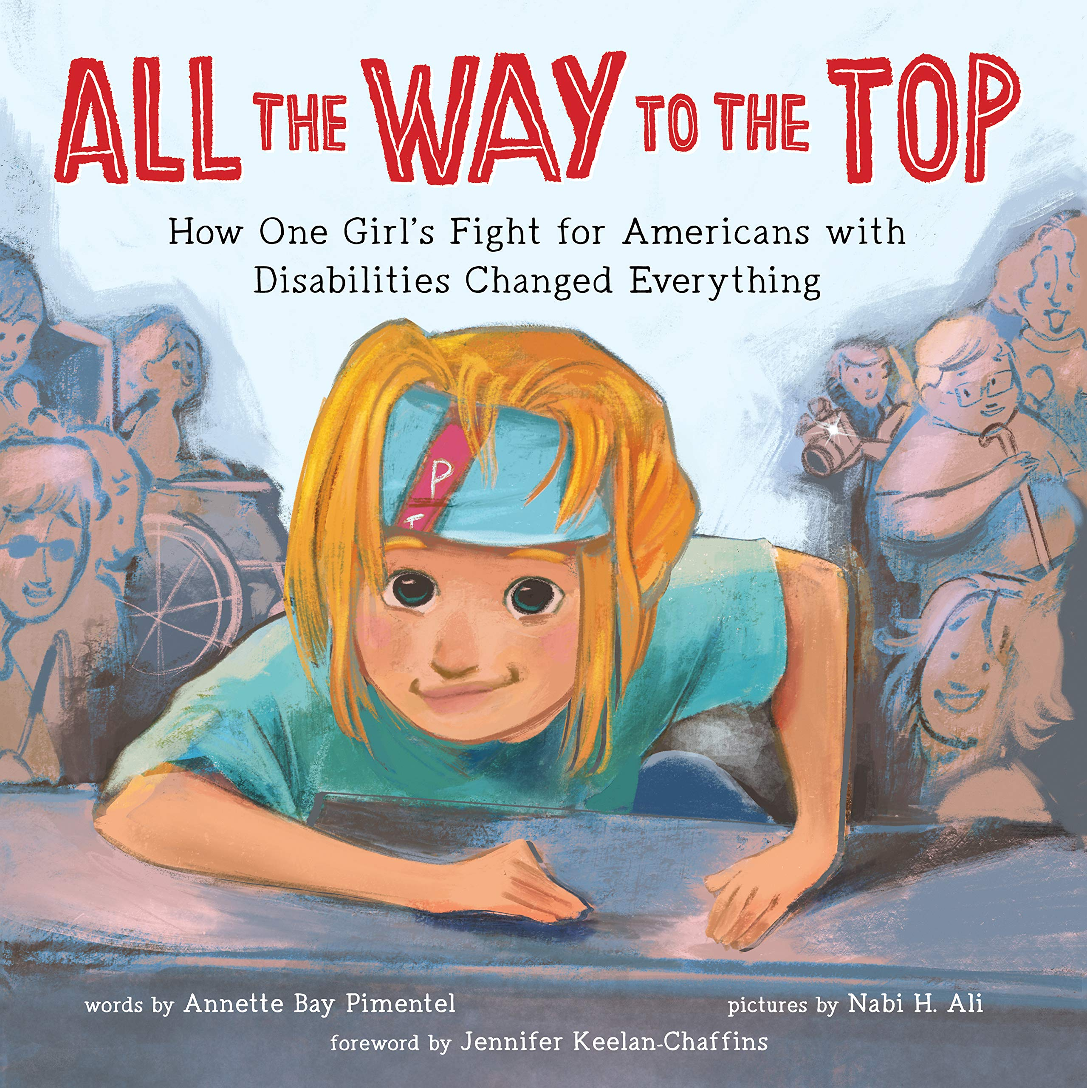Jennifer Keelan-Chaffins never wanted her wheelchair to slow her down, but the world around her was built in a way that made it hard for people with disabilities to do even simple things like go to school or eat lunch in the cafeteria. When the Americans with Disabilities Act (ADA) was proposed to Congress to make public spaces accessible to everyone, Jennifer joined activists in Washington, DC for what became known as the Capital Crawl.
Verdict: A wonderful, albeit brief, introduction to the ADA and the struggles that people with disabilities can face on a daily basis. It'd be a great picture book to share when children start asking questions about the differences they notice in people, or even better, before they start asking!
Find it: J B KEE

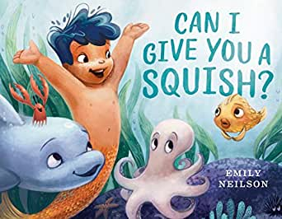Can I Give You a Squish?
By Emily Neilson
Kai loves hugs. But not everyone enjoys his "squishes," as he and his mermaid mama call them. When Kai tries to squish a shy puffer fish, the creature swells up in fright and hides! Kai feels awful - until he and his bubbly band of buddies figure out other ways to greet new friends.
Verdict: A cute story to relay the importance of asking rather than assuming. As we grow, we learn that everyone is different and likes different things. For youngsters, that can be a hard thing to wrap their head around (you mean not everyone likes the TV show I like?!?) but this book does a nice job broaching the subject! Plus, there are mermaids and all kinds of fun sea creatures!
Find it: NEW PIC NEI

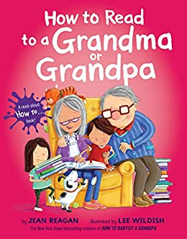How to Read to a Grandma or Grandpa
by Jean Reagan
Now that you know how to babysit your grandma and grandpa, it's time to teach them how to read with you! These kids show their grandparents how to pick out the best books, find the perfect spot to read, and which read-aloud voices to use with which books.
Verdict: A very cute book that actually does give you some ideas on how to read a book together! Reading is more fun when you use fun voices, try various voices, and turn the pages differently. Everyone is sure to love learning How to Read to a Grandma or Grandpa (or mom, or dad, or sibling...!).
Find it: NEW PIC REA

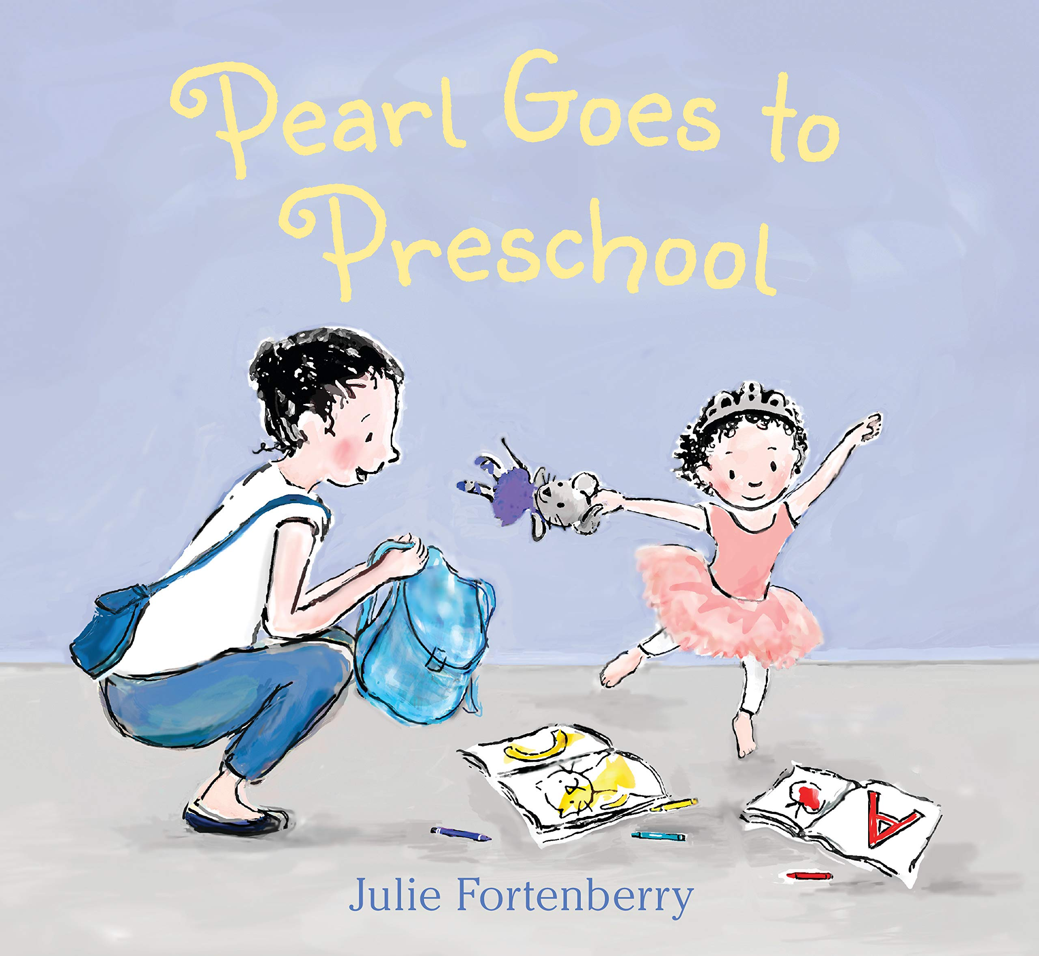Pearl Goes to Preschool
by Julie Fortenberry
Pearl loves attending dance classes at her mother's ballet school. Even though Pearl is the youngest and smallest ballerina, she knows how to count her poses and follow along. When her mom suggests that Pearl try going to preschool, Pearl has a lot of questions: What will she learn? Will there be dancing?
Verdict: A sweet story about new experiences, perfect for children that might be starting preschool this year or beginning some other new experience. Anyone who loves dance will also appreciate this story.
Find it: NEW PIC FOR

After Squidnight
by Jonathan Fenske
When the clock strikes midnight, a squad of squids creeps out of the ocean--and over to your house! Their mission? To leave their inky mark by drawing on walls, the floor, and even your toys. This rhyming tale showcases a crew of creative creatures as they make art (or maybe just a mess) and leave you to deal with the consequences!
Verdict: If your child has ever made up a crazy tale to try to get out of trouble, you'll love this book! What parent will believe that squids came in during the night to draw all over the house? Certainly not these ones! Beware – your child may use, "The squids did it!" as an excuse for months to come!
Find it: NEW PIC FEN

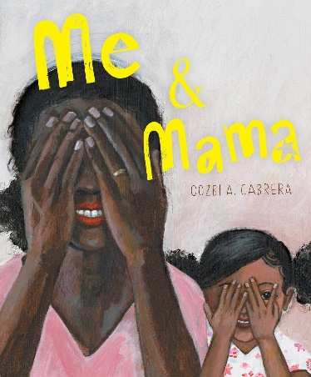
Me & Mama
By Cozbi A. Cabrera
On a rainy day when the house smells like cinnamon and Papa and Luca are still asleep, when the clouds are wearing shadows and the wind paints the window with beads of water, I want to be everywhere Mama is.
Verdict: A beautiful tribute to the special relationship between a mother and a daughter. From getting ready in the morning to laying down for bed, the text and images take you on a journey with this little girl and her Mama. Young readers will likely find a lot of similarities to their own days with their Mama.
Find it: NEW PIC CAB

