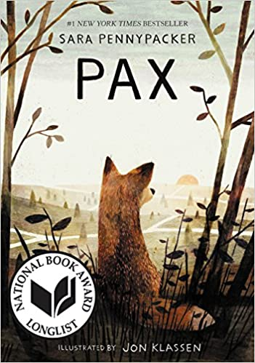Pax
By Sara Pennypacker
From the day Peter rescued Pax as a tiny fox kit, the two were inseparable. That is, until Peter’s dad is sent off to war, Pax is turned loose in the forest, and Peter goes to live with Grandpa. Peter sneaks out to find his fox while Pax anxiously awaits the return of his boy. Both endure many adventures along the way, but will they ever be reunited?
Verdict: Though penned for the 8-12 age range, this emotional story will grip readers of all ages. Having grown up with Peter, Pax has a lot to learn when he’s suddenly thrust into the forest with challenges all new. Likewise, Peter must face the truths of war, grief, and loyalty while fleeing from one home (Grandpa’s) to find his true home with Pax. This book will appeal to animal lovers, those with interests in war novels, and those that just enjoy a good, heartwarming tale.
Find it: J FIC PEN

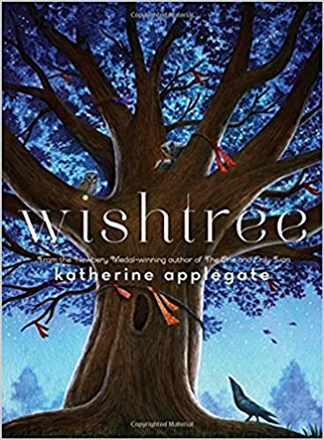Wishtree
By Katherine Applegate
Every year, the neighborhood people write wishes on pieces of cloth and tie them to the branches of a tree. This tree is Red, an old oak tree. Red watches over the neighborhood and is sure she’s seen it all. That is, until a new family moves to town. Not everyone is welcoming, which makes Red’s role even more important.
Verdict: When I chose this book, I was looking for a short audiobook for a trip I was going on. Little did I know I’d stumble upon a gem of a story. Yes, the book is a nice story about a tree and it’s [highly anthropomorphized] animal inhabitants, but it’s also so much more than that. Themes of inclusion, friendship, religious tolerance, and the power of wishes will resonate with readers.
Find it: J FIC APP; JCD APP

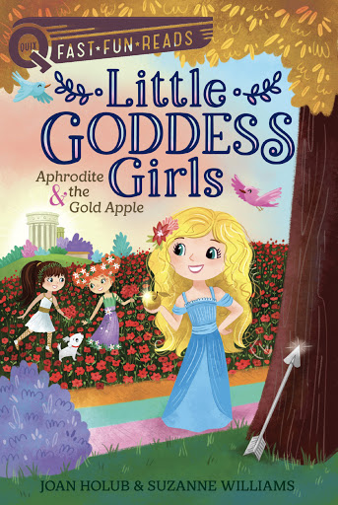Aphrodite & the Gold Apple (Little Goddess Girls #3)
by Joan Holub & Suzanne Williams
The Little Goddess Girls series features Athena, Persephone, Aphrodite, and Artemis as they adventure on the magical Mount Olympus. In the third book, Aphrodite is hoping to have friends, but she tends to speak before she really thinks about the words coming out of her mouth and upsets a lot of people! On this adventure, she hopes that Zeus will grant her the gift of likability.
Verdict: This series is great for those readers transitioning to chapter books. It features only a few pictures, but the text is large and spaced so that beginning readers can easily follow the story along the page. As hinted at by the titles, this series pulls ideas from Greek mythology, but it also borrowed ideas from The Wonderful Wizard of Oz by L. Frank Baum. It’s a fun literary combination and will be sure to keep readers entertained. The Goddess Girls are 8 years old in this book and seem to pretty accurately portray how children that age would interact.
Find it: J FIC HOL

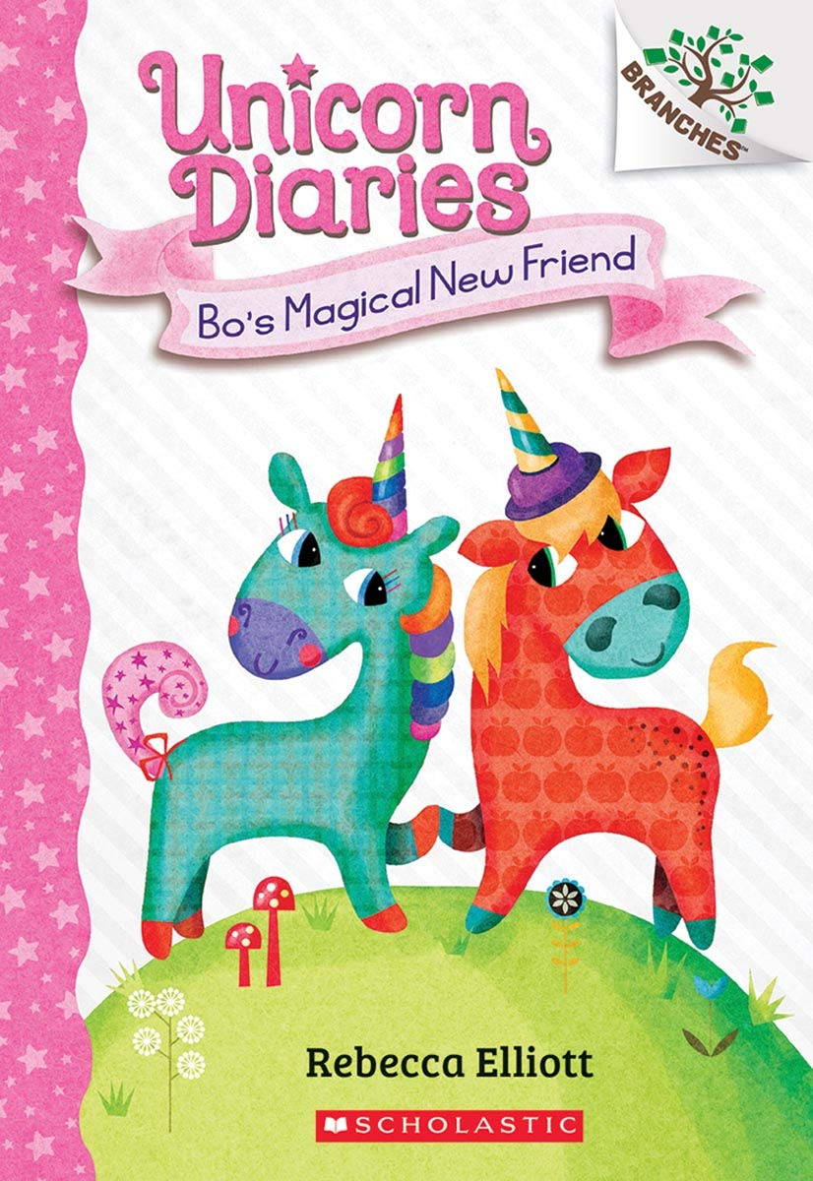Bo’s Magical New Friend (Unicorn Diaries #1)
By Rebecca Elliott
Rainbow (Bo) Tinseltail live in Sparklegrove Forest and loves attending Sparklegrove School for Unicorns. But, what Bo really wants is a best friend. Then, a new magical unicorn, Sunny, arrives in the forest. Will Bo be able to fulfill the wish of finding a new best friend?
Verdict: Written like a diary (as the series name suggests), this book is filled with illustrations and is perfect for readers transitioning into longer, chapter books. The story is cute and will keep readers entertained, but my favorite part is the comprehension questions at the back of the book! If your young reader is having issues with comprehension (and likes unicorns!), this book may be a good tool to help bridge the divide. Of course, any lover of unicorns will enjoy the book as well!
Find it: J FIC ELL

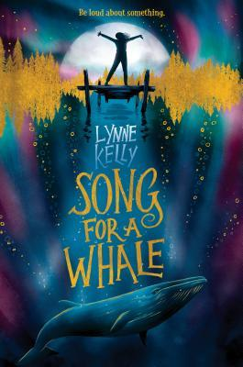Song for a Whale
By Lynne Kelly
Twelve-year-old Iris is a tech genius. She’s also the only deaf child at her school, and often gets treated like she isn’t very smart. When she learns about Blue 55, a whale who isn’t able to speak to other whales, she instantly feels as though they have a connection. Iris believes she can create a way to ‘sing’ to him; But, the whale is 3000 miles away! How will Iris ever play her song for Blue 55?
Verdict: While there are lots of board books that include sign language and plenty of biographies on Helen Keller, there are not a lot of juvenile novels that portray a deaf protagonist. This book will certainly appeal to those that feel as though they don’t fit in, readers with disabilities, the animal lovers, and the techie group! A wonderful feel-good story.
Find it: J FIC KEL

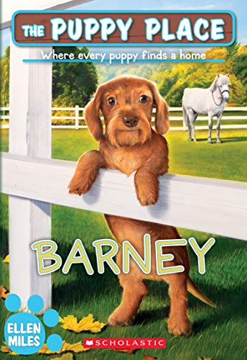Barney (Puppy Place #57)
By Ellen Miles
Lizzie Peterson is excited to watch her best friend Maria in an equestrian competition. As the horses get ready to compete, a curious dachshund races straight into the ring! When Lizzie finds that the puppy belongs to a family who is a bit overwhelmed, she decides to help them re-home Barney. But finding the perfect owners for this loud and peppy dog might not be so easy.
Verdict: This is the 57th book in the Puppy Place series, and is perfect for horse and puppy lovers alike! A short, cute story that is hard to put down. Lizzie's family fosters puppies and has lots of adventures, so if you like this book, certainly check out the other books in the series!
Find it: J FIC MIL

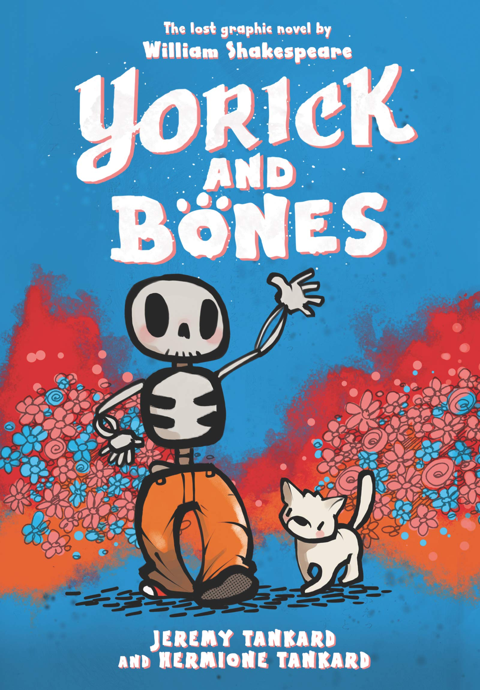Yorick and Bones
By Jeremy Tankard & Hermoine Tankard
Yorick is a skeleton who was just dug up after a few hundred years of sleep. He speaks like it too. “Forsooth, my joy, I barely can contain!” Bones is the hungry dog who did the digging. Though he cannot speak, he can chomp. What will become of these two unlikely companions? Will Yorick ever find the friend he seeks? Will Bones ever find a tasty treat that does not talk back?
Verdict: Written in Shakespearean text, the graphic novel is a fun read. Young readers will likely learn new vocabulary, like "cacophony" and "pram" as they read, and may be interested to delve into more Shakespearean works as a few other characters (Puck, Calaban, Rosencratz, Romeo) are named in the book. Obviously, Yorick comes from the famous work, Hamlet, but this is a fun play on what his life might be like if he were to suddenly arise today.
Find it: JGR TAN

Willa the Wisp
(Fabled Stables #1)
by Jonathan Auxier
Welcome to the Fabled Stables, a magical building filled with one-of-a-kind creatures. Creatures including the Gargantula, the Yawning Abyss, the Hippopotamouse . . . and Auggie. Auggie is the only human boy at the Stables, and he takes care of all the other animals. The Fabled Stables have a mind of their own, and every so often, the building SHAKES and SHUDDERS, TWITCHES and SPUTTERS—it’s making room for a new arrival! It’s Auggie’s job to venture out and rescue a new creature from mortal danger. But will he be able to complete his mission before it’s too late? With some help from Fen (a literal stick-in-the-mud) and his animal companions, Auggie saves the day and makes a new friend in the process.
Verdict: This series is great for beginning readers. It's fully illustrated with beautiful colors and features lots of interesting creatures. It's a fast read but also contains 'chapters' so you don't loose your place if you have to set it down for a bit. Any lovers of animals or fantasy will enjoy this brand new series!
Find it: J FIC AUX

Lucky Day
(Noodleheads #5)
By Tedd Arnold
Twin brothers Mac and Mac are soooo lucky. How lucky are they?
• When they get hit on the head with an acorn, they're lucky that little acorns and not big watermelons grow on trees.
• When their frenemy Meatball gives them a bag full of bees, they're lucky that Mom has just built a beehive to put them in.
• And when their watermelon DOESN'T hatch a kitten, they're lucky that there's another way to get a pet.
Verdict: From the creator of Fly Guy comes Noodleheads! These graphic novels contain several chapters all revolving around a central theme - this one is Lucky Day! The content is very silly and definitely reflects the stories that kids tell in elementary school. Every one is sure to have a laugh (or an eye roll!) with the Noodleheads.
Find it: NEW JGR ARN

