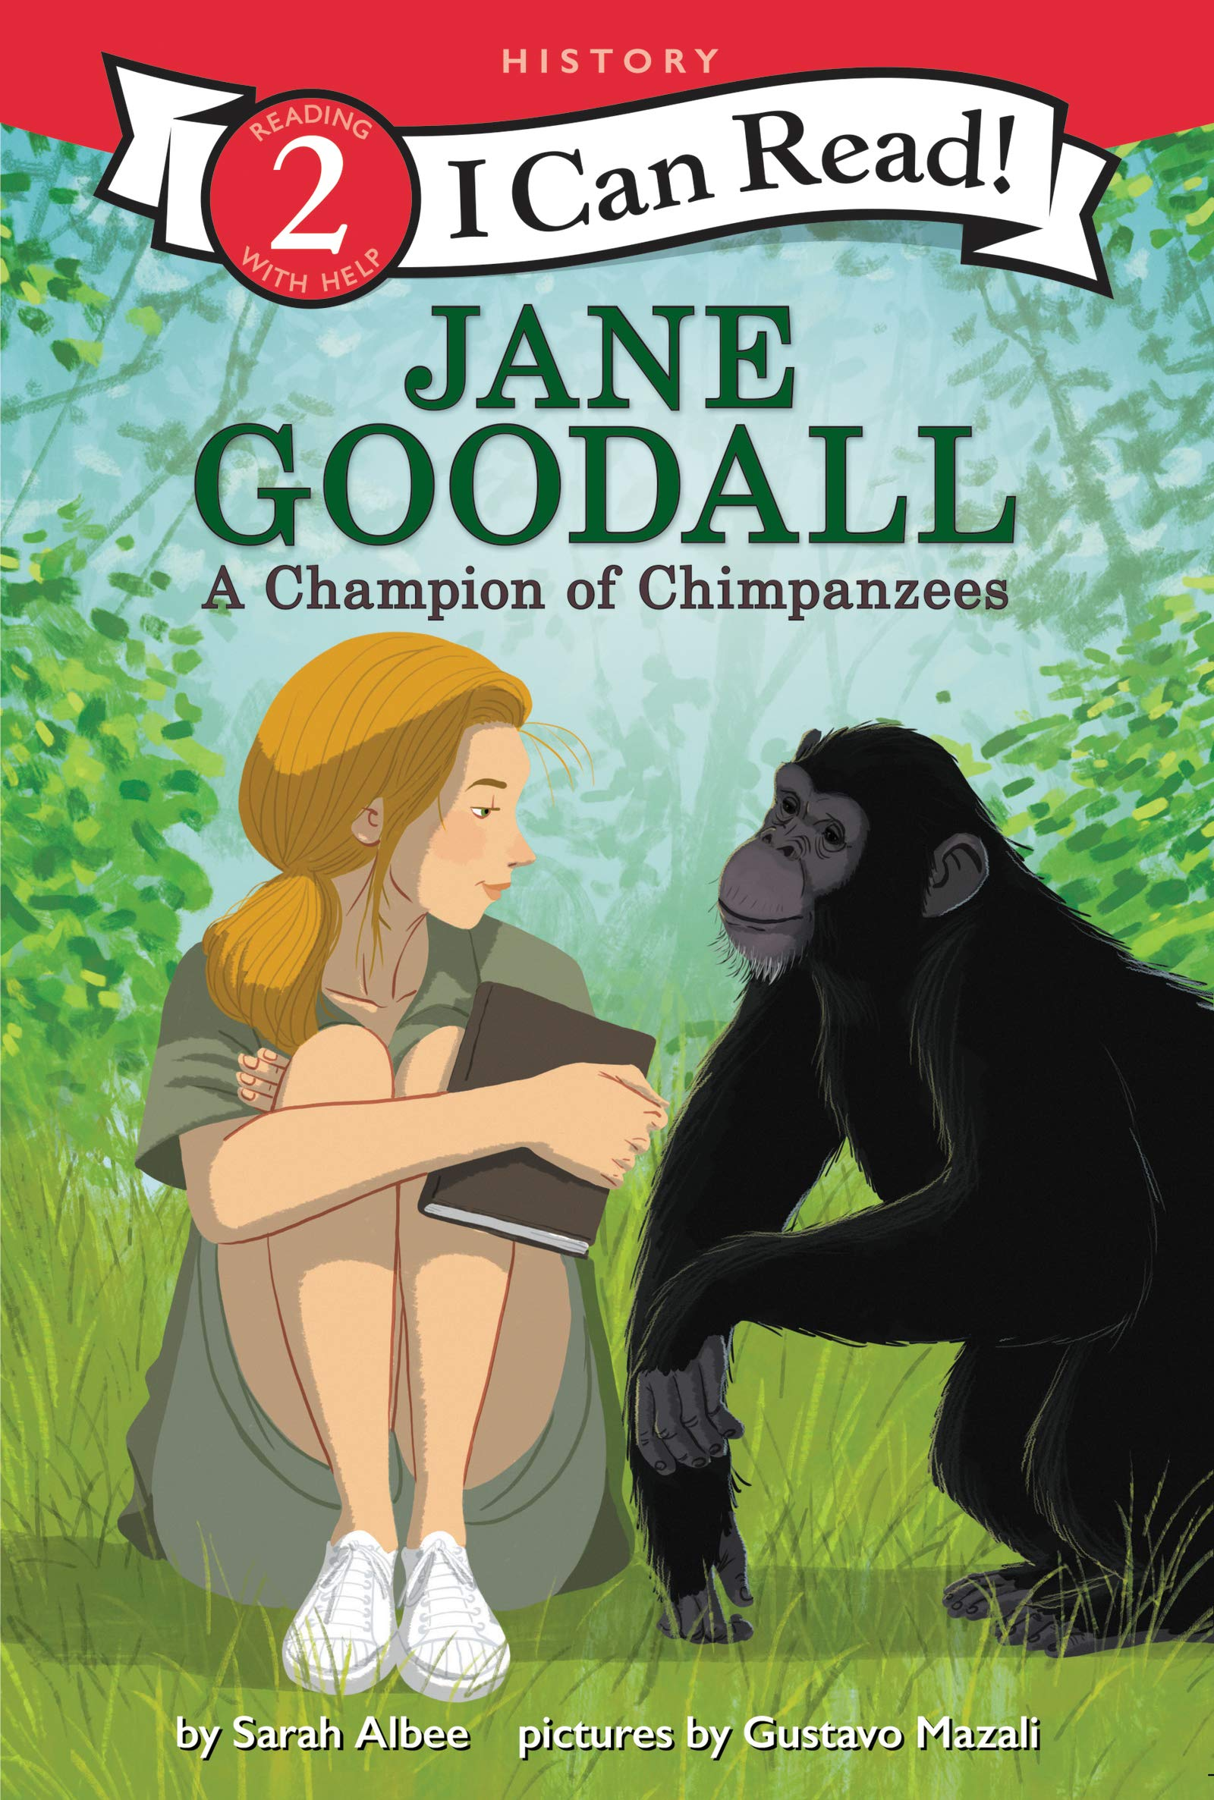Jane Goodall: A Champion of Chimpanzees
by Sarah Albee
Jane Goodall was the first person to study wild chimpanzees up close in a rain forest. She befriended the chimps and discovered amazing facts about their behaviors. What she learned forever changed how people look at these animals. This biography includes a timeline and photos all about the life of this inspiring scientist.
Verdict: Any fans Jane Goodall, animals, or chimpanzees in particular, will enjoy this Easy Reader biography. After learning about Dr. Goodall, there are facts about chimpanzees in the back, as well as additional question and answer text for further investigation.
Find it: E B GOO

Let’s Play, Crabby!
by Jonathan Fenske
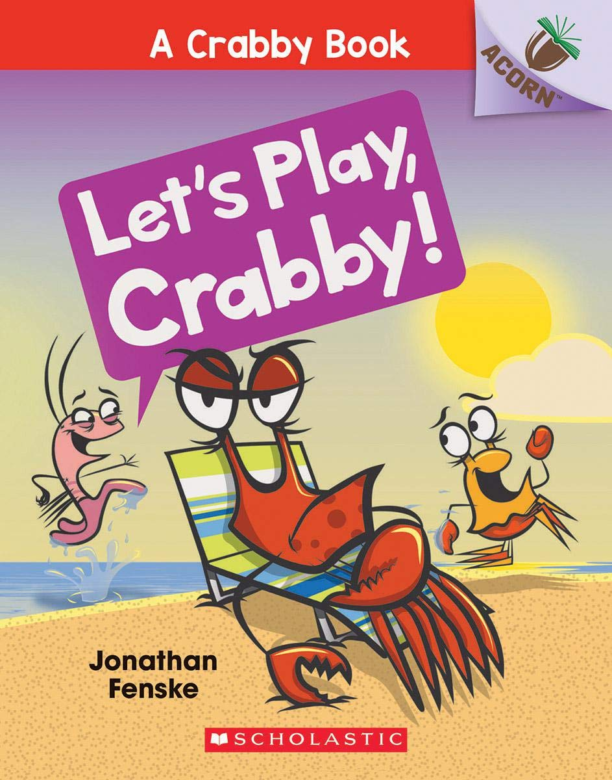Plankton wants Crabby to play a game. Plankton tries to get Crabby to play Simon Says, Tag, and Hide-and-Seek. But Crabby does NOT want to play with Plankton. Will Plankton give up? Or will Crabby finally play along? With comic speech bubbles and full-color artwork throughout, the series is sure to be a hit with new readers!
Verdict: I love the Scholastic line of books with different ‘tiers’ for different readers. Acorn is their Easy Reader line and is great as a transition before chapter books. At 44 pages, this book is longer than a lot of other easy readers, but is still simple enough for those just learning to read on their own. Most pages have more than just one line of text, but most are short sentences. Bonus: at the end, you get to learn how to draw Plankton!
Find it: E FEN

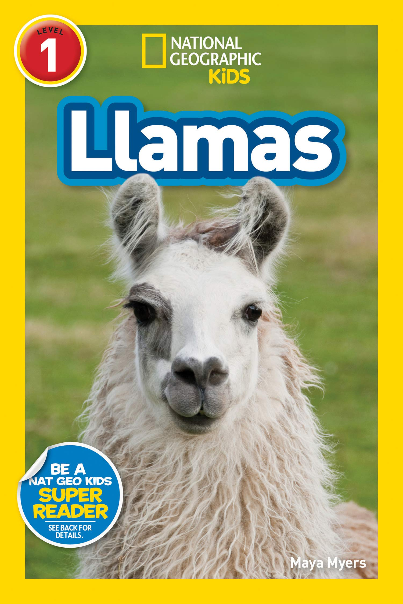Llamas
by Maya Myers
Learn all about the fascinating lives of llamas–including what they eat, where they live, how they help people, and their behavior in this new National Geographic Kids Reader. The level 1 text provides accessible, yet wide-ranging, information for beginning readers.
Verdict: Llamas are quickly becoming a new favorite animal for many, and this book will only reinforce that! This book is full of fun facts, vocabulary words, jokes, great photos, and a fun trivia game at the end. Did you know llamas can weigh up to 440 pounds? That’s just one of the many things you’ll learn if you check out Llamas!
Find it: E 599.63 MYE

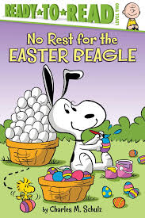No Rest for the Easter Beagle
by Charles M. Schulz
It’s almost Easter and Snoopy is exhausted! He still has lots of eggs to color and hide. When Lucy recommends that the Easter Beagle take a break, it’s up to the Peanuts Gang to color and hide all the eggs. Everyone wants to help, but are they up to the task?
Verdict: Peanuts fans will have fun with this book. Each character’s personality really comes to light as they all try to ‘help’ with the Easter eggs. Some, of course, aren’t much help at all! A cute story for Easter but could be read any time of year as a way to promote working together and how everyone is important!
Find it: E SCH

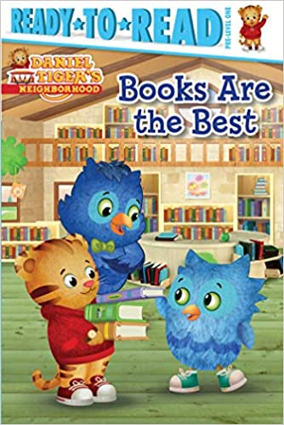Books are the Best
by Maggie Testa
It’s storytime at the library! Right away, Daniel and O find a really cool pop up-book and can’t wait for O’s Uncle X to read it to them. But as soon as Uncle X begins, O looks around and gets distracted by all of the other great books! Can O’s uncle teach him to focus on what’s special about the book they are reading at that moment before moving on to the next?
Verdict: Children familiar with the TV show will love the Daniel Tiger easy readers! I particularly like this one because the text tells a full story. Many easy readers have page after page of the same text but with a slight change in a word or a letter – this is, instead, a simply written narrative of the episode. It also comes with a moral, like most Daniel Tiger stories, of “Enjoy the wow that is happening now,” which is a great lesson for any age!
Find it: E TES

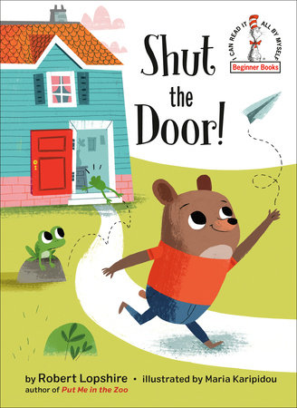Shut the Door!
by Robert Lopshire
When a little bear forgets to close the door to his house, he encounters a series of unwelcome (and untidy) visitors--including a swarm of flies, an egg-loving skunk, and a moose in search of a bath! This rhymed easy-reader by Robert Lopshire--author of Put Me in the Zoo and I Want to Be Somebody New!--is perfect for beginning readers, and its surprise ending will leave kids giggling with glee while reinforcing the message that we ALL need to be responsible for our actions.
Verdict: At first I wasn't sure about this book, but it turned out to be a fun read with a great twist at the end. As a parent, we've probably all said, "Shut the door!" or "Turn off the lights!" or something similar, and this book is an exaggerated version of what can happen when we don't! The story is longer than some easy readers so beginning readers may need helping getting through it but it's long enough to be interesting to those that are starting to transition to chapter books. Check it out for yourself today!
Find it: E LOP

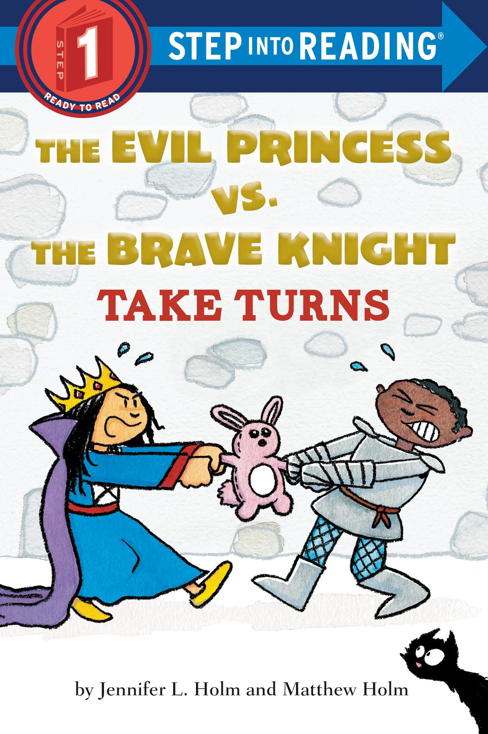The Evil Princess vs. the Brave Knight Take Turns
by Jennifer & Matthew Holm
The Evil Princess casts terrible spells, while the Brave Knight fights dragons. Could these siblings be any more different? Watch them try to learn to TAKE TURNS!
Verdict: For any parent that is tired of saying, "Can't you two just get along?" - this book is for you! It doesn't necessarily teach children how to take turns, but it does introduce the concept in a semi-humorous way. Those children that like castles, princesses, knights, and cats will enjoy this book even more!
Find it: E HOL

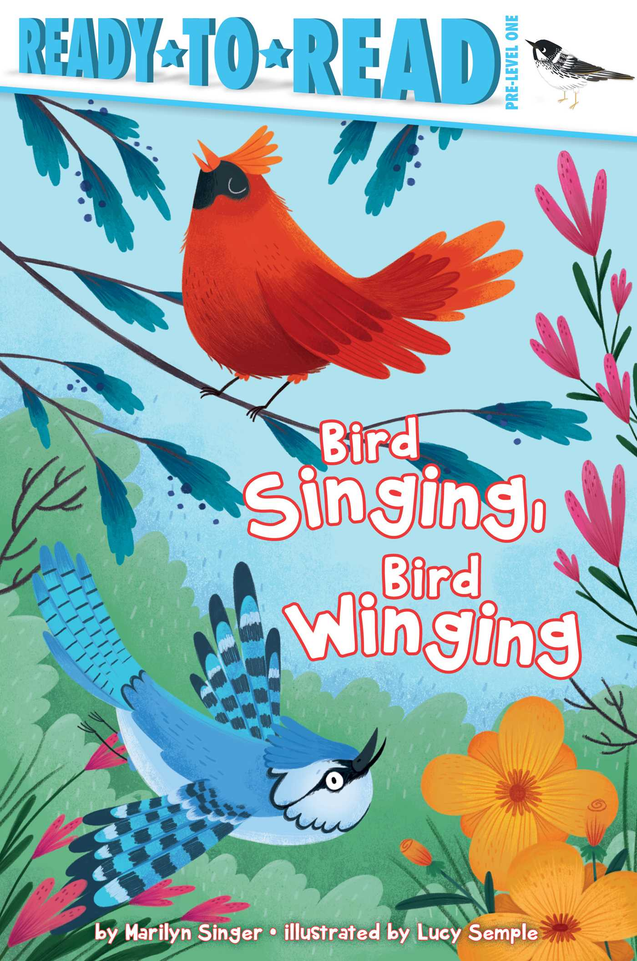Bird Singing, Bird Winging
by Marilyn Singer
See birds of all different kinds in this easy non-fiction reader. See them singing, winging, walking, talking, and so much more in this charming book that includes a special section at the back with facts on each type of bird.
Verdict: This book is a very, very elementary introduction to the life of birds. Young readers will be introduced to new vocabulary terms, like preening and lapping. For those wanting more substance, the end of the book is filled with lots of fun facts about the birds pictured in the pages of the story. Overall, a good starter book for learning about birds as children also learn to read.
Find it: E 598 SIN

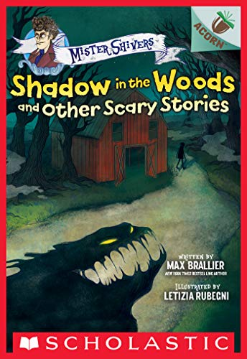Shadow in the Woods
and Other Scary Stories
by Max Brallier
What is making that strange sound in the woods? Who wrote that dark message on the wall? These five spine-chilling stories will have beginning readers everywhere begging to stay up late to read (with the light on!). With authentically scary, easy-to-read text and creepy, full-color artwork throughout, this book is perfect for young children who crave lite scares. This scary story collection from New York Times bestselling author Max Brallier is THE book to share at sleepovers or around a campfire. It will send SHIVERS down your spine!
Verdict: For children just learning to read that like scary stories, this is the series! This book is the second Mister Shivers book and is a perfect transition between traditional easy readers and chapter books. At the end of the book, you even get a drawing lesson and a writing/talking prompt!
Find it: E BRA

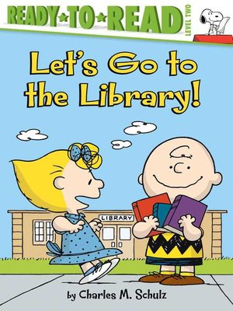
Let's Go to the Library!
by Charles M. Schultz
Sally is so excited; she is going to the library to get her very first library card. And of course her brother Charlie Brown and Sweet Babboo Linus are there with her to celebrate this big day!
Verdict: What librarian wouldn't love a book about getting your first library card? Peanuts fans are sure to enjoy following Sally on her trip and any reader will probably agree that "Happiness is having your own library card."

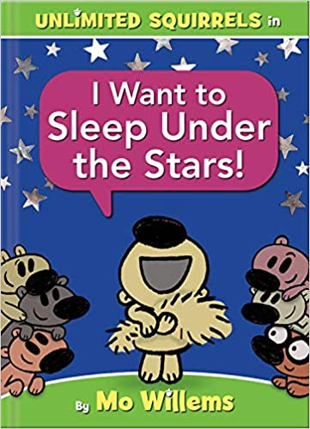I Want to Sleep Under the Stars
by Mo Willems
Zoom Squirrel dreams of sleeping under the night stars. The Squirrel pals are excited to help! But will their encouragement be enough-or too much? Do you know more about sleeping under the stars than the Squirrels do? You will by the end of this book!
Verdict: If you like the Pigeon or Elephant & Piggie books by Mo Willems, Unlimited Squirrels will keep you laughing. The series bridges the transition between easy reader and early chapter book and includes the story, jokes, and facts, as well as (my favorite part!) Emote-Acorns [acorn emoticons] that pop up when the squirrels have BIG feelings.
Find it: NEW E WIL

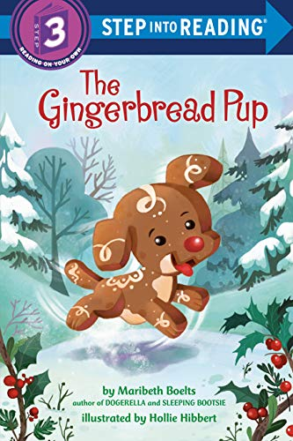
The Gingerbread Pup
by Maribeth Boelts
Evalina desperately wants a dog, so she bakes one out of gingerbread and he springs to life! But the gingerbread pup gets into mischief all over town and Evalina must find a way to catch him if she can.
Verdict: This fractured fairy tale features an adorable pup that gets into all kinds of trouble. A few twists in the story keep readers engaged and guessing what might happen next. Pair it with a classic "Gingerbread Man" book for some fun seasonal reading!
Find it: NEW E BOE

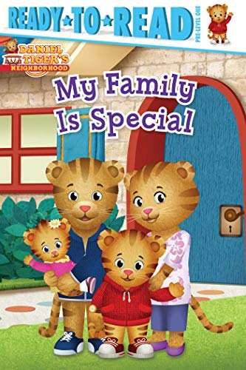My Family is Special
by Maggie Testa
Daniel and his friends spend a fun day at the library learning about what makes their families unique and grr-ific! All families are different. Find out what makes yours special!
Verdict: Based on the TV show Daniel Tiger's Neighborhood, the song from the show is echoed throughout the book: "Families are different, and that's okay!"? The book is a great introduction to why everyone's family is special, even though we may all have families that look or act a little different. Whether you live with your parents or your uncle, have orange fur or blue feathers, your whole family (and you!) is special.
Find it: NEW E TES

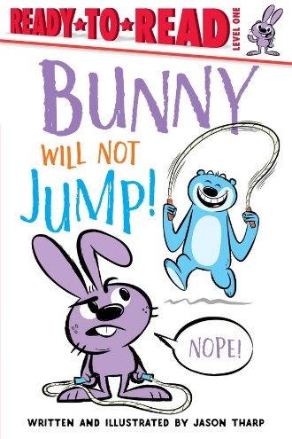
Bunny Will Not Jump
by Jason Tharp
Bunny will not jump. He usually loves jumping! But when he sees how high his friend Big can jump, Bunny does not want to jump anymore. Big just wants Bunny to do what he loves in his own way. He needs your help—by following interactive prompts in the story—to make it happen!
Verdict: Written in similar style to Elephant and Piggie (Mo Willems), Bunny and Big are good friends working through different issues. This book brings to light jealousy and differences between friends, which are inevitable. Kids will love the antics and adults will love the message. A win-win!
Find it: NEW E THA

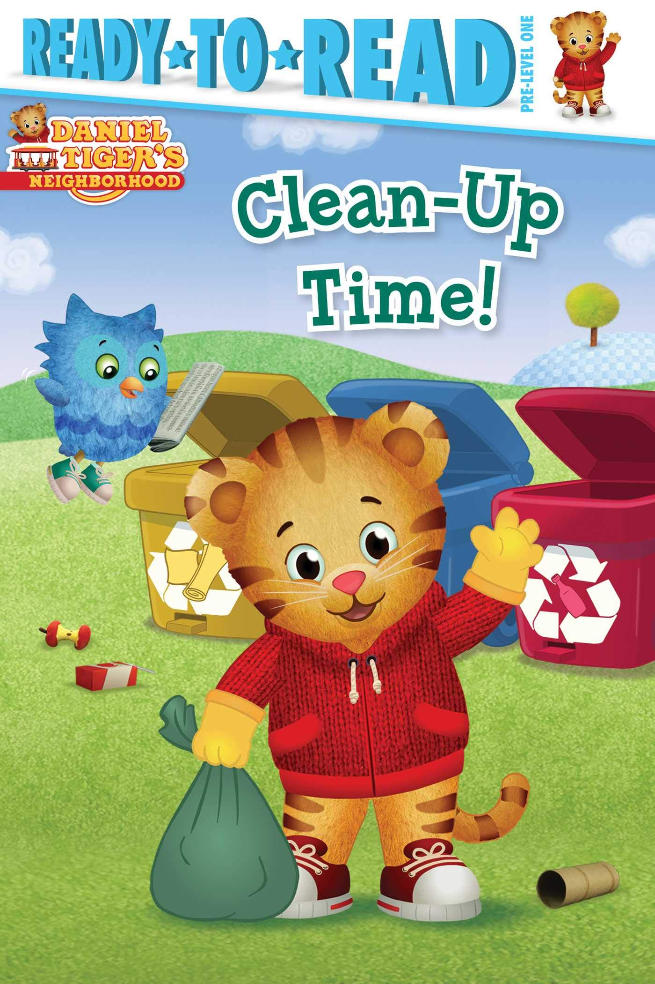Clean-Up Time
by Patty Michaels
A windstorm has made a mess of the neighborhood playground and no one can play. Everyone helps by throwing away and recycling the trash. The children learn that they can all work together to keep their neighborhood clean!
Verdict: Follow Daniel and his friends through another adventure in the Neighborhood. A particularly great choice for Earth Day, but the story isn't time-specific, so it can be a fun read any time for Daniel lovers! The story line also reinforces the narrative of work first (clean up), play later.
Find it: NEW E MIC

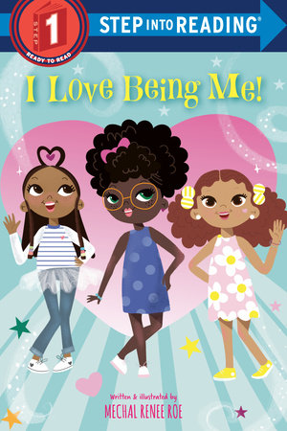I Love Being Me!
by Mechal Renee Roe
Girls will love seeing strong, happy reflections of themselves in this vibrant, rhyming, Step 1 reader about the joy of being a girl. Featuring a variety of kids and the activities they enjoy - reading, soccer, cooking, swimming, gardening, and more - this easy reader promotes girls' self-esteem, smarts, and strength.
Verdict: This book should be read by every child. Throughout the book, seven (7) diverse girls talk about what they love about themselves. It's a very positive, self-affirming book in a world that doesn't always give our children that. It's okay to be different and love who you are - that's what makes life interesting!
Find it: NEW E ROE

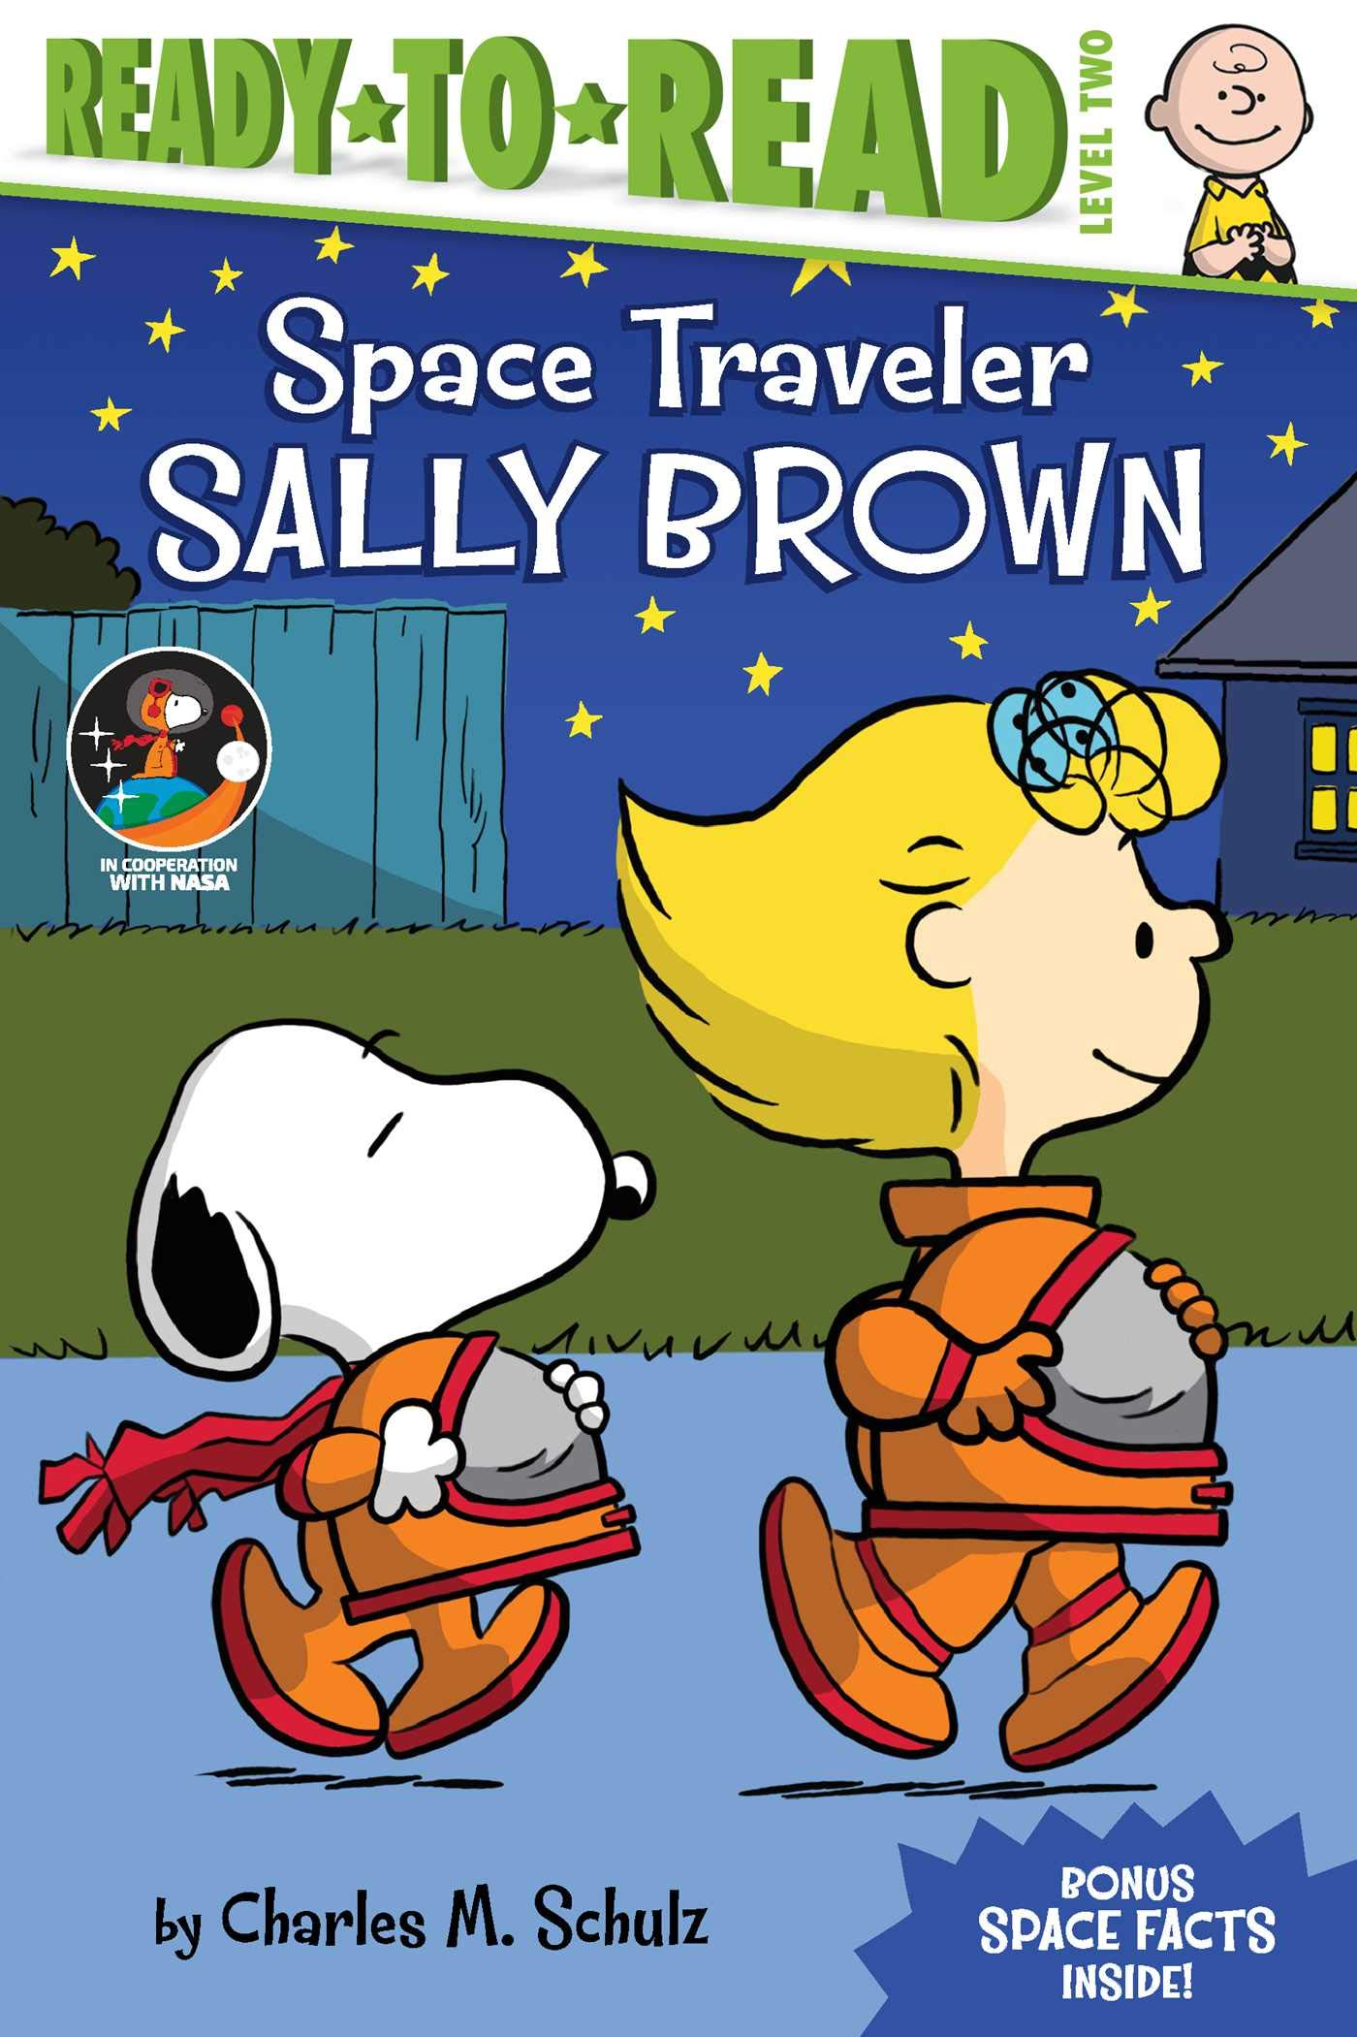Space Traveler Sally Brown
by Charles M. Schulz
Sally Brown is writing a report about Sally Ride, the first American woman in space. There’s only one thing for Sally Brown to do: Become an astronaut, too! A special section at the back of the book includes nonfiction facts about famous female NASA astronauts!
Verdict: A lot of children dream of being an astronaut one day - everything about space is so intriguing! Join the Peanuts gang as they learn about Sally Ride and other famous astronauts, including Snoopy of course. The publisher partnered with NASA to create the book, so there are lots of great facts and a few cool photos of space in the back, too!
Find it: NEW E SCH

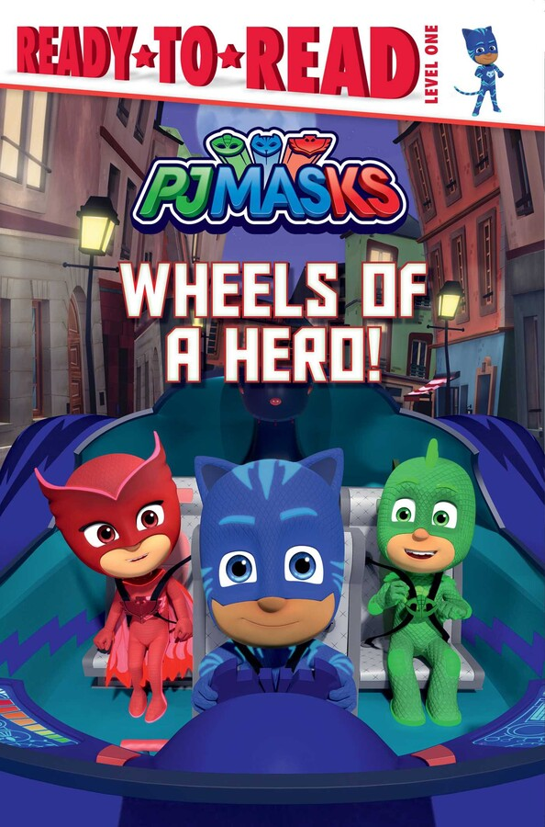Wheels of a Hero!
based on the PJ Masks TV episode
Catboy, Owlette, and Gekko track down a car thief in this Level 1 Ready-to-Read based on PJ Masks, the hit preschool series airing on Disney Junior!
It’s nighttime in the city, and someone has stolen all the PJ Masks vehicles! Will Catboy, Gekko, and Owlette be able to find them?
Verdict: Fans of PJ Masks will enjoy this adaptation of the show. Those that are unfamiliar with the series may have more difficulty since they don't know the characters as well; however, superhero fans would likely still enjoy the book.
Find it: NEW E PJ

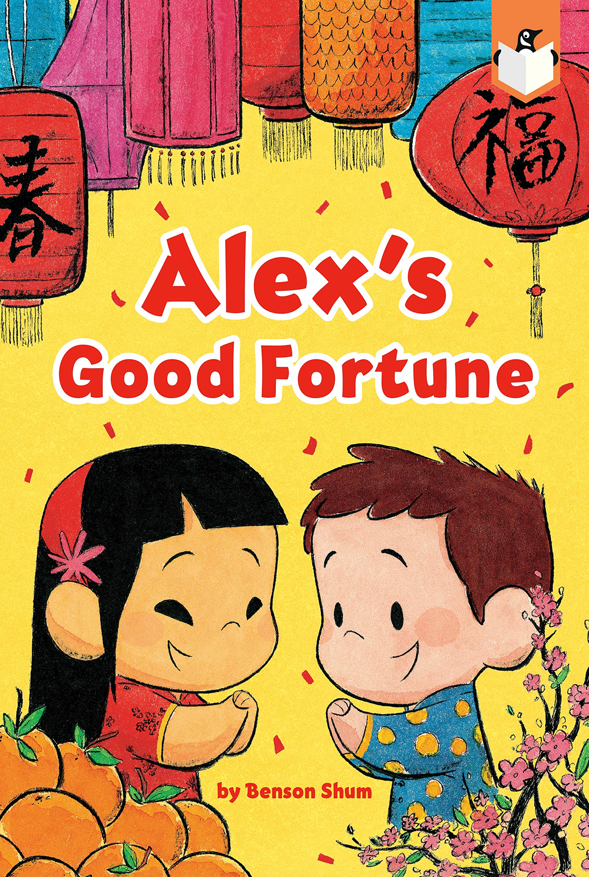Alex's Good Fortune
by Benson Shum
Chinese New Year is the most important holiday for Alex and her family, so it's even more special when she gets to share her favorite traditions with her best friend, Ethan. Together, they join the Chinese New Year parade and get to help make the dragon dance. Then they prepare for the festivities by tidying up, decorating, and making dumplings. After that, it's time to open red envelopes, eat a great big feast, and enjoy the lantern festival!
Verdict: A great introduction to Chinese New Year and the weeks-long celebration that occurs. At the end there is some information about the Chinese zodiac, which each animal represents, and also some bilingual Chinese New Year wishes!
Find it: NEW E SHU
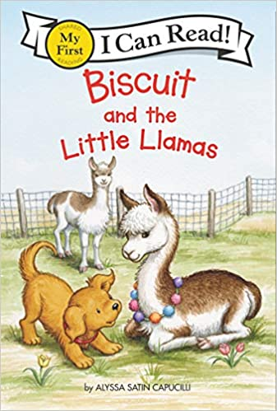

Biscuit and the Little Llamas
by Alyssa Satin Capucilli
It's spring on the farm. Join the beloved and bestselling little yellow puppy, Biscuit, as he makes friends with the piglets, the lambs, the chicks, and even the little llamas!
Verdict: A nice spring-time book featuring the beloved puppy, Biscuit, and all the farm animals. Young children will love imitating Biscuit as he "woofs" his way through the farmyard.
Find it: NEW E CAP

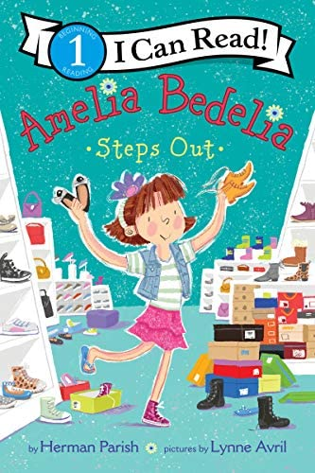Amelia Bedelia Steps Out
by Herman Parish
Amelia Bedelia and her mother need new shoes, but Amelia Bedelia adores her comfy, broken-in sneakers. But the shoe is on the other foot when Amelia Bedelia spots the perfect pair—only to find out that they belong to Mary Jane!
Verdict: Every child has to go shoe shopping at some point, and Amelia Bedelia certainly makes it comical. Good luck getting through the book without chuckling at least once!
Find it: NEW E PAR

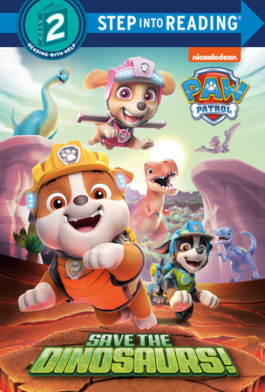Save the Dinosaurs!
PAW Patrol
PAW Patrol is on a roll! The dinosaur eggs are missing. It is up to the pups to save them.
Verdict: Nickelodeon's favorite pups are back with a BIG mission. Meet the new team member, Rex, and travel through the waterfall to the land of the dinosaurs in this fun new PAW Patrol adventure. Every dog and dinosaur lover will enjoy this easy reader.
Find it: NEW E PAW

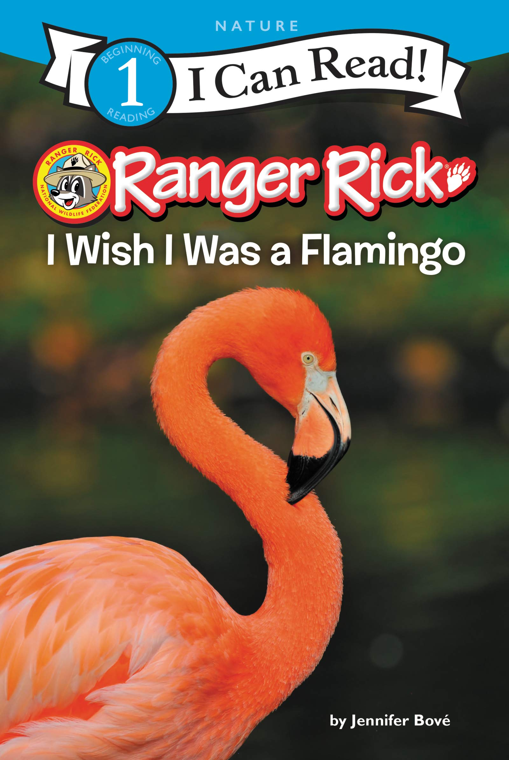I Wish I Was a Flamingo
by Jennifer Bove
What if you wished you were a flamingo and then you became one? Could you eat like a flamingo? Talk like a flamingo? Grow up in a flamingo family? And would you want to? Find out!
Verdict: Learn all about flamingos in this new Ranger Rick book. Amazing photographs span every page and bring the book to life. The end contains even more facts and a fun activity to do together.
Find it: NEW E 598.3 BOV

