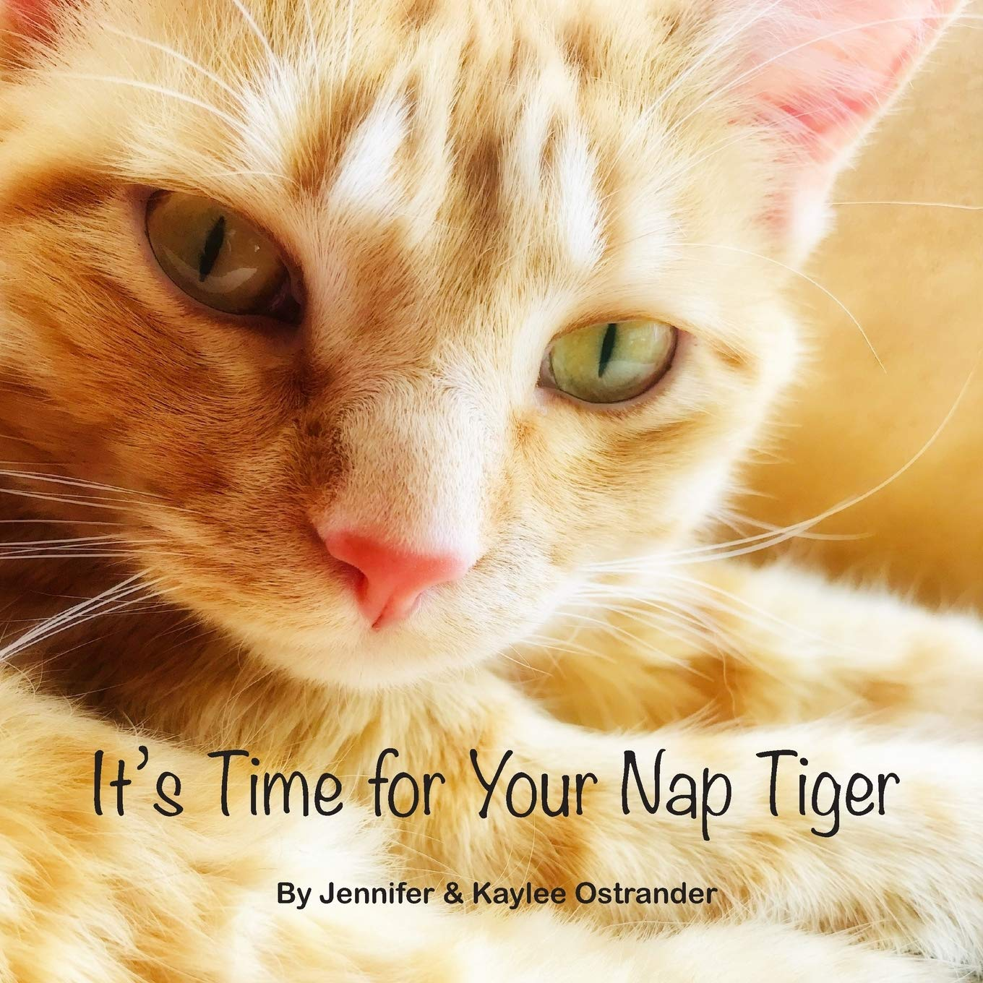It’s Time for Your Nap Tiger
by Jennifer & Kaylee Ostrander
The darling orange tabby cat named Tiger who stars in this book will do anything to avoid taking his nap. Read along in this extra cute book full of high quality photos of a real orange tabby cat to find out what finally changes his mind about his nap. It’s time for your nap Tiger!
Verdict: Cat lovers rejoice – Tiger is here! An all-too-true tale of avoiding a nap that is sure to appeal to children and adults. The dialogue between Tiger and the narrator mirrors a relationship between a young child and their caregiver. Check out this local authors’ book today!
Find it: NEW PIC OST

There Was an Old Woman Who Lived in a Book
By Jomike Tejido
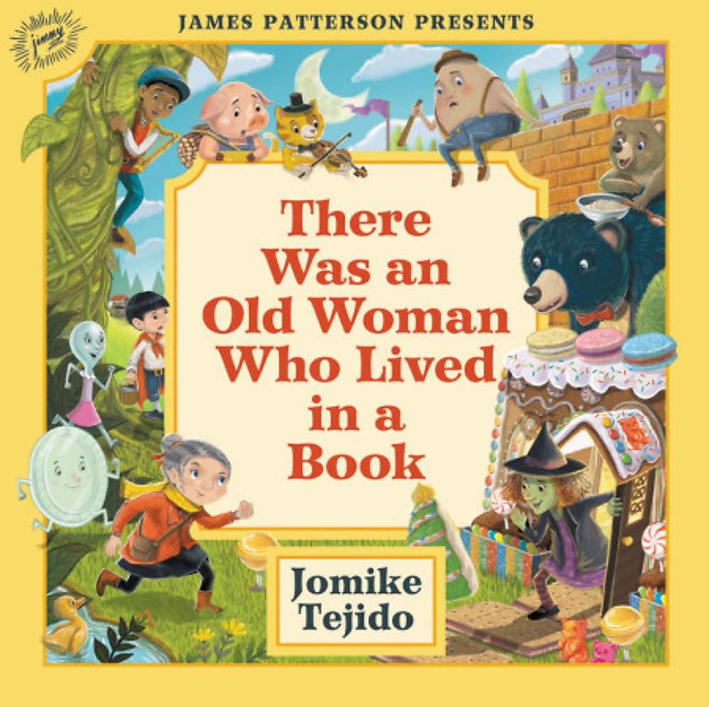The old woman has lost her children! On her journey to find them, she realizes that there is something missing from all of our favorite fairy tales and nursery rhymes! Can they find all the missing items, and the children, before it’s too late?
Verdict: A cute book if you know all of your fairy tales and nursery rhymes. Younger children who haven’t been introduced to many of these yet may have a hard time following the story. It could be a great opportunity to check out other books with these tales in them and learn all about Goldilocks and the Three Bears, Baa Baa Black Sheep, Jack and the Beanstalk, Hansel and Gretel, and many others. Older children may be able to follow the story line better having heard the various tales it references.
Find it: NEW PIC TEJ

When the Babies Came to Stay
By Christine McDonnell
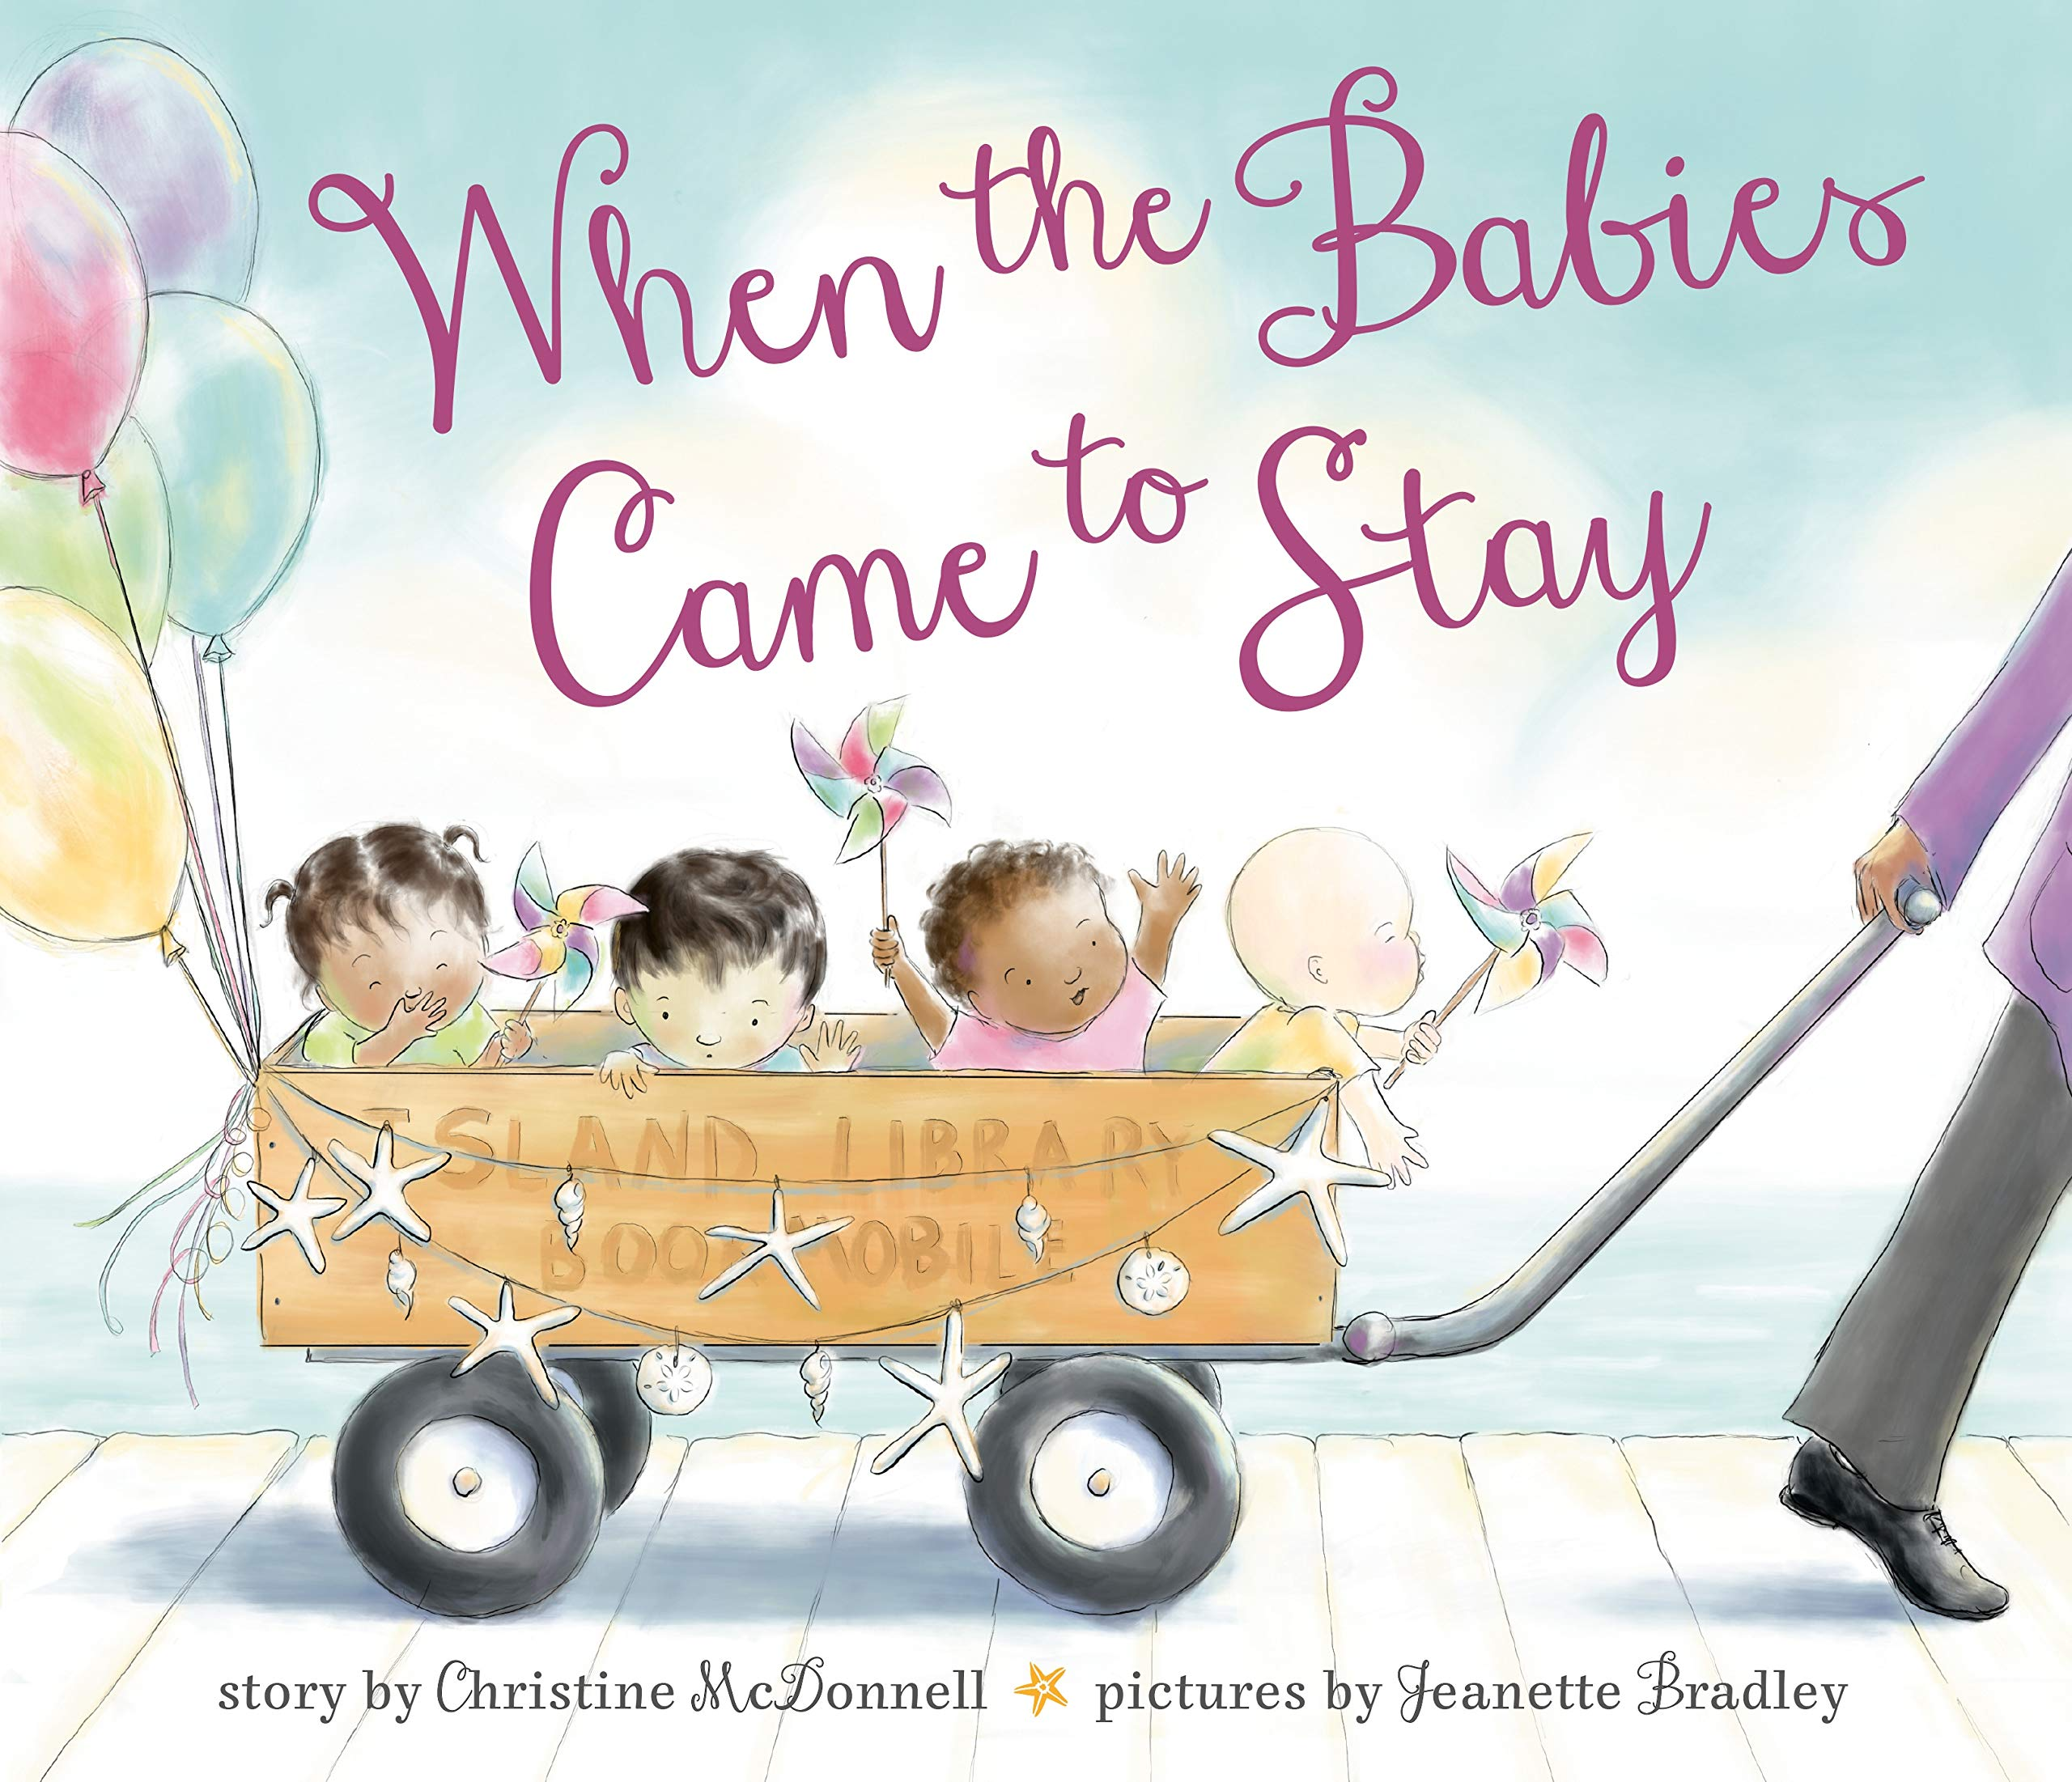“Families don’t always look alike, you know, and where we’re going is more important than where we came from.” Four little babies arrived on an island with notes pinned to their blankets. This lighthearted story tells the tale of adoption and how an island community came together to keep the four babies safe.
Verdict: A beautiful story introducing the concept of adoption, albeit in an unusual way. Other children ask why they don’t all look the same or where the came from, and the children take the questions back to their adoptive mother. Being a librarian, she normally had answers to questions, and she couldn’t have answered her children any better than she did. A great read for anyone, but especially those looking for heartwarming stories about adoption and mixed families.
Find it: NEW PIC MCD

Wild About Dads
by Diana Murray
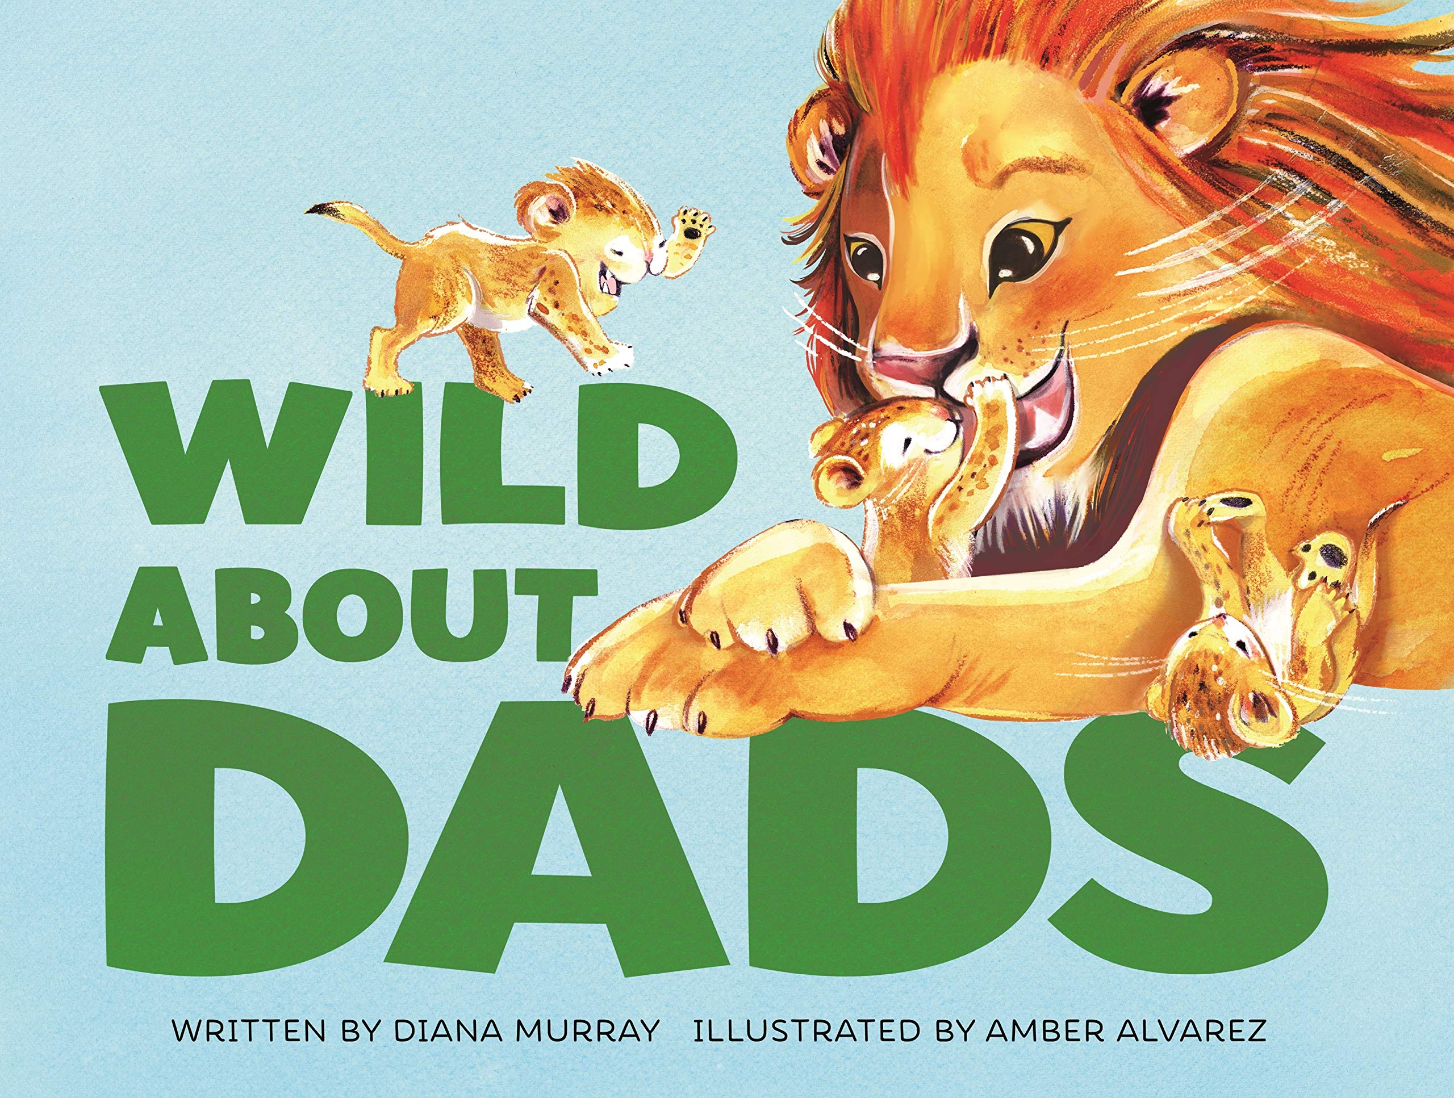Dads can help you reach up high,
and help to keep you warm and dry.
Dads are strong, dads are brave,
but sometimes dads could use a shave.
Everyone loves dads―humans, lions, frogs, prairie dogs, and even pelicans! See all these animals snuggle their little ones in this sweet, rhyming picture book that celebrates fatherhood in its many forms.
Verdict: A great book for dads of all kinds – Perfect for sharing for Father’s Day! The storyline is simple, so maybe better suited for younger readers and their caregivers, but it’s filled with lots of animals and kids will surely enjoy pointing out all the ‘babies’ and ‘daddies’ on the pages.
Find it: NEW PIC MUR

Plenty of Hugs
by Fran Manushkin
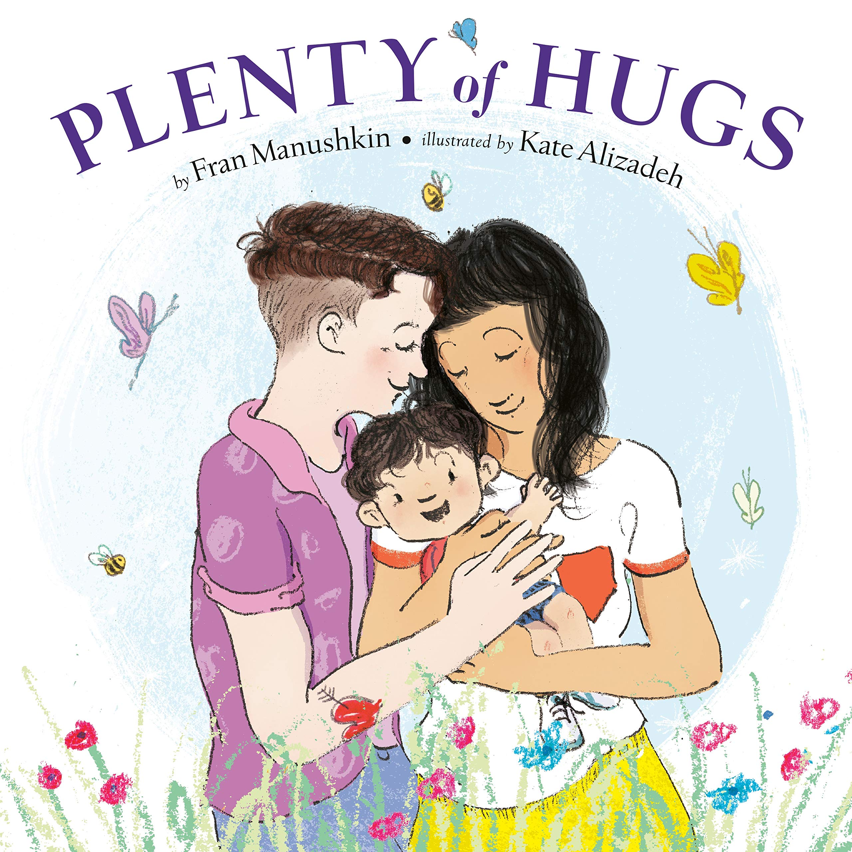This cheerful book follows a family from morning to night in lively rhyme that rolls off the tongue. There’s a buzz for each bug, and a breeze for each tree, and plenty of hugs for you and me. The toddler and mommies take a morning bike ride to a farm stand, they visit a zoo in the afternoon, and in the evening there’s the bath and storybook routine before the child is tucked cozily into bed. There are seas for ships and kisses for lips, so we can whisper I love you!
Verdict: A cute rhyming story that will be loved by any family! The story line is really a love letter from parents to their child and shows them exploring their world throughout the day. I especially appreciate the language used to describe the mommies – any my strong arms to carry you!
Find it: NEW PIC MAN

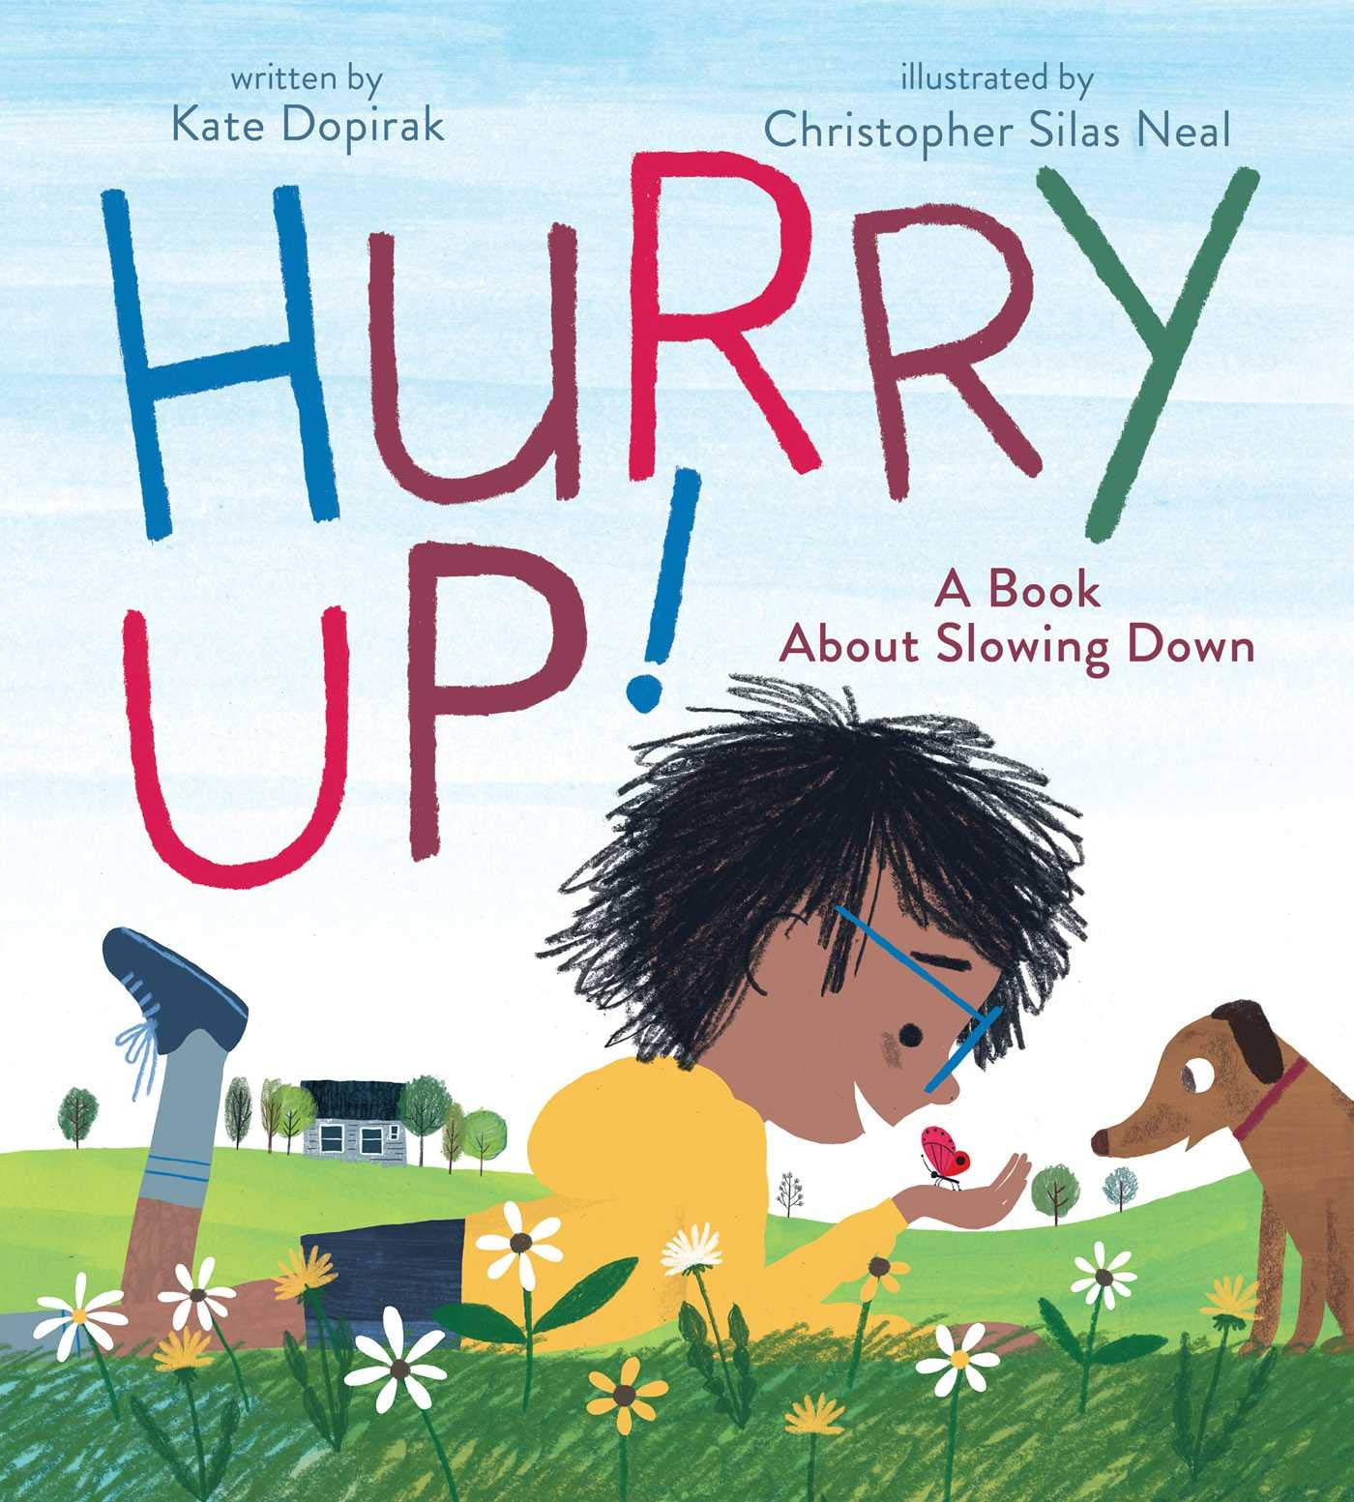Hurry Up!
By Kate Dopirak
For one busy boy, life is all hurry up, hurry down, hurry round and round and round! That is until he takes a big breath...and a big break...and slows down to see all the wonderful things in the world around him.
Verdict: A great reminder to take a step back and enjoy what's around you today. Anymore, everyone is so rushed to get to the next thing on their list that they don't stop to enjoy new flowers, playing fetch with their dog, or counting the stars. Whether your family likes to stay busy or take things moment by moment, you'll enjoy this book and the beautiful illustrations.
Find it: NEW PIC DOP

All the Way to the Top
By Annette Bay Pimentel
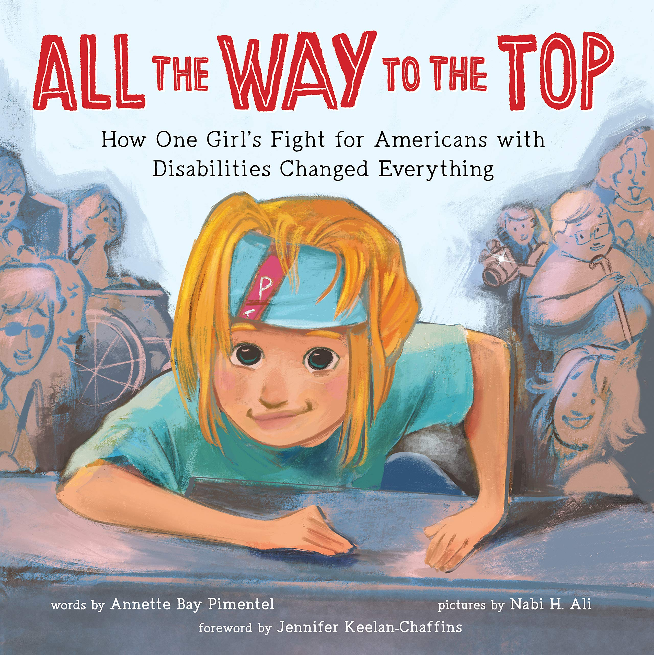Jennifer Keelan-Chaffins never wanted her wheelchair to slow her down, but the world around her was built in a way that made it hard for people with disabilities to do even simple things like go to school or eat lunch in the cafeteria. When the Americans with Disabilities Act (ADA) was proposed to Congress to make public spaces accessible to everyone, Jennifer joined activists in Washington, DC for what became known as the Capital Crawl.
Verdict: A wonderful, albeit brief, introduction to the ADA and the struggles that people with disabilities can face on a daily basis. It'd be a great picture book to share when children start asking questions about the differences they notice in people, or even better, before they start asking!
Find it: J B KEE

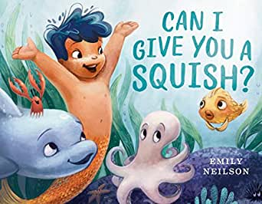Can I Give You a Squish?
By Emily Neilson
Kai loves hugs. But not everyone enjoys his "squishes," as he and his mermaid mama call them. When Kai tries to squish a shy puffer fish, the creature swells up in fright and hides! Kai feels awful - until he and his bubbly band of buddies figure out other ways to greet new friends.
Verdict: A cute story to relay the importance of asking rather than assuming. As we grow, we learn that everyone is different and likes different things. For youngsters, that can be a hard thing to wrap their head around (you mean not everyone likes the TV show I like?!?) but this book does a nice job broaching the subject! Plus, there are mermaids and all kinds of fun sea creatures!
Find it: NEW PIC NEI

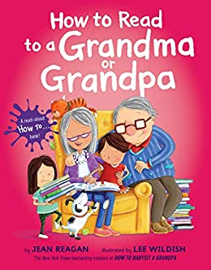How to Read to a Grandma or Grandpa
by Jean Reagan
Now that you know how to babysit your grandma and grandpa, it's time to teach them how to read with you! These kids show their grandparents how to pick out the best books, find the perfect spot to read, and which read-aloud voices to use with which books.
Verdict: A very cute book that actually does give you some ideas on how to read a book together! Reading is more fun when you use fun voices, try various voices, and turn the pages differently. Everyone is sure to love learning How to Read to a Grandma or Grandpa (or mom, or dad, or sibling...!).
Find it: NEW PIC REA

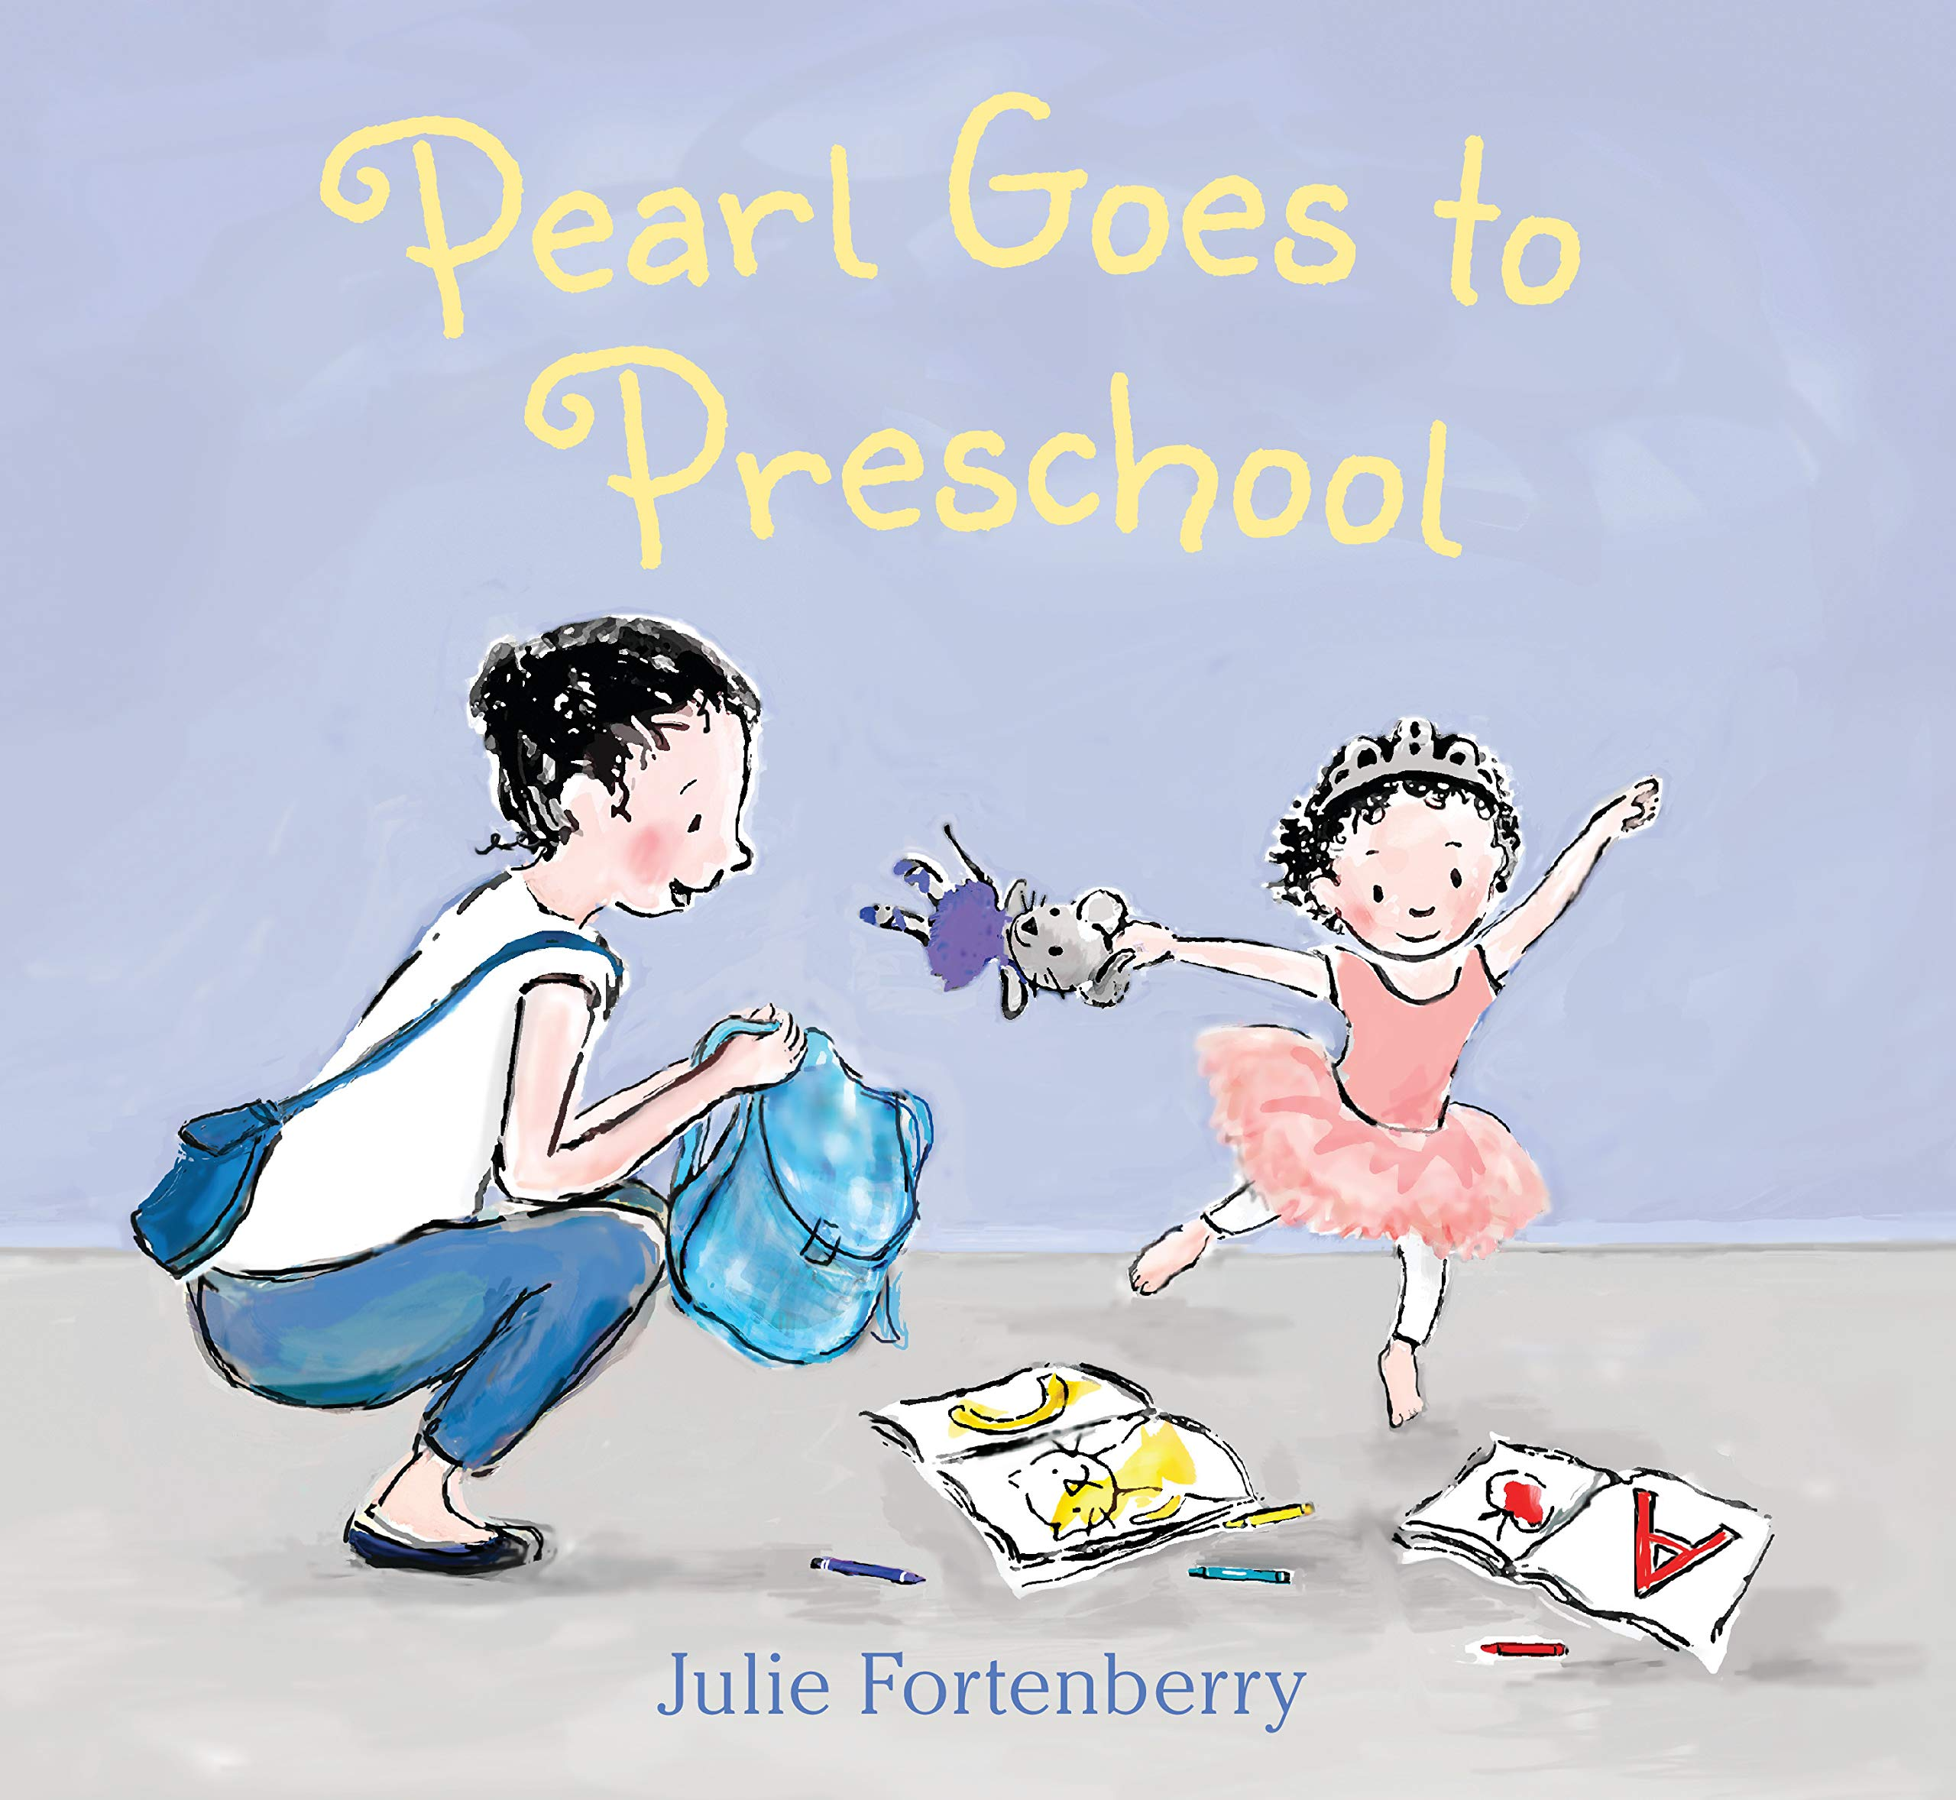Pearl Goes to Preschool
by Julie Fortenberry
Pearl loves attending dance classes at her mother's ballet school. Even though Pearl is the youngest and smallest ballerina, she knows how to count her poses and follow along. When her mom suggests that Pearl try going to preschool, Pearl has a lot of questions: What will she learn? Will there be dancing?
Verdict: A sweet story about new experiences, perfect for children that might be starting preschool this year or beginning some other new experience. Anyone who loves dance will also appreciate this story.
Find it: NEW PIC FOR

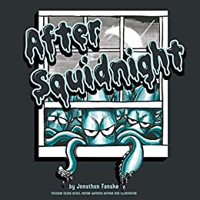
After Squidnight
by Jonathan Fenske
When the clock strikes midnight, a squad of squids creeps out of the ocean--and over to your house! Their mission? To leave their inky mark by drawing on walls, the floor, and even your toys. This rhyming tale showcases a crew of creative creatures as they make art (or maybe just a mess) and leave you to deal with the consequences!
Verdict: If your child has ever made up a crazy tale to try to get out of trouble, you'll love this book! What parent will believe that squids came in during the night to draw all over the house? Certainly not these ones! Beware – your child may use, "The squids did it!" as an excuse for months to come!
Find it: NEW PIC FEN

The Polio Pioneer
By Linda Elovitz Marshall
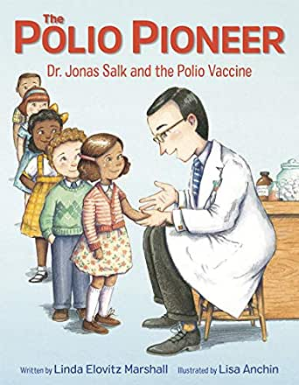Dr. Jonas Salk is one of the most celebrated doctors and medical researchers of the 20th century. In 1952, Dr. Jonas Salk invented the polio vaccine, which nearly eliminated polio from this country. For the rest of his life, Dr. Salk continued to do groundbreaking medical research at the Salk Institute, leaving behind a legacy that continues to make the world a better place every day.
Verdict: "Parents kept children away from movie theaters, sleepovers, and crowds." A very timely book discussing how a disease can change the way people live. While polio and covid-19 are very different diseases, this picture book biography is great for bridging the gap and discussing the hope of things returning to 'normal' in the future. Kids will naturally find the correlations between the feelings of then and now, develop questions, and hopefully find solace in knowing that the threat of polio was rather short-term, and, likewise, things won't always be like this.
Find it: NEW J B SAL

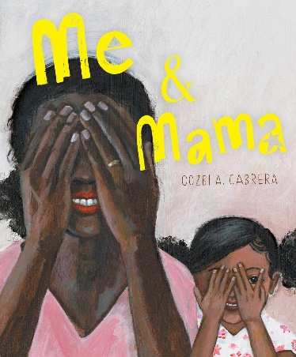
Me & Mama
By Cozbi A. Cabrera
On a rainy day when the house smells like cinnamon and Papa and Luca are still asleep, when the clouds are wearing shadows and the wind paints the window with beads of water, I want to be everywhere Mama is.
Verdict: A beautiful tribute to the special relationship between a mother and a daughter. From getting ready in the morning to laying down for bed, the text and images take you on a journey with this little girl and her Mama. Young readers will likely find a lot of similarities to their own days with their Mama.
Find it: NEW PIC CAB

Mad Mad Mad
by Leslie Patricelli
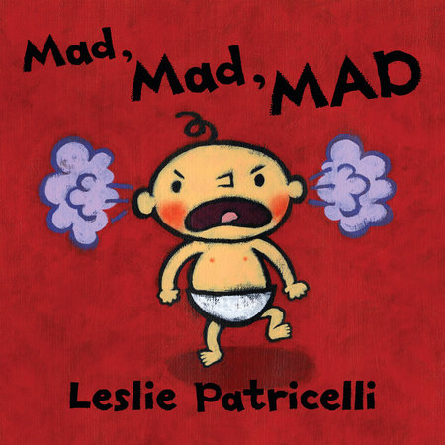Sometimes Baby is sad. And sometimes mad, mad, MAD! Baby screams and falls to the floor, and a spectacular tantrum follows, from furious crying to the final flop. What happens when Baby wants to stop, but even hugging a beloved blankie doesn't dissolve the cranky? Maybe a walkabout is in order, with some mindful breathing to boot?
Verdict: This is a great book for helping toddlers discover their emotions and start to understand how to work through those. Every child will develop their own way to cope with their feelings, whether it's by finding their beloved toy or spending some time alone, and Baby has to try a few different things in the book to find his own way to overcome the anger.
Find it: BOARD PIC PAT

All Because You Matter
by Tami Charles
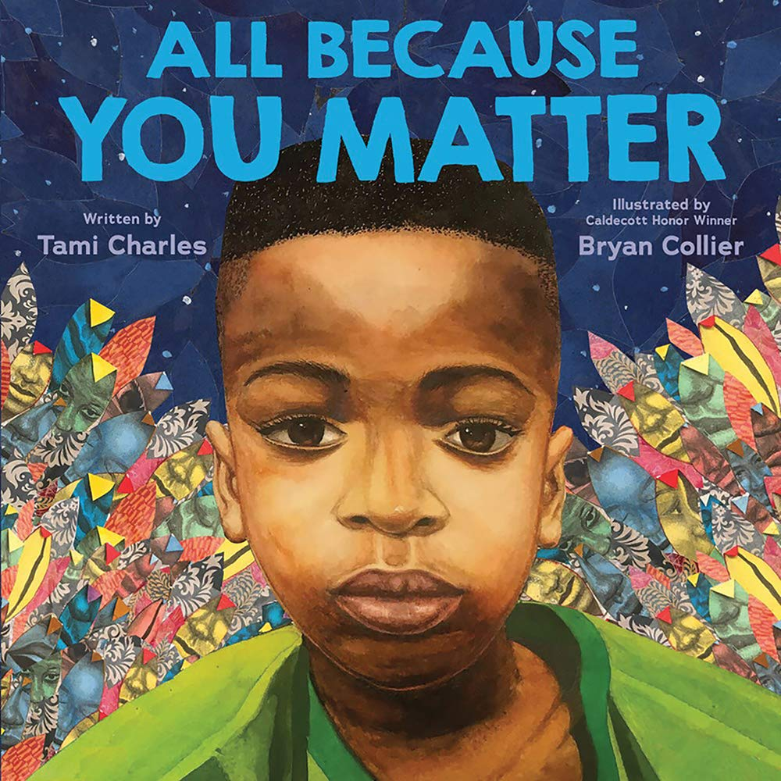A Black couple who are expecting a child begin to speak to the baby while still in the womb about how his life matters. As he grows, he sees in the pages of the story characters and images of children like him. Beautiful collages carry the messages of "you matter," not to give up despite adversity, and that "beauty and strength is within you."
Verdict: Although clearly written as affirmation for black children that they matter, this can certainly be an important read for all families. At some point, almost every child asks themselves if they "matter," and of course, the answer is always "yes!" This is a truly powerful picture book that should be revisited by every family again and again.
Find it: NEW PIC CHA

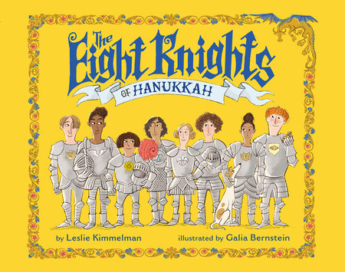The Eight Knights of Hanukkah
by Leslie Kimmelman
On the last night of Hanukkah, Lady Sadie summons her children, the Eight Knights of Hanukkah, to stop the dastardly dragon that is interrupting party preparations, using kindness and bravery. Includes notes on the traditions of Hanukkah and directions for playing the dreidel game.
Verdict: A fun spin on the eight nights of Hanukkah that introduces readers to some Jewish traditions while really exemplifying the themes of kindness and community. Full of humor and, of course, a dragon, there is something in the book for everyone!
Find it: NEW PIC KIM

Shapes
By Shelley Rotner
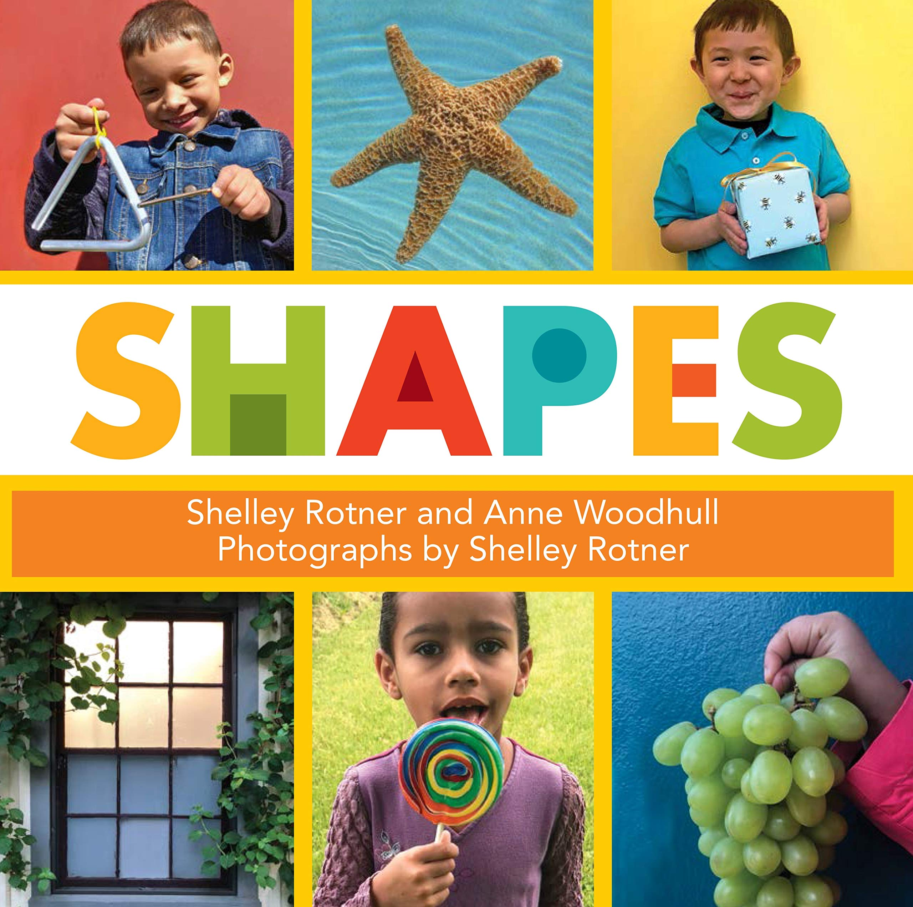Shapes are everywhere, from a small marble to the moon and stars. Each page discusses one shape and the many places it can be found. The large, vivid photographs will encourage preschool readers to point out their favorite shapes on each page.
Verdict: A great book for helping children to identify the shapes all around them. They can find circles in the sky (sun, moon), squares at the playground (hopscotch), and ovals in the kitchen (eggs). Don't be surprised if they start pointing out ALL the shapes around you after reading this book!
Find it: NEW J 516 ROT

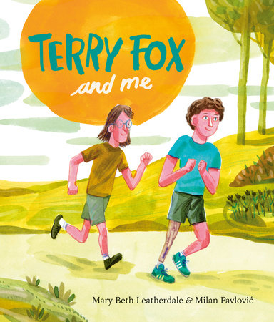Terry Fox and Me
By Mary Beth Leatherdale
Before Terry Fox become a national hero and icon, he was just a regular kid, with a friend named Doug. Doug was by Terry's side every step of the way: when Terry received a diagnosis of cancer in his leg, when he was learning to walk - then run - with a prosthetic leg and while he was training for the race of his life, his Marathon of Hope.
Verdict: A beautiful story about friendship and resilience, told from the perspective of Terry's best friend, Doug. Even if you haven't heard of Terry Fox and the Marathon of Hope, this book and it's gorgeous illustrations will not disappoint. A story worth knowing.
Find it: NEW J B FOX

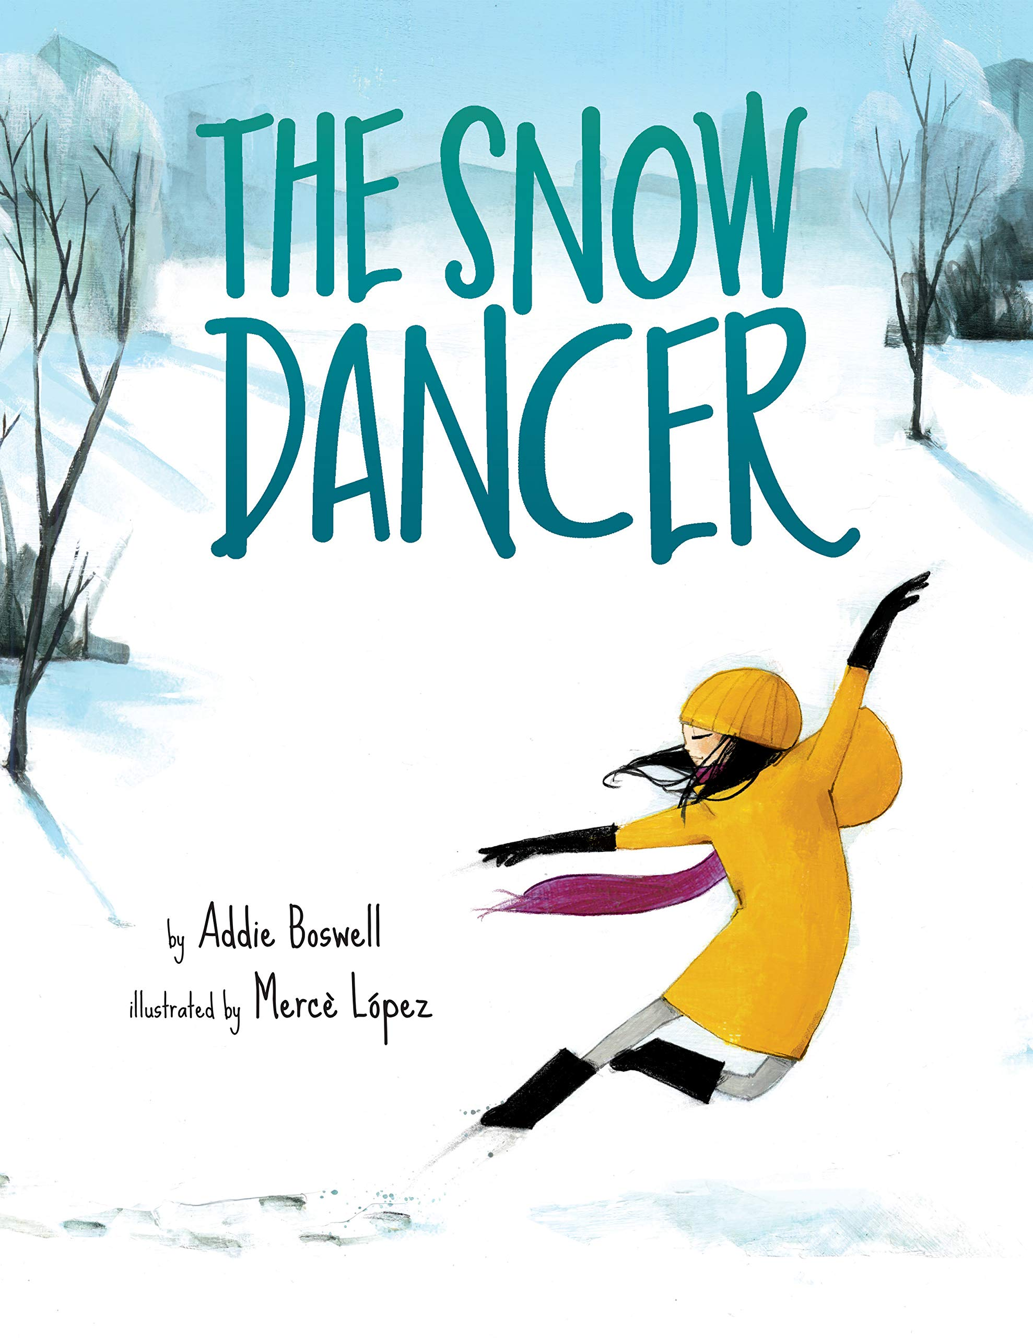The Snow Dancer
by Addie Boswell
Young dancer Sofia wakes up to a quiet, white world—it’s a snow day! She makes her way outside to the neighborhood park, where a field awaits her, white and shining and open. It isn’t long before the rest of the neighborhood wakes its sleepy head—and the other kids make their way to the park, scattering all of Sofia’s beautiful silence. But with the help of a new young friend, Sofia is ready to show everyone what a snow dancer can do on a perfect day like this.
Verdict: This book brings to life the excitement of a snow day! The fresh fallen snow, making those first tracks, sledding, snowball fights, and of course, hot cocoa to end the adventure. It'd be the perfect book to share after your own snow day adventure.
Find it: NEW PIC BOS

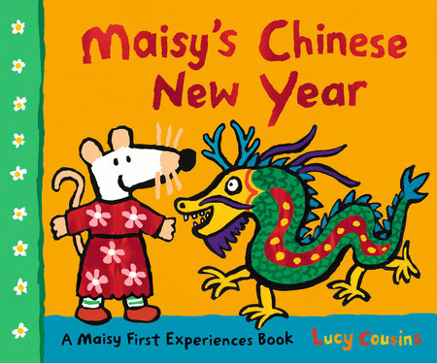Maisy's Chinese New Year
by Lucy Cousins
Tomorrow is Chinese New Year, and Maisy’s friend Tiger is coming home for the occasion. Hooray! Tiger has brought some beautiful gifts, some with a special symbol that means good luck. Maisy has asked all her friends to her house to celebrate with a delicious feast, and Penguin and Ostrich are handing out lucky red packets with money inside. Now it’s time for Tiger to tell the story of Chinese New Year, while everyone stays up late for fireworks. But the best is to come on New Year’s Day, when Maisy and all her friends take part in a dragon dance!
Verdict: Chinese New Year is always fascinating for kids - from the bright colors to the large dragon in the parade. Learn a little bit more about it in this new book with beloved Maisy. The 2021 celebration of Chinese New Year is on February 12th.
Find it: NEW PIC COU

Alone Together
By Julia Seal
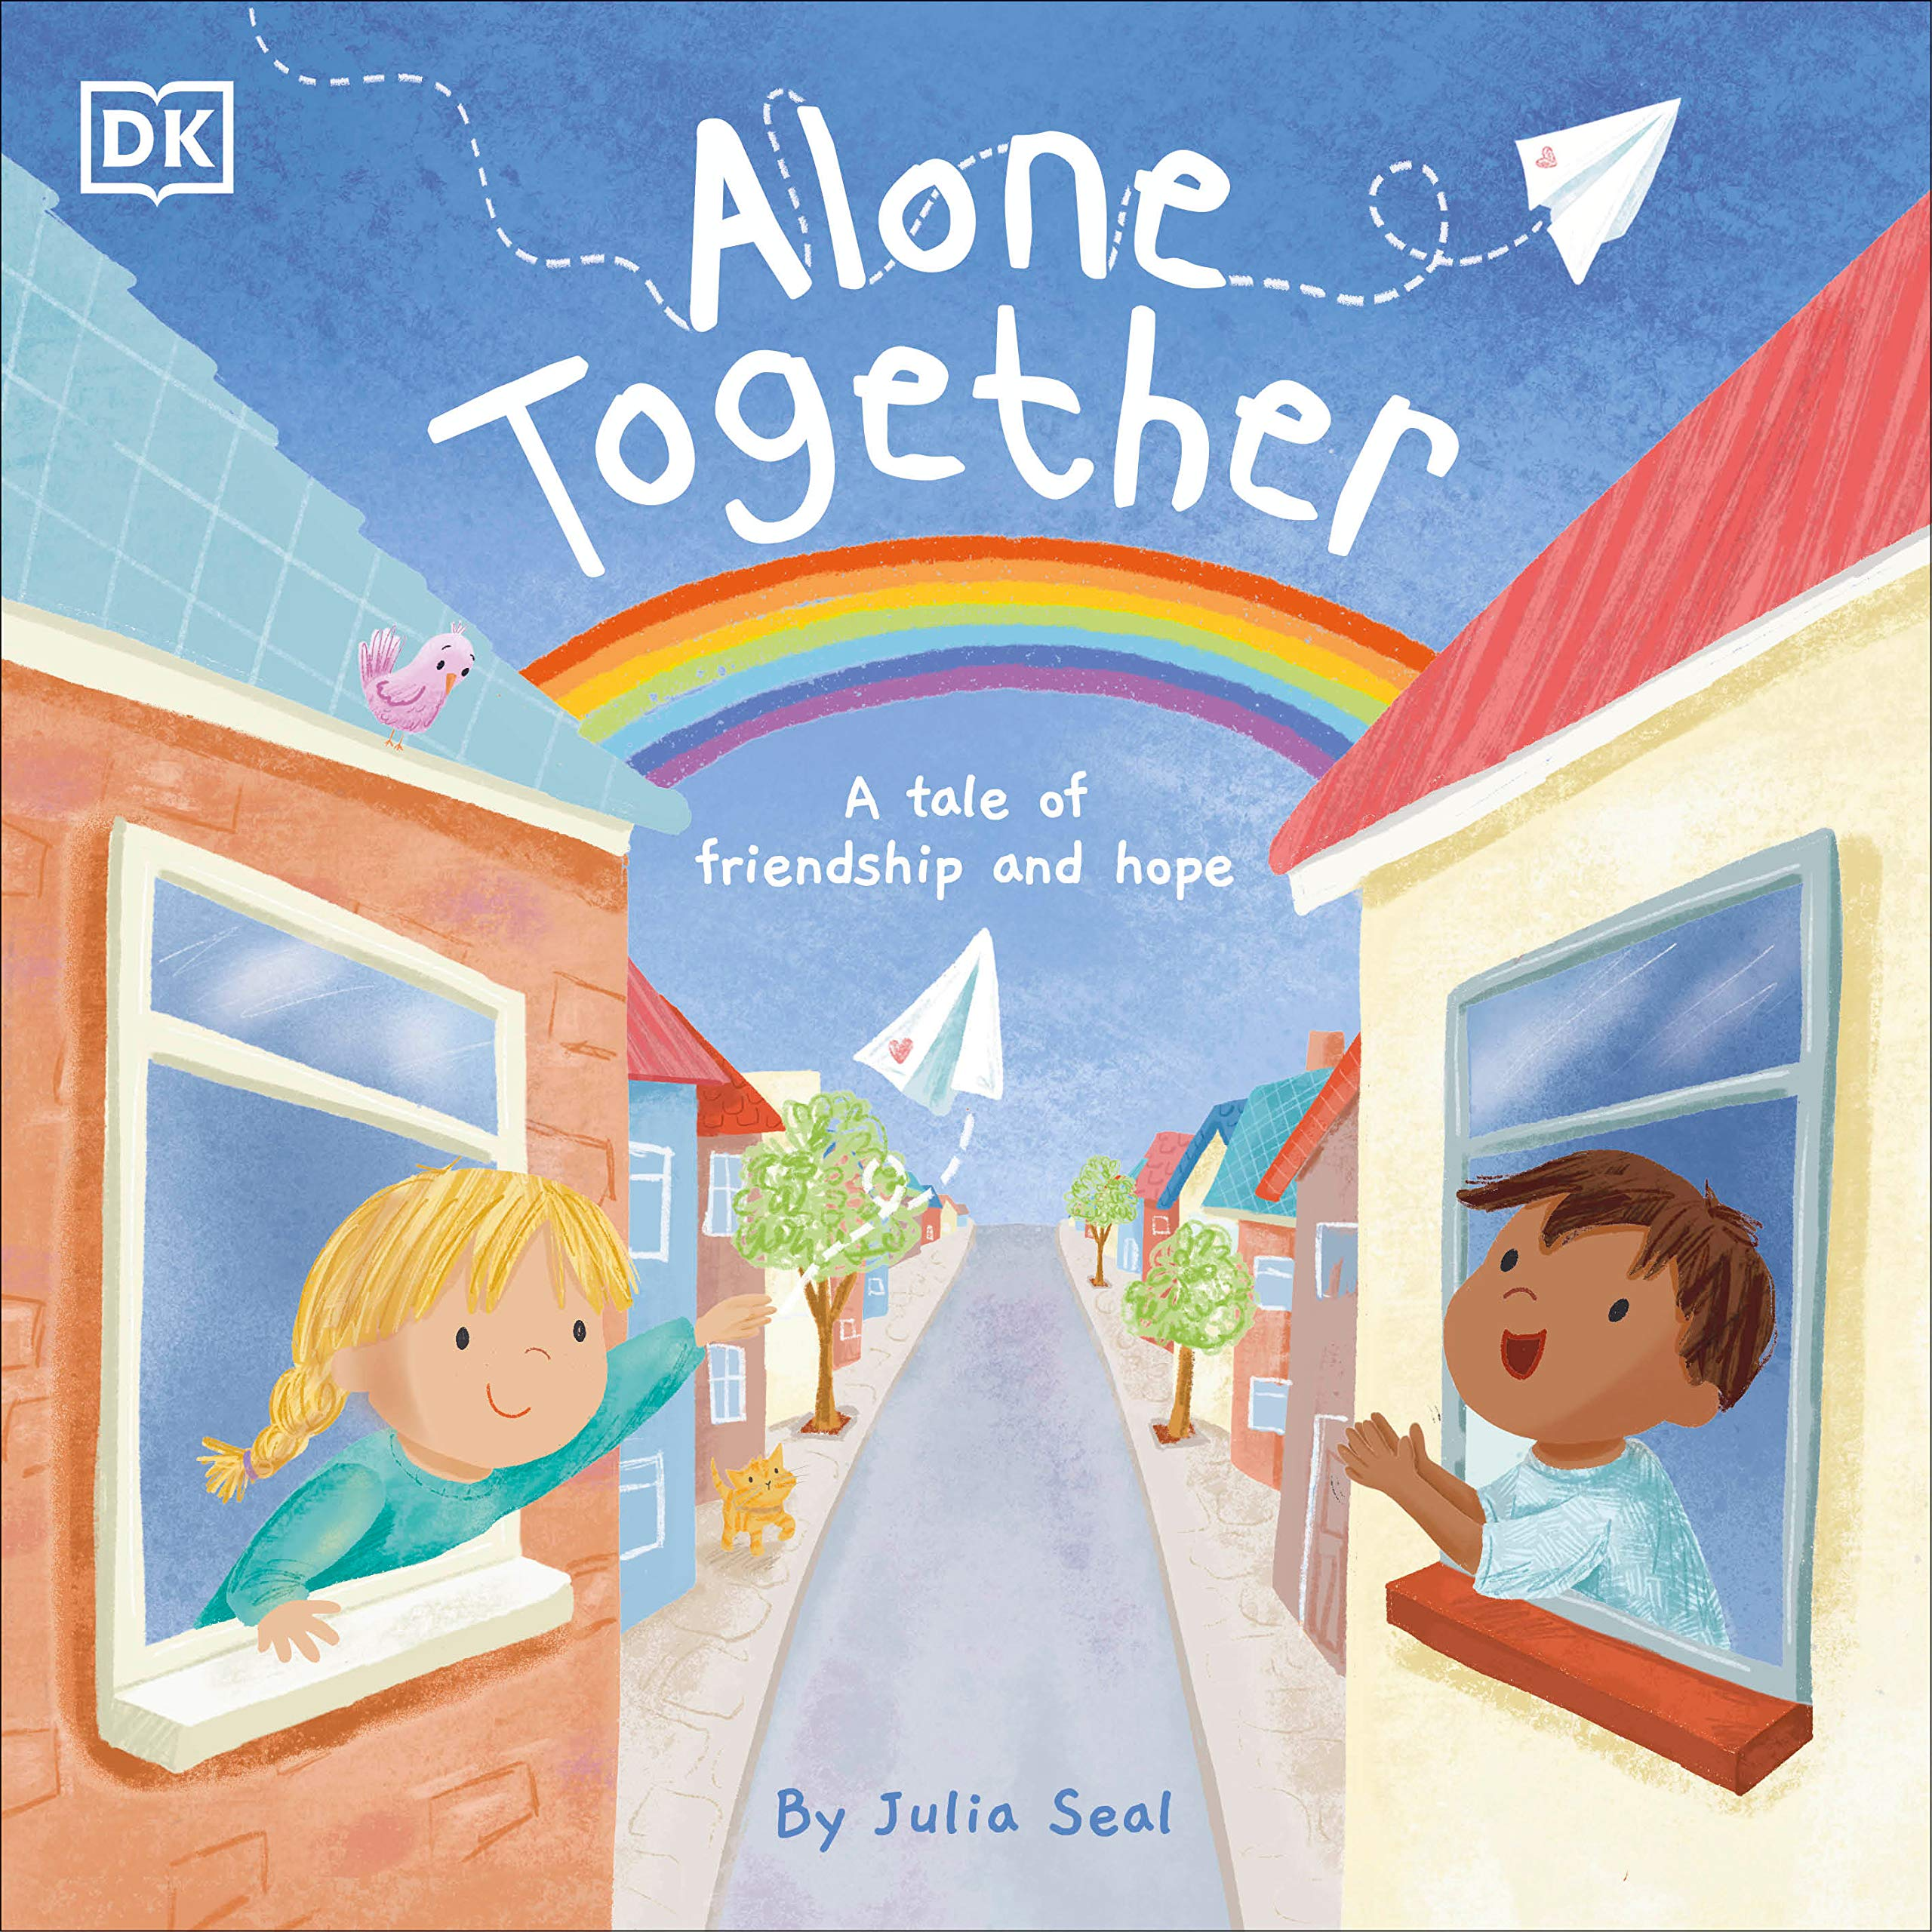Having to stay home can be confusing and lonely for children. This heart-warming story by author-illustrator Julia Seal highlights the importance of friendship and community during these challenging times. The beautiful illustrations and message of hope will help children see the power of togetherness, and understand that even though we might feel like we're alone, we're alone together.
Verdict: This book was obviously written in the midst of the coronavirus pandemic with stating at home and social distancing in mind, but could easily be used for any time a child has to stay home - maybe someone in the family is sick or there is bad weather. It focuses on the children's feelings and what we CAN do instead of being sad that we can't do what we normally would.
Find it: NEW PIC SEA

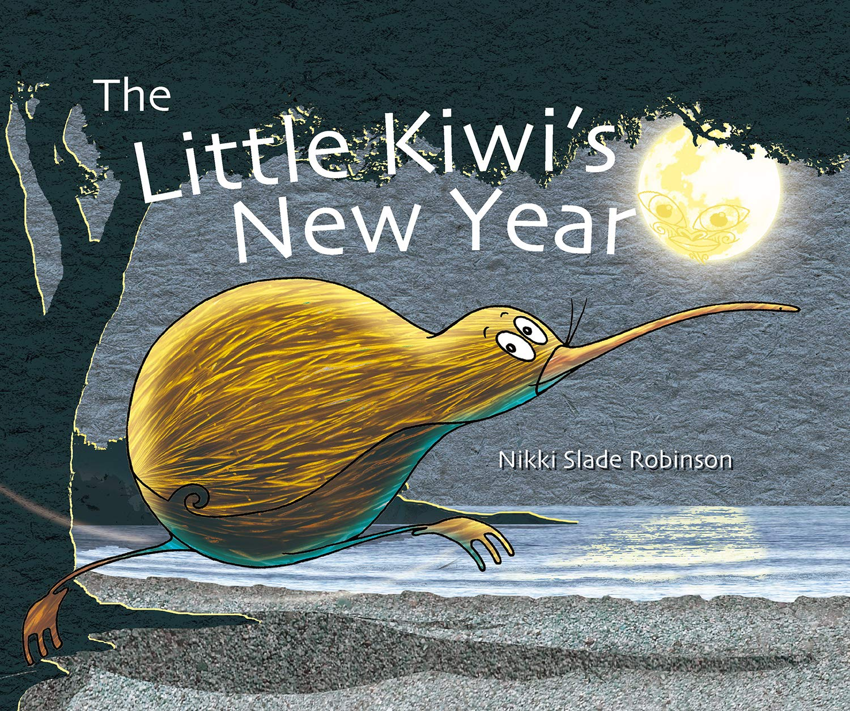The Little Kiwi's New Year
By Nikki Slade Robinson
The Maori New Year is a time for celebrating, food and family. A little Kiwi in the New Zealand coastal bush wakes up in the middle of her sleep because she can feel it coming. One by one, she runs to her friends to wake them up so that they can spend the Maori New Year together.
Verdict: Travel to New Zealand to learn about the Maori New Year with Little Kiwi and her friends.
You'll be introduced to several interesting animals that live in New Zealand and the Pleiades (Seven Sisters) constellation. There isn't a lot of information about the holiday itself, but it's still a fun introductory book from another culture!
Find it: NEW PIC ROB

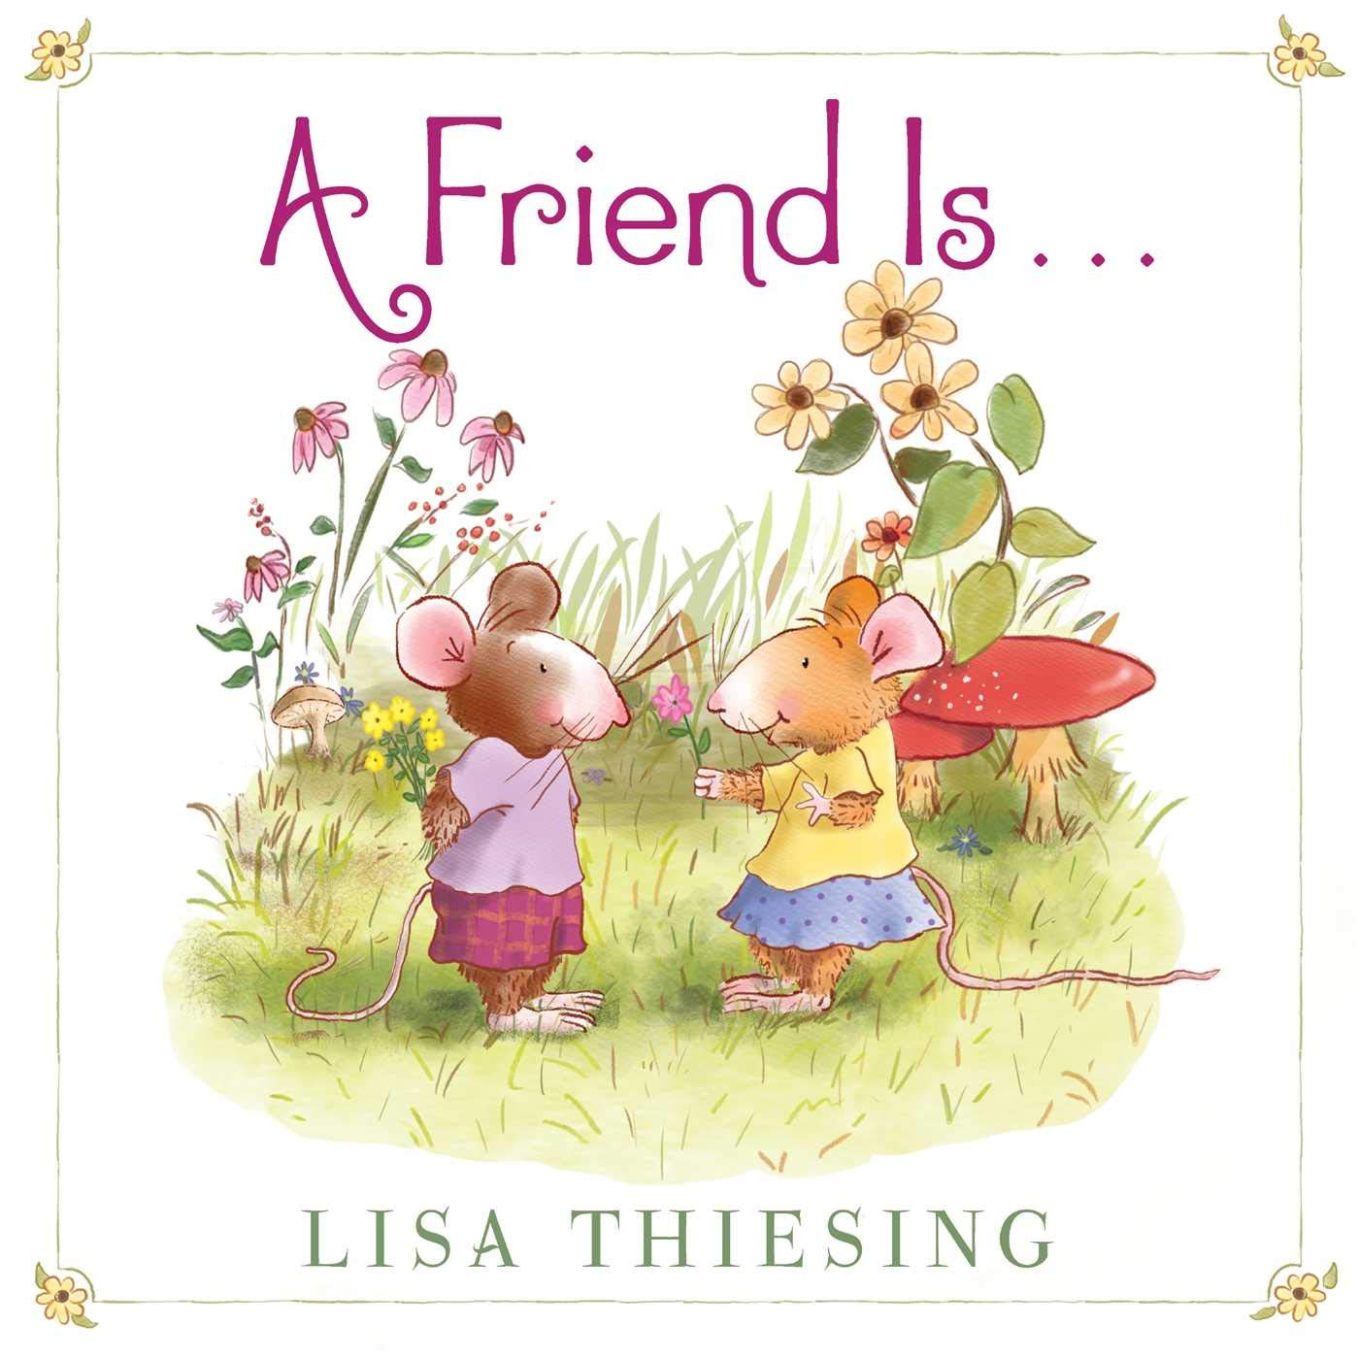A Friend is..
by Lisa Thiesing
For many reasons and through many seasons, people need friends in their lives. Whether sniffing a sweet flower or star gazing, building a snowman or jumping into a pile of leaves, ice skating or playing hide and seek…who better to share everything with than a friend?
Verdict: A cute, short story about what it means to be a friend. What the book lacks in text, it more than makes up for in illustrations as the friends navigate every season together. Maybe you'll even get an idea for something new you can do with friends in the coming year!
Find it: NEW PIC THI

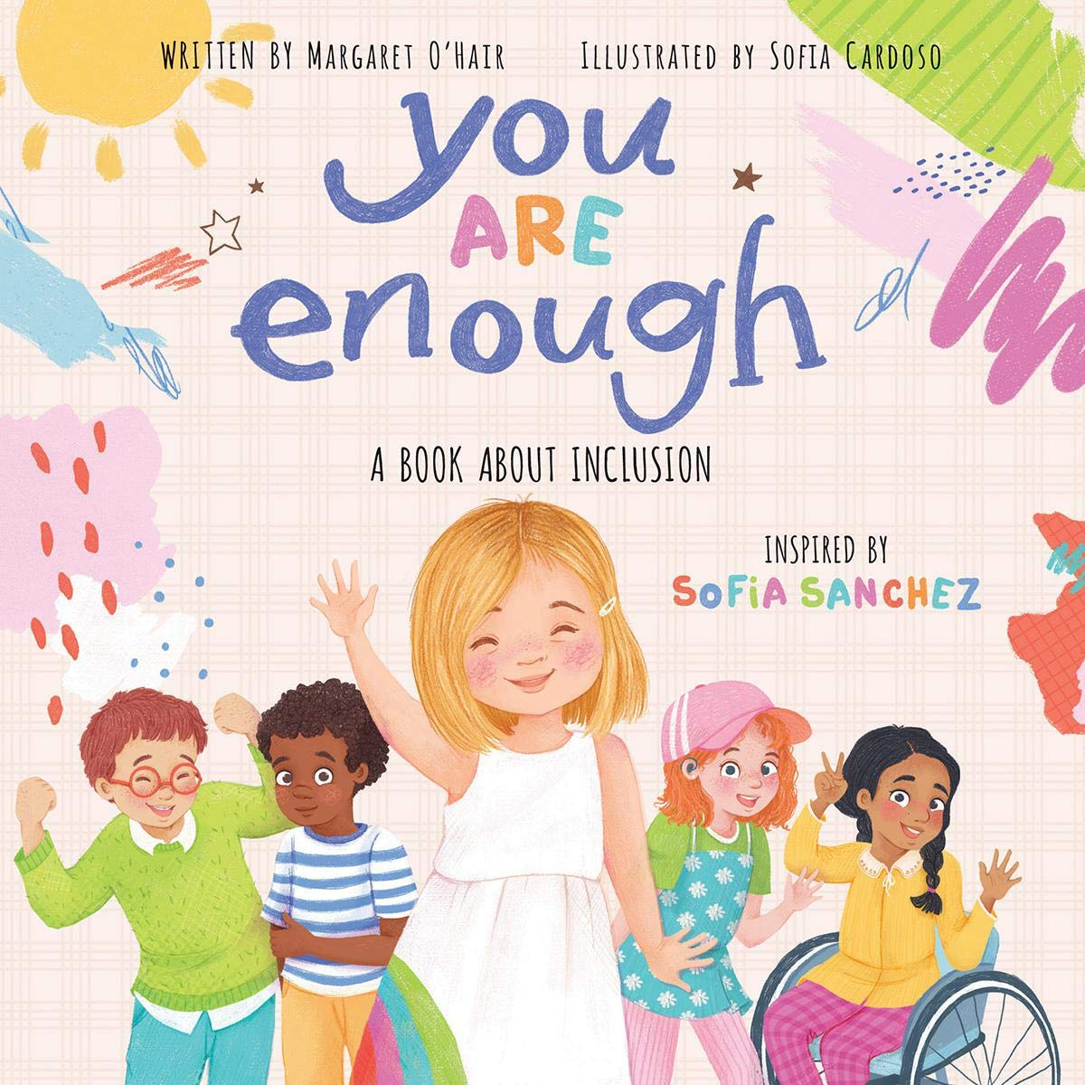You Are Enough
by Margaret O'Hair
It can be hard to be different - whether because of how you look, where you live, or what you can or can't do. But wouldn't it be boring if we were all the same? Being different is great! Being different is what makes you YOU.
Verdict: A beautiful picture book for every child. The book features diverse children of all abilities and skill sets, and discusses the importance of being different and loving yourself. Everyone should read this!
Find it: NEW PIC OHA

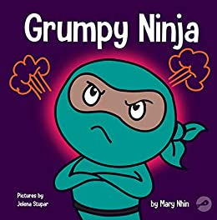Grumpy Ninja
by Mary Nhin
Life is hard! And it's even harder for children who are just trying to figure things out.
The new children's book series, Ninja Life Hacks, was developed to help children learn valuable life skills. Fun, pint-size characters in comedic books easy enough for young readers, yet witty enough for adults.
Verdict: We just added 17 new Ninja Life Hack books to the collection and they are all great! Perfect for ninja lovers or families that are working on social-emotional learning, each book gives advice on how to handle different emotions and situations.
Find it: NEW PIC NHI

Raindrops to Rainbow
By John Micklos Jr.
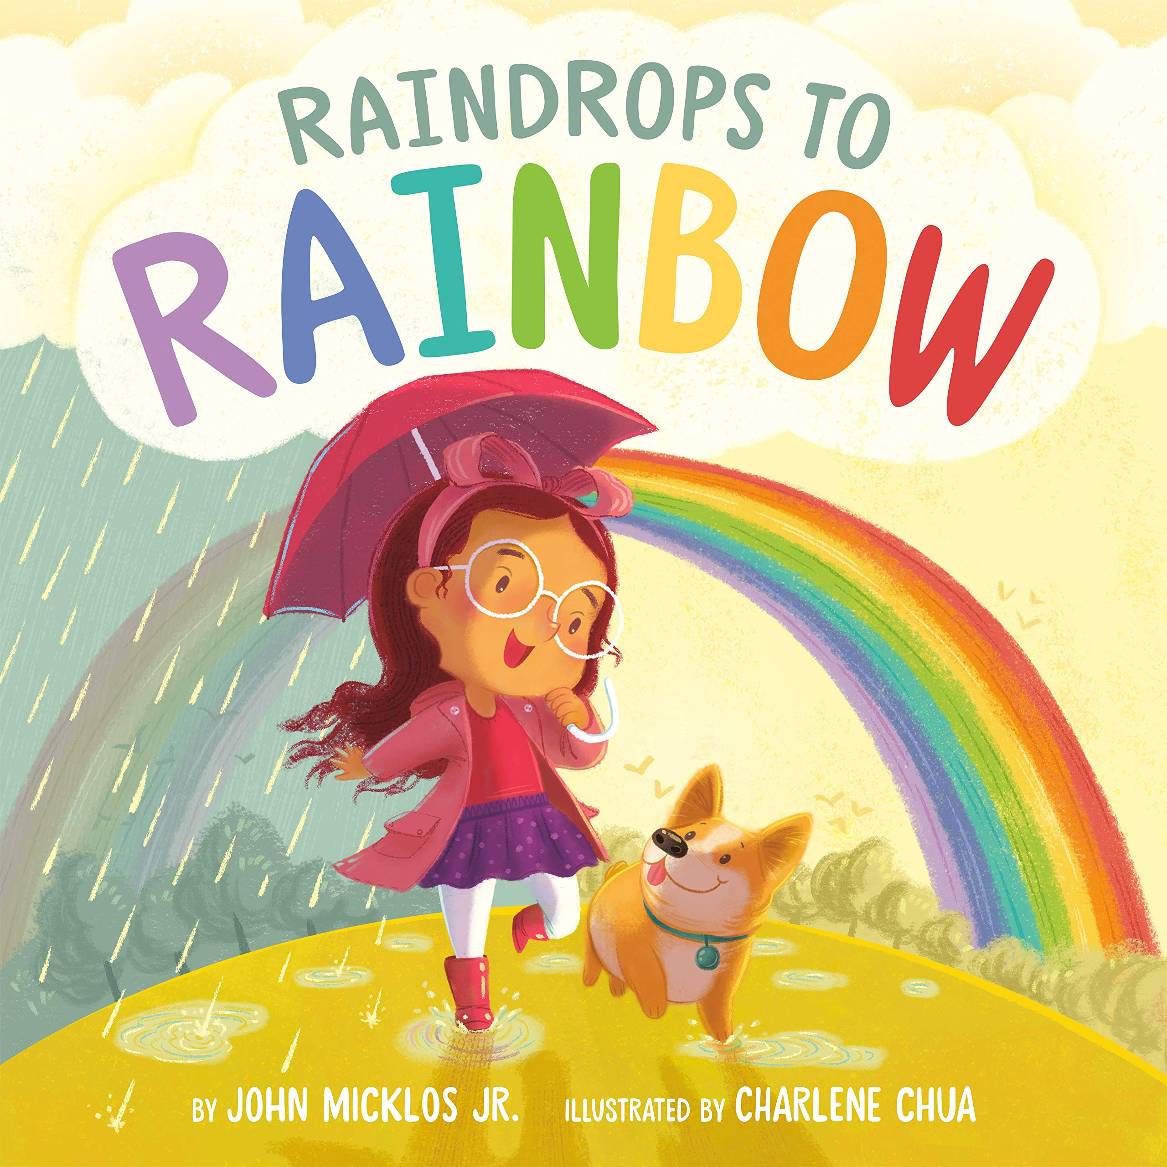Raindrops are falling outside, but there's still a world of color to experience! Delightful rhymes and brilliant illustrations detail how a gloomy, rainy day might not actually be so gloomy after all when you get to spend time with Mom, Brown Bear, and the colors around you. And when a "beaming rainbow, bold and bright" cuts through the sky, everyone gets to experience the joy of all the colors that can only come after the rain.
Verdict: A fun, rhyming picture book that focuses on colors and feelings throughout. A great message of "this too shall pass" when the storm finally ends and a rainbow shines bright.
Find it: NEW PIC MIC

Seven Special Somethings
By Adib Khorram
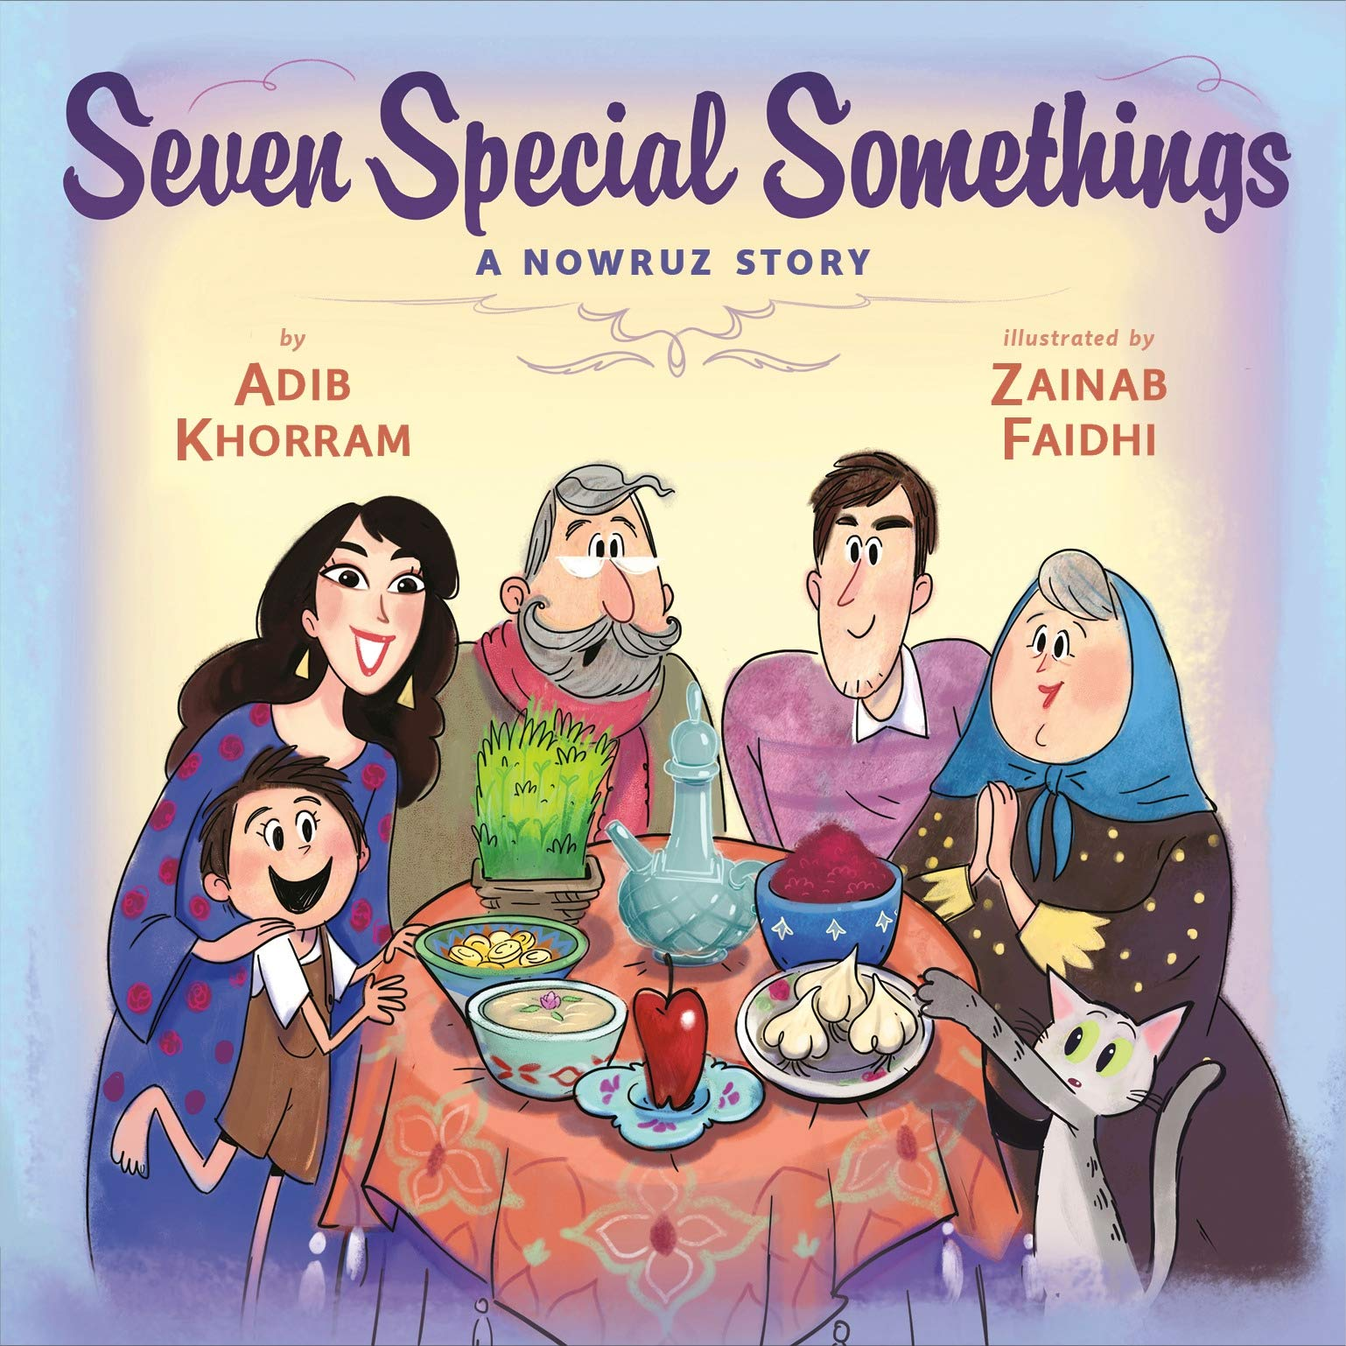Kian can't wait for Persian New Year! His family has already made a haft-seen, and Kian's baba and maman told him that all the things on it start with S and will bring them joy in the new year. Kian wonders if he could add just one more S, to make his family even happier. Hmm . . . Sonny the cat's name starts with S--but Sonny knocks the whole table over! Can Kian find seven special somethings to make a new haft seen before his family arrives for their Nowruz celebration?
Verdict: I had never heard of Nowruz before this book and am so glad I read it! The Persian/Iranian New Year tradition was fun to learn about and the book puts a great story in action as the child tries to 'fix' what the cat has ruined. Of course, he doesn't necessarily do it in a traditional way. A fun read!
Find it: NEW PIC KHO

Shape Up, Construction Trucks!
by Victoria Allenby
It’s no secret that toddlers love big vehicles. Each spread highlights geometric shapes hiding in plain sight on excavators, bulldozers, cranes, and more. And after the toddlers have browsed the pages to their heart’s content, a final note to parents offers enriching, age-appropriate activities to keep building their child’s foundational skills.
Verdict: The book is padded with heavy duty pages, great for little hands. Combining the concepts of vehicles and shapes is brilliant and sure to engage a child that likes to focus on either of those concepts!
Find it: NEW PIC ALL

